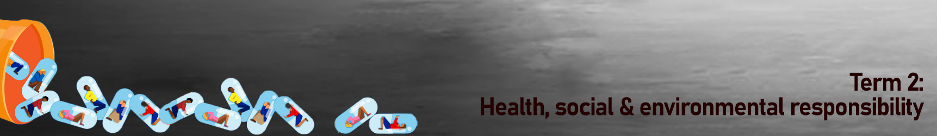
Lesson 2 – Worksheet

Activity 1:
How to say “No” to drugs. In the spaces below provide another TWO possible responces you could say for each point:
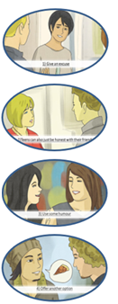

Activity 2:
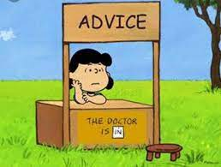

Charlie has written to you asking for advice. Charlie has a problem, every weekend he gives in to binge drinking trying to forget his problems. He has written to you asking to help him get out of this cycle.

- Suggest THREE possible steps Charlie could take to stop binge drinking. (3x1)(3)
________________________________________________________________________________________________________________________________________________________________________________________________________________________________________________________________________________________________
________________________________________________________________________________________________

- Discuss ONE positive and ONE negative possible outcomes if Charlie stops binge drinking. (2x2)(4)
________________________________________________________________________________________________________________________________________________________________________________________________________________________________________________________________________________________________
________________________________________________________________________________________________________________________________________________________________________________________________________________________________________________________________________________________________

- Name TWO hobbies Charlie could take up instead of consuming alcohol and explain the positive benefit of doing these hobbies. (2x2)(4)
________________________________________________________________________________________________________________________________________________________________________________________________________________________________________________________________________________________________________________________________________________________________________________________________
________________________________________________________________________________________________________________________________________________________________________________________________

Activity 3: Reflection Activity
Choose the emotion that best describes your response to the following statements on the work we have covered in the last TWO lessons.
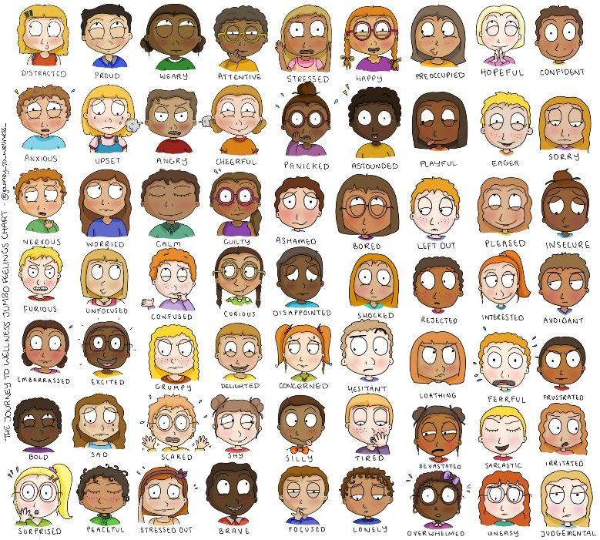

I would feel __________________ if someone told me they were a drug addict.
I feel _______________ about the content we have covered on substance abuse.
I feel _______________ I could identify when the media glamourizes alcohol abuse and choose to avoid alcohol abuse.
When I encounter a situation where I need to say NO to drugs, I feel ___________________ that I could do it.
Remember, change comes when we reach out and partner with those who believe in us and want the best future for us. You don’t have to do it alone!

