IEB CAT A: EXTRA SOURCES DOCUMENT

CONSUMERISM (2023)

SOURCE 1: What is Consumerism? Impact, Importance, Pros & Cons
Retrieved from: https://swotandpestleanalysis.com/what-is-consumerism-impact-importance-pros-cons/
Date accessed: 6 March 2023

INTRODUCTION
Love it or loathe it, we live in a world of consumerism and it influences our choices and ultimately decisions. You may think that you’re in control of everything you choose and buy from the market, but the marketers and advertisers make decisions. Today, we’ll discuss what is consumerism; conspicuous consumerism, its impact, importance, and pros, and cons.

WHAT IS CONSUMERISM?
The focus and goal of consumerism are to increase the sale and consumption of products and services. The idea behind it is that the happiness and wellbeing of a person rely on acquiring and possessing material and consumer goods. From the economic and Keynesian point of view, the main driving force of an economy is to encourage consumers to increase their spending. That’s why it has a positive influence in fuelling the country’s economic growth. In short, we can say;
- The gist of the consumerism theory is that people would be happy when you utilize more products/services
- Economists suggest that more spending fuel the economic growth and production rate
- Many have criticized the impact of consumerism in terms of psychological, environmental, social, and economic reasons.

EXPLANATION
In the capitalist economy, people live a high materialist lifestyle and that comprises conspicuous over-consuming, reflexive, and wastefulness of products/services. Consumerism refers to this state of being that people should live this type of lifestyle.
Many critics perceive that it is destroying the natural way of life and traditional values within society. They further say that big companies are exploiting consumers and resulting in the form of bad psychological impacts and environmental degradation.
After the great depression and WWII, consumerism helped the US economy to get back on its feet again. That’s why the term had positive connotations attached to it in the mid of 20th century. Its focus was on the benefits that the capitalist economy was offering like;
- Developing such economic policies that are focusing on the interests of customers
- Improving the standards of living
Economists said that when consumers increase their spending, then it is beneficial for both parties. Like it helps companies to increase their profit, revenue, and sales; and consumers derive benefits from utilizing the product/service. For instance, the auto manufacturer would enjoy profitability by the increase in the sale of vehicles. The sale of relevant businesses would also increase like tires, steel, and accessories. That’s how consumer spending offers a lot of benefits to the consumers and the economy.
Some other economists say that it’s a difficult goal for companies to establish and maintain economic growth by increased spending and consumption. It’s irrelevant to its benefits to society and consumers as a whole.

CONSPICUOUS CONSUMPTION
Thorstein Veblen came up with the concept and floated the term conspicuous consumption. It’s when consumers buy, utilize, or possess a certain product/service, then they not only derive direct-use-value but also send a signal of economic and social status.
The standard of living of people has increased significantly since the industrial revolution, so has conspicuous consumption. Its high price usually falls under the category of negative or wasteful zero activity, because it consumes real resources not to produce really useful products rather than the image they represent.
It’s such a form of consumerism that imposes a lot of cost on the country’s economy. Here it consumes real resources for the sake of commercial benefits and social status. However, it results in the form of destroying the market for consumers and other products and services.

IMPACT OF CONSUMERISM
Keynesians macroeconomists say that the main target policymakers in an economy are consumer spending via monetary and fiscal policy. High spending creates a major share in the country’s GDP (gross domestic product) and aggregate demand. Therefore, the government sees the best way to improve the country’s economic growth by amplifying the spending of consumers.
It perceives consumers as the target cash cows and economic policy of businesses and companies, and it believes that more spending fuels economic growth. Savings lower consumer spending and it’s harmful to the economy.
Many business operations and functions happen due to consumerism. It helps you to develop better products and displace the competition by making certain products/services in a planned way. Most importantly, it creates the demand of the product/service in consumers by marketing and advertising rather than using marketing only to inform customers.

IMPORTANCE OF CONSUMERISM
Consumerism plays a significant role in the economy. It makes sure that the people would be willing to spend, and the money would circulate in the country and won’t stick in the few hands. However, if spending decreases, then it would suggest problems like high-interest rates, higher unemployment rates, etc. One factor, consumption tells the overall health of the economy.

PROS & CONS OF CONSUMERISM
Some of the main advantages and disadvantages of consumerism are as follows;

ADVANTAGES OF CONSUMERISM
- Higher spending causes more production of products/services
- The country’s GDP would increase
- Higher consumer demand is a sign of their confidence in the US
- More consumption and sale benefit both owners and employees either directly or indirectly

DISADVANTAGES OF CONSUMERISM
- It has developed a materialistic culture and society that focuses on high quantity and costly goods rather than quality and traditional way of production
- It promotes globalization and trade of global brands which undermine the production of local indigenous products, and incompatible high consumption cause debt, recession, and financial crisis
- Many of the environmental problems occur because of the high production, spending, and consumption; and it results in the form of wastage of resources, ultimately more pollution
- It has made the mindset of people status-conscious, and often it causes stress and anxiety by keeping up with the social status
- Studies have shown that people exposed to consumerist culture, have a mindset of possessing materialistic things, status quo, and wealth conscious

CONCLUSION: WHAT IS CONSUMERISM? IMPACT, IMPORTANCE, PROS & CONS
After an in-depth study of what is consumerism; conspicuous consumption, its impact, importance, and advantages and disadvantages; we’ve realized that consumption plays a significant role in the country’s economic growth. The criticism is also worth considering, therefore, a middle ground would be better.

SOURCE 2: The Effects of Consumerism

Retrieved from: http://www.paggu.com/business/world-economy/the-effects-of-consumerism/#:~:text=Negative%20Consumerism%20Effects%3A%20Top%20negative%20consumerism%20effects%20are%3A,whether%20a%20society%20is%20highly%20developed%20or%20not.Accessed
Date accessed: 8 March 2023

Consumerism is becoming the hallmark of most world economies. In the West, it is a common phenomenon, but now even developing countries in the world are resorting to it.
Consumerism refers to the consumption of goods at a higher rate. The production and selling of goods judge the economy. The gross national product is the total of goods and services produced for a specific period at a specific time. The more goods produced and consumed by society, the higher the growth rate of the economy. The prosperity of a nation is judged by the per capita income of individuals residing in it. The economy is considered to be “doing well” if the purchasing power of the people is high.
In a consumer society, people replace their goods with newer ones. They purchase goods, use them and throw them away. Newer ones replace new goods when they become old. The question of repair does not arise. People have money to purchase products in plenty. In case they do not do so as it leads to recession and depression and also results in unemployment.
What are the effects of the consumerism?
Consumerism is appreciated in Western economies since a person’s standard of living is valued by his or her material possessions. There are certain positive effects such as:
Positive Consumerism Effects
Primary positive consumerism effects are:
- More industrial production.
- A higher growth rate economy.
- More goods and services available.
- More advertising since goods manufactured have to be sold.
- Increased production will result in more employment opportunities.
- A variety of goods and services to choose from.
- More comforts for a better living style.

There are always certain pitfalls to a given situation in a society. Material prosperity may be there in consumerism but, it has its negative effects on the people and society at large.

Negative Consumerism Effects
The top negative consumerism effects are:
- Craving for goods is high. The wants and desires of the people increase. The better their income, the better their purchasing power. But in case, they are not able to do so, and then they feel dissatisfied.
- One is in a rat race to earn more and is forced to cope with stress and other work-related tensions.
- Material wealth is the deciding factor about whether a society is highly developed or not. Spiritual values are underplayed. This may not be suitable for a person from the East, who generally is appreciative of spiritual values.
- Over-dependence on labor-saving devices.
- A car for each individual would mean gradual erosion of public transport.
- Crime rate also increases as wants to possess of expensive gadgets increases. Thefts become common, and daylight robberies take place.
- Personal relationships also get affected as people are busy trying to earn more to maintain their standard of living.
- Cheaper goods are imported from other goods affecting the growth of locally-based manufacturing industries.
- Consumerism has also resulted in ecological imbalances. The natural habitat is being destroyed to create more goods and build more buildings affecting the weather. Global warming will eventually result in health problems. Industrial pollution is affecting people in many ways.
- People’s lifestyles have also changed in a sense they are more lavish, full of material comforts rather than focusing on simplicity. Eastern spiritualism and philosophy have always emphasized simplicity. Gandhian principles and values favor a non-materialistic approach to life. Even well-known sages such as Jiddu Krishnamurthi have also eulogized simplicity in one’s lifestyle and thinking.
- Consumerism is also depleting the natural resources of the respective country.
- Psychological health also can get affected if one’s desires are not meant, such as depression. Jealousy and envy can lead to crime.

The United States is a consumer economy and is known for its material growth and prosperity. But presently, the economy is reeling under the pressure of the recession. People who have lost their jobs are finding it difficult to meet both ends. In the East, India is also progressing toward materialism, although this goes against its ancient philosophical approach towards materialism, which favors a simple, non-materialistic life.

Effects of Consumerism FAQs

How does consumerism affect poverty?
Consumerism hurts poverty because it encourages people to buy things they don’t need to feel good about themselves. This cycle of excessive spending ultimately harms the economy and creates more poverty, as people cannot purchase necessary goods and services. This increase in expenditures causes inflation and affects the quality of life for those below the poverty line. Consumerism also pushes people into debt, which can be incredibly difficult to repay. It also contributes to workplace stressors such as low wages and long hours that harm mental health. Ultimately, it diminishes social welfare by encouraging individuals to prioritize self-interest over the well-being of society.

How did consumerism affect society?
Consumerism has significantly impacted society because it has allowed for the rise of industries and businesses that capitalize on people’s needs and wants. As a result, people have become desensitized to their desires and are more likely to buy things impulsively or in excess. This insatiable thirst for possessions has directly led to the global economic downturn of recent years, as consumers became overstretched and began spending less money than they could afford. Unfortunately, this behavior also negatively affects individuals and societies by contributing to financial instability, environmental destruction, social unrest, obesity rates, health problems…the list goes on!
One way to counter this is by encouraging sustainable consumption – buying products made with minimal harm or exploitation to the planet. Another approach is through responsible marketing – promoting brands that appreciate humans and nature. The lasting legacy of consumerism will likely be its devastating economic and emotional effects on our societies. By being conscious of how our actions affect not only ourselves but also other species on Earth, we can create a more sustainable future for all!

How do consumers affect the environment?
Consumers significantly impact the environment because they are responsible for the number of resources they consume. For example, when consumers buy packaged food items, this affects both the production and packaging processes. Additionally, when people drive their cars or use energy-intensive appliances such as air conditioners or refrigerators, they use more resources than necessary. Other examples include the production and consumption of goods and services, waste generation, transportation choices, and purchasing habits.
Consumers also indirectly impact the environment by engaging in pro-environmental behaviors like recycling or reducing their energy use during peak hours*.

SOURCE 3: Overconsumption is Affecting Our Mental Health
Retrieved from: https://robertastylelee.co.uk/overconsumption-is-affecting-our-mental-health/#:~:text=Research%20as%20far%20back%20as%20the%201800%E2%80%99s%20has,with%20others%20but%20rarely%20increasing%20their%20own%20well-being.%E2%80%99
Date accessed: 8 March 2023
We all know how buying new things gives us a short term burst of happiness. However, unfortunately, it’s a blast that doesn’t last and before long you feel the need to buy something else. This creates a vicious cycle of consumerism and stuff that many of us (including myself in the past) fall victim to.
As damaging as this cycle is for our bank accounts it can be just as damaging to our mental health. In honour of World Mental Health Day today this is something I wanted to highlight.
Research as far back as the 1800’s has found that there is a link between over consumption and poor mental well-being. In 1899 the American economist Veblen found that people were ‘living on treadmills of wealth accumulation, competing incessantly with others but rarely increasing their own well-being.’ This observation is still extremely relevant to our society and how we live our lives today.
Modern research tells a very similar story. Tim Kasser is an acclaimed psychologist, known for his work into materialism and well-being. Kasser observes that there is a connection between an excessively materialistic outlook and increased levels of anxiety and depression.
Kasser found that when people prioritised materialistic goals in their lives they tended to have poor personal well-being. Kasser found that these people had lower happiness and life satisfaction levels and had more personal illnesses such as anxiety and depression. He also observed that they behaved differently socially. They were more manipulative and competitive towards the people in their lives, and lacked empathy.

HOW TO PUT AN END TO THE CYCLE
The thought of changing how you consume products and breaking out of what is likely a lifelong habit can seem daunting and next to impossible but trust me, it’s not. If you follow these three easy steps you will be well on your way to a more conscious and mentally healthy lifestyle… not to mention saving yourself money.

Educate yourself.
Know what you are consuming before it consumes you. Before you buy, ask yourself what am I buying?, who made it?, what is it made from?, and what is the true cost of this item? Do you think if you knew the truth behind your Boohoo haul it would still give you that happy buzz?

Reassess where you get your happiness from.
If you’re relying on the quick fix of consumption to give you happiness and that feeling of fulfilment, it can be hard to stop. It can be almost like you’re addicted. Reassess where you get your happiness from, start by recognising what you have in life, not just possessions but the wonderful people you have around you and all the amazing experiences you have. The truth is… in the end no one is going to remember those four cute tops you got on sale so look for the things that really matter in life.

When you do buy, buy well.
No one is saying you should never shop again. Of course not, just become more aware of what you are buying. There is no harm in feeling good about a purchase when that purchase is actually doing good.
When you buy good quality, ethical products rather than cheap, fast fashion you’re not only doing good for the planet you’re also buying items that are going to last and won’t need replacing next season. If you want to discover some amazing ethical brands that you can trust check out my Ethical Brand Directory. I hope you found this helpful and feel inspired to change how you consume, even if it’s just a little.
Remember, look after your mental health! It’s just as important as your physical health, and never feel afraid to reach out if you are struggling. We all have our problems and if we talked about them more the world would be a better place.

SOURCE 4: 5 Ways the Consumer Society Has Distorted Our Perception of Happiness
Retrieved from: https://www.learning-mind.com/consumer-society-happiness/
Date accessed: 8 March 2023

The consumer society we live in has altered our perceptions on so many levels. It has changed the way we see things in our everyday lives.

The consumer society wants us to believe that in order to be happy, we need to constantly buy newer and better things. Life becomes a never-ending pursuit of the attributes of success. I’m using the word ‘attributes’ because our society doesn’t really want us to strive to be truly successful or happy. It wants us to strive to look so.

But the saddest fact is that our consumer society has distorted the way we view and treat other people. And this distortion is rooted so deeply inside our minds that most people today don’t even realize that something is wrong with this mindset.
Below are the ways our consumerist mindset has messed with our perception of happiness and personal relationships.

1. We are never happy with what we have

The first basic thing we learn in today’s consumer society is that we are not good enough. Our life is not good enough. Our house is too small, our car is too old, our smartphone is too outdated and so on. We are constantly told that in order to be cool, happy and successful, we need to buy new stuff.
Hold on for a minute and think about your grandparents’ lives. Back to the times when they were young, did they have all the things you have today? Did they have so many household appliances at their place? How many clothes did they have and how often did they buy new ones? Did they have a car, did they even have a TV?
A few decades ago, life was much simpler than it is now. For this reason, people’s understanding of happiness and life satisfaction was also much simpler. Today, it’s much more difficult to feel accomplished and satisfied with all these expectations and pressure the society is putting on us. As a result, we struggle to appreciate what we have and to be grateful for all the good things in our lives.

2. We don’t fix things anymore – we just throw them away and look for the new ones

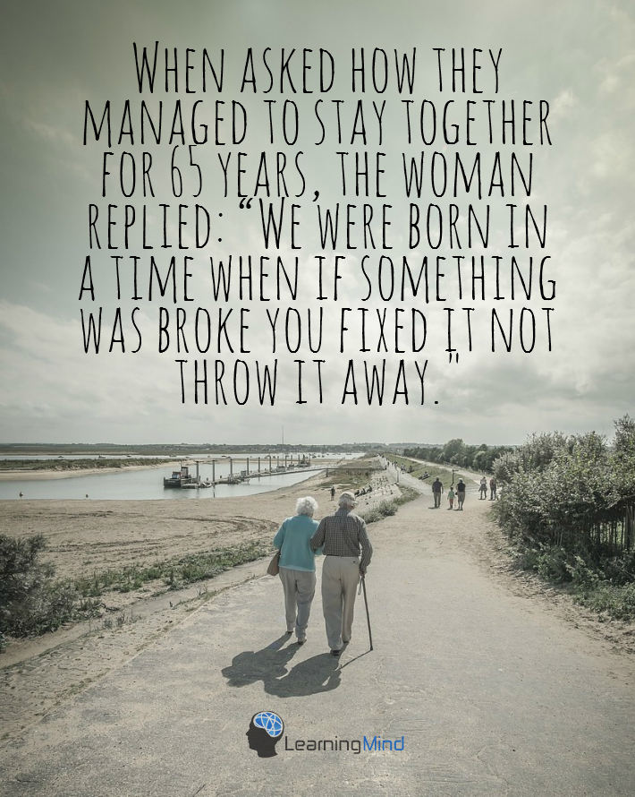

When asked how they managed to stay together for 65 years, the woman replied: “We were born in a time when if something was broken, you fixed it, not throw it away.”
-Unknown

Today, it’s possible to buy literally anything. This has lead us to think that all the things we have can be easily replaced with new ones. If your phone is out of order, you can always buy a new one, right?

Sadly enough, this mindset the consumer society cultivates has had an enormous effect on our personal relationships too. Whether we are aware of it or not, we have started to treat people in our lives the same way.

When we face problems in our relationships or friendships, we often give up too easily. We decide that this person is not good enough for us and just cut them out of our life. Of course, in some instances, such as toxic and abusive relationships, it can be a wise option.

Still, we often label people as toxic or negative before we really get to know them and the hardships they may be going through. As a result, we often fail to understand those around us and tend to burn bridges too soon.
And all this has to do with the consumerist mindset – we feel like we can always replace our friend or partner with a new one. However, personal relationships just don’t work this way.

3. We need constant social validation

The consumer society we live in thrives on comparison and competition. Who is more successful than me? Who is richer, whose relationship is happier than mine, who has a bigger house?
Today, we compare ourselves with others all the time. It has become the norm. It’s one of the ways the consumer society makes people buy more stuff in order to be “better” – or, more precisely, feel better – than those around them.

For this reason, we often feel the need to show our accomplishments to others. We share the details of our private lives on social media and upload pictures of our vacations and special moments. In reality, it’s a cry for attention and validation.
“Everyone, look at me, how happy I am!” “Hey, people, check out my new car/house/job, are you as successful as I am?”

But sit and think about it a little more in-depth. Are all your Instagram followers genuinely interested in your life? Do all your Facebook friends care about you and want to see you happy?

This is another lie our consumer society feeds us with – that other people care to learn every little detail of our lives, so it is important that we demonstrate our success and happiness to them. However, in reality, most people just don’t care and some would even be glad to see you fail.

And most importantly, we often forget that chasing social validation will never bring us happiness. Quite the opposite, actually. It is more likely to bring us disappointment, self-esteem issues loneliness and even depression. It’s simply impossible to be good enough for everyone.

Never forget that:

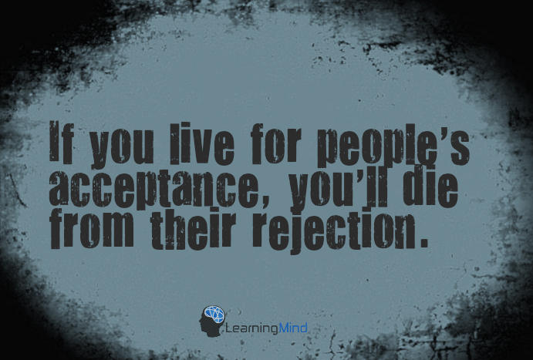

4. Taking advantage of other people is the norm

Consumer society is all about obtaining, using and finally, throwing things away. We buy tons of unnecessary stuff just to get rid of it later.
While this approach is causing a tremendous devastating effect on the environment, it is also devastating to our personal lives. We have started to treat people the same way we treat objects.
I believe every one of us has been taken advantage of. Remember that friendly colleague who seemed so kind and interested until you helped him write a report? Or that old classmate of yours who reappeared in your life just to get your help in formatting her laptop? Or maybe that friend who wants to see you only when he is in trouble but doesn’t return your calls when you need someone to talk to?
Situations like this are a part of today’s life and don’t even surprise us anymore. Sadly enough, it has become a rarity to meet an individual without hidden motives. Someone who genuinely cares about you and is glad to see you only because he or she enjoys your company. If you have a couple of such people in your life, consider yourself lucky.
The truth is that this mindset will never make you happy. You may indeed achieve some of your goals by taking advantage of other people. But in the end, all you will be left with is the voice of your conscience and all-consuming loneliness.

5. We focus on material values and ignore the real ones

What is the greatest purpose of life in a consumer society? To have a high paying prestigious job and a fat bank account, to own a great house and car along with all the other attributes of wealth and success. Only a person who meets these criteria is considered truly successful and receives everyone’s praise and respect.

But is the meaning of life really about obtaining material wealth and looking good to others? Many people nowadays are fooled by the lies the consumer society tells us on a daily basis. As a result, they find themselves stuck in jobs they hate and living a life that feels monotonous and meaningless. This is probably one of the reasons why depression rates have never been higher than today.

Our consumer society distracts us from the things that have a real value in life. Instead, it directs us towards ephemeral goals, making us serve its interests without even being aware of it.



Society judges people by their successes. I get attracted by their dedication, simplicity, and humility.
-Debasish Mridha

Finding happiness in the consumer society

Well, I guess I draw a pretty dull picture of today’s world. But you know, like with all things, there is a bright side to living in a consumer society. And it is about the countless opportunities it offers.

While modern life often makes us forget what life is all about, it also gives us numerous possibilities to make our dreams come true. There have never been so many various businesses, jobs, and career paths before, and everyone can find something to fulfill their purpose in life.

So instead of letting the consumer society fool you into pursuing the wrong things, focus on the right ones, and seek to find your unique path in life.
Forget what is popular or prestigious and look for what matters to you. Don’t try to look successful and gain everyone’s approval; follow your soul’s calling. Because this has always been and will always be the only way to reach true success and happiness.

SOURCE 5: Conscious Consumerism: What It is, How It Can Affect Change & 10 Ways You Can Be a Conscious Consumer Yourself


Retrieved from: https://growensemble.com/conscious-consumerism/
Date accessed: 7 March 2023

From food and clothing to consumer electronics and vehicles, purchasing some things some times is an inevitable part of our lives. While purchases may be well integrated in our day-to-day, mindless consumption doesn’t have to (and shouldn’t) be.

But what are the implications of buying something?

Its impact doesn’t stop at you spending money and using the product. There’s a whole process that takes a product from the raw material stage to being displayed on shelves, and not to mention what happens to it after it comes to the end of its useful life (at least in its current form).
Along with price and quality, the social and environmental impact of products from production to disposal is influencing consumers’ purchasing decisions. In other words, conscious consumerism is on the rise.

The Rise of Conscious Consumerism
An Overview of the Conscious Consumer Movement
Imagine your trips to the grocery store. When you peruse the aisles of seemingly endless food, drink, and home products do you consider the impact of every item you add to your cart? Many of us focus first on cost, often by necessity. But, we may also consider, where does this chicken breast come from? How was this chicken raised? What kind of impact does poultry farming have on climate change?
Yes, some find themselves wondering about a product’s social impact and the best sales—these questions aren’t mutually exclusive!

What kinds of questions are you asking yourself when you go shopping?

A Quick Conscious Consumption Definition
By now you probably have a pretty good idea of what conscious consumerism is, but to eliminate any doubt, here’s a quick definition: Conscious consumerism is when buying practices are driven by a commitment to making purchasing decisions that have positive social, economic, and environmental impact.
In other words, it’s a movement whereby consumers vote with their dollar by buying ethical products, avoiding unethical companies, and sometimes not purchasing at all. So, a socially or environmentally conscious consumer will think whether consumption is necessary, then once they decide to buy, they look at who is providing the product and how the product impacts each environment touched in its creation and delivery.
Eliminating impulse buys and opting for companies and products that create positive impact, consumers communicate a preference for better-for-the-world business and products.
Conscious consumerism (otherwise known as ethical consumerism or green consumerism) is a trend that grows more and more popular by the day.
But where did it get its start?

A Brief History of Conscious Consumerism
The concept of a “conscious consumer” dates back to the 1970s. But the first inklings of the modern concept of “dollar voting” can be traced back even further to 1954, when economist James Buchanan stated that individual participation in the economy is a form of pure democracy, in his article Individual Choice in Voting and the Market.
Not surprisingly, formal consumer movements that advocated for consumer rights were developed during the late 19th and early 20th centuries in industrialized countries such as the U.S. and UK. These movements came into existence to combat unfair labor practices, ensure product safety, encourage healthy competition in the market, and implement financial regulation (for example, cheaper access to credit and better loan education for borrowers).
Advocating for consumer rights remains an important aspect of participating in the marketplace today, but consumers have transformed what it means to be a consumer by placing a large focus on making responsible purchase decisions.

How the Conscious Consumption Movement Came to Prominence
Conscious consumerism spreads as more and more consumers become more aware (or should I say…conscious) of harsh realities related to each purchase such as climate change and pollution, as well as grossly underpaid workers with poor working conditions.
Consumers increasingly pay mind to the impact their actions have on every stakeholder affected in the process of creating and delivering the product they buy.
Technology makes buying easier than it’s ever been. Technology also makes conscious decision making easier if you know where to look. With a brief search online, you can find much of the information you need to navigate your buying practices toward more ethical and sustainable options.
Of course, we, at Grow Ensemble, exist to connect people with values-aligned companies, organizations, and communities.

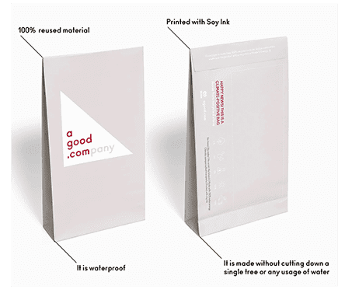
When searching for information, some companies themselves embrace transparency as a tenant of business. Our partners at A Good Company, for example, share publicly how their products are thought up, sourced, and what materials they use. They share their decision-making process with their customers, so everyone can see how each product came to be what is delivered to your door (in their own stone paper shipping material).

This level of insight into business operations has historically been exclusively available to those involved in the business, leaving buyers without much to base purchasing decisions on outside of price and end-product quality.
The more we understand our impact, the more we can each take action to make that impact positive. Then, we can work our positive impact into each decision we make as individuals, citizens, and consumers.

Has Consumer Consciousness Changed the World?
Here’s an encouraging statistic: a whopping 73% of global consumers say they would definitely or probably change their consumption habits to reduce their impact on the environment.

As consumers become increasingly aware of consumer goods’ effects on their bodies and the world around them, they’re also more interested in buying sustainable products. Millennials are reportedly willing to even pay more for these products over more destructive alternatives. And it’s not just millennials. In the US alone, consumers are expected to spend $150 billion on sustainable products by 2021.
The Benefits of Conscious Consumerism

As an individual, it may be hard to see the benefits of being a conscious consumer. What does buying organic soap or boycotting a company known for using sweatshops do in the long run? But adding up each person’s actions equates to big changes in the grand scheme of things.

The same logic applies to harmful behavior such as littering. A person might be ok with throwing a candy wrapper on the sidewalk, but imagine if every single person had this attitude. Many parts of the world already have to deal with more waste than they know what to do with.

Plus, consumer opinion and individual action trigger exponential change! The reality is that for many of us, price is the determinative factor in our purchasing habits by necessity.

But, when individuals consume (or choose not to consume) with impact in mind, industry responds to meet consumer demands, and this expands accessibility. With access to more information and more product choices, more people are given the opportunity to weigh in on the ethics and standards of our day to day consumption.
Okay, but does it really make any difference? Do big companies care what we think? Well, like we mentioned, the trends on the consumer-side are clear: we want to engage with companies that prioritize social and environmental wellbeing.

Before 2013, only 20% of S&P 500 companies chose to disclose their environmental, social, and governance (ESG) information—that means finding that information took major sleuthing on the part of buyers if it was even possible at all. Parallel to conscious consumer trends, however, in 2019, 90% of S&P 500 companies published sustainability/responsibility reports. In short, they are definitely listening.

Still not convinced?

Let’s look at another sector, organic farming in the U.S., as an example of how conscious consumerism can affect change: Twenty years ago, organic farming was a niche industry with $3.6 billion in sales in 1997.

But as more consumers began to appreciate the idea of agriculture free from toxic synthetic pesticides that pollute air and water and degrade soil, they started shifting their purchases, starting with food.

By 2016, organic food sales had boomed to $43.3 billion, and further up to $50 billion in 2019.

Today, the industry continues to see the needle move further and further toward better-for-the-world practices. The future of agriculture holds regenerative practices that will improve the health of the planet beyond what we could’ve imagined decades ago, even helping to reverse climate change.

More good news: Consumer impact is having other world—and market-changing effects. It turns out choosing renewable energy is more than just a fashionable trend. Thanks to growing demand as more and more people are installing solar panels, buying renewable energy credits, and using green power for a variety of purposes, renewable energy sources have become even cheaper than coal and natural gas!

Criticisms of the Conscious Consumption Movement

For all the praise that conscious consumerism and conscious consumers receive, there is continuing criticism of accessibility.

The fact of the matter is that many sustainable products are more expensive than their counterparts. In certain cases, they’re even considered luxury items. Needless to say, high-end luxury items are out of reach for most people. This leaves much of our population unable to participate, kind of eviscerating Buchanan’s “pure democracy” idea.

If much of our community doesn’t have the option to vote with their dollar for sustainability, they are left not only without their voices heard of the issues of corporate impact, but also exposed to the products and practices conscious consumers are speaking out against. Often, the communities most damaged by corporate irresponsibility are the exact communities who can’t opt for better-for-the-world alternatives due to cost constraints.

This is a major issue and accessibility to healthier, more ethical products must be universal because in the end, it’s not a preference, it’s a necessity—the thing that makes products ethical is that they are good for humans and planet, and that is important for us all!

The more consumers demand ethical, organic, and fair trade products, the more commonplace they’ll be, and the cheaper they’ll become, which makes them more accessible to everyone. Sustainability should be the norm, and we are definitely making progress to that end, but there’s still work to do.

Unfortunately, oftentimes, what people say they want to do doesn’t align with what they actually do. Consumers want to make more ethical choices with their purchases, but unsurprisingly, price and convenience remain powerful driving factors. In certain cases, those are the determining factors for product choice which is why those consumers often opt for the cheapest product, regardless of the underlying ethical implications. The gargantuan success of Amazon is an example of exactly this.

That being said, when we look at sustainable products that are minimally or moderately more expensive, conscious consumers have to consider the total cost in the long run. The fashion industry is a prime example of this.

Sustainable, circular fashion—clothing made from organic, reusable materials—can last for years and reduce truck loads of textile waste per day, whereas fast fashion sources leave textiles with rips or tears after only a few outings putting more and more into our landfills. We do have to give kudos to H&M for vowing to use recyclable materials by 2030, though.

The critics also find fault with shoppers that buy green products to look good and quell their guilt rather than doing so out of a genuine desire to help the planet and the people in it. The fact of the matter is, not everyone will be driven by the same things to help others and the planet—and that’s ok! The results of conscious consumerism are the same regardless of the motivations behind it.

The key is sustaining progress. Like any movement that aims to combat the status quo, it’s an ongoing effort that needs to grow and be cultivated. The good news is that there are signs of progress as we outlined above. The more consumers demand that companies behave ethically, the more likely they are to make conscious business decisions by considering all their stakeholders.

10 Ways You Can Be a Conscious Consumer

There are many ways that you can be a conscious consumer and do your part in making the world a better place:

- Incorporate minimalism into your life as much as possible. Distinguish between necessary and unnecessary buys. When searching for everyday products, consider how they are made and their entire lifecycle impact—our partner, A Good Company, is leading the way on this front.
- Choose to buy from companies that put planet and people first. Our friends at A Good Company aren’t alone in their efforts to redefine business as a force for good.
- Buy fair trade coffee, fashion, handicrafts, fruit and more.
- Buy earth friendly products that are made with natural ingredients and materials, e.g. a composting phone case. And these don’t just have to be for you! Check out our list of the perfect environmentally friendly gifts.
- Buy cruelty-free, plastic-free toiletries and cosmetics.
- Limit air travel and get around by using rideshares, biking, taking the train and public transport and if possible, drive electric vehicles
- Go zero-waste.
- Eliminate the use of single-use plastics and use reusable cups, utensils, bags and containers instead.
- Reuse items and buy second-hand whenever you can: peruse flea markets, borrow from friends and family, shop on online marketplaces and try to fix broken goods rather than buying new.
- Always recycle paper and plastic, dispose of old clothes responsibly, and consider composting at home.

How Can You Determine Which Companies are Ethical?

Companies understand that being ethical is in vogue so their marketing messaging touts sustainability and ethical practices. While that may be a sign of the prevailing conscious consumer (woo!), it’s always good to look a little deeper to make sure companies are actually taking action consistent with what they’re promoting.

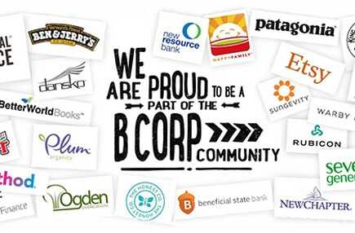
It can be hard to know what to look for when determining whether a company is ethical or not. But once you can identify the characteristics of truly socially responsible companies, you’ll be able to parse through what is pandering and what sustainability goes to the core of a company’s operations.

Social entrepreneurs are everywhere, and the number is only growing! We suggest looking into which companies are certified B Corporations. These companies undergo a rigorous vetting process through the B Impact Assessment that scores impact across business operations.

Conscious Consumerism is Only One of our Tools, but Still One to Use

It would be naive to say that buying things is going to save the planet; it won’t.
However, it would be equally naive to resign ourselves to inaction. Unless you live off the grid, grow your own food, build your own shelter, etc.—more power to self-sustaining individuals!—buying things is an inevitable fact of your existence.

If we have to be consumers, why not vote with our dollars like we mean it and buy from companies who genuinely care about making the world a better place? Why not support environmentally friendly companies that prioritize our planet’s health? Why not boycott companies who engage in labor unethical practices?
When you look at it as if you’re fighting an insurmountable beast, it seems like a futile, unwinnable undertaking, but the fact is, every single bit counts. Taking on that perspective is critical in being a conscious individual, not just a conscious consumer.
For inspiration from nation-wide movements, you can look at countries like The Gambia, Morocco, Costa Rica and India, which are making great strides in reaching goals against fighting climate change.

So much can be done: We can take institutional actions such as supporting our governments in investing in renewable energy; group action volunteering time and money to organizations fighting for the rights of marginalized groups; community action encouraging our friends, family, and colleagues to go green; and, as you know, individual action, including using our dollar as conscious consumers.
Is it easy? Not by a long shot. Is it worth it? Hell yeah.

