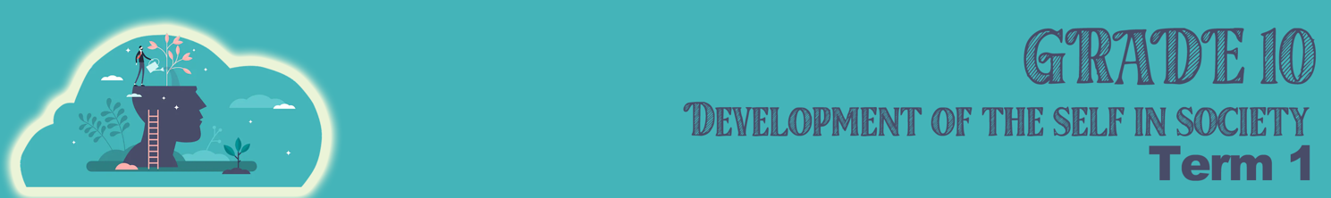

Lesson 2 – Worksheet MEMO
Activity 1: Fill in the following definitions while we work through the PowerPoint.
to have control over a person or environment. Power is the ability to get things done
POWER

POWER RELATIONS
is the sharing of power between two people in a relationship. In an unequal power relationship, one person tends to dominate over the other. This is not a healthy relationship.

STEREOTYPE
when a group of people are judged based on a single quality or characteristic.

womanliness or the female sex. This also refers to ways typically behaved as a female.

FEMININITY

MASCULINITY
this refers to maleness or the male sex. This also refers to ways typically behaved as a male.

this refers to the characteristics of women, men, girls and boys that are socially constructed. Behaviours and roles associated with being a woman, man, girl or boy, as well as relationships with each other. Gender is learnt, not a biological function.
GENDER
.
Activity 2:
Identify which of the following statements belong to a male and which to a female:
1. Menstruate - Female
2. Have an X and Y chromosome - Male
3. Can give birth - Female
4. Testicles that produce sperm - Male
5. Small breasts that do not produce milk - Male
6. Fertile till old age. - Male
7. Skull is thinner and weaker - Female
8. Smaller % of body fat - Male
9. Longer lifespan - Female
10. Better night vision- Female
11. Better depth perception - Male
12. Sexual organs outside the body - Male
13. Skin is thicker and oilier because of more collagen and sebum - Male

Activity 3:
In your group put all the adverts that had to be collected for homework on the table. As a group complete the table below and then answer the questions individually.
How many adverts stereotype men?
How many adverts stereotype women?
How many adverts address racial stereotypes?
How many adverts challenge negative stereotypes?

How many adverts/posts challenge abilities/ talent based on gender.

Based on the data that you have collect discuss the following:
Do you think there are certain careers that can be done by only men/women? Why would you agree/ disagree?

Are there any cultural stereotypes that you are aware of that prevent men and women from opportunities to study after school?

Can you identify any stereotypes in your school around playing sport? How do these stereotypes make you feel?

Activity 4:

- Write a short paragraph on what you have learnt today of gender roles in the home.
___________________________________________________________
___________________________________________________________

- Think about your own family home. How would you be able to support your parents to breakdown stereotypes that exist in your own home?
___________________________________________________________
___________________________________________________________

