
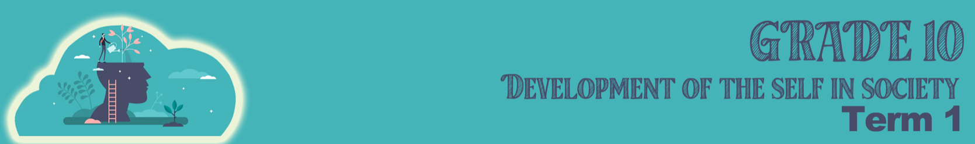
Lesson 1 – Worksheet MEMO
Activity 1:
Can you describe the difference between self-awareness and self-esteem by referring to examples from your own life?
Self-awareness would be knowing my talents and interests, like the sports I enjoy.
It’s also knowing what strengths I have - like my ability to make friends easily.
My weaknesses could include my lack of time-management. (Suggested answer)
Self-esteem (as in Activity 2) refers to how I feel while doing these above activities.
Activity 2:
Take a few minutes to reflect on your self-esteem. How would you respond to these questions about yourself? Draw an X over the block that you feel is most accurate response to how you FEEL about yourself.
I FEEL I CAN ASK FOR HELP WHEN I AM STRUGGLING WITH A SUBJECT. | ALWAYS | SOMETIMES | I DON’T | NOT REALLY | NEVER
I WILL STAND UP FOR MYSELF IF SOMEONE PUBLICALLY SLANDERS ME. | ALWAYS | SOMETIMES | I DON’T | NOT REALLY | NEVER
I AVOID LOOKING INTO SOMEONE’S EYES WHEN I TALK TO THEM. | ALWAYS | SOMETIMES | I DON’T | NOT REALLY | NEVER
I’M AFRAID OF FAILING AND DISAPPOINTING MY FAMILY. | ALWAYS | SOMETIMES | I DON’T | NOT REALLY | NEVER
I CAN SAY NO IF MY FRIENDS ASK ME TO DRINK ALCOHOL WITH THEM AND I DON’T WANT TO. | ALWAYS | SOMETIMES | I DON’T | NOT REALLY | NEVER
I PREFER NOT STARTING A NEW HOBBY / SPORT THAN TRYING TO DO IT AND MAKING A BUNCH OF MISTAKES. | ALWAYS | SOMETIMES | I DON’T | NOT REALLY | NEVER

Self-Reflective – Learners will give personal responses to this activity.

Activity 3:
On your tables are small pages of square paper. Start by writing your name on the one side of this piece of paper. On the other side you will have 5min to illustrate. You cannot use any words. These little drawings will end up on my classroom wall in another activity that I’ll explain later. You may get started.

Activity 4:
Find a person in the class that you don’t know. Sit opposite them, looking at one another, maintain eye contact during this activity. Each person will have 2min to ask questions and listen to the answers from the other person. After 2min swop and ask the other one questions.
1) What is your name?
2) What are your interests/ talents?
3) What are your religious beliefs?
4) Tell me something that you believe makes you unique.
5) What quality about yourself do you like the most?

Learners will give personal responses to this activity.
Activity 5: Respect Challenge
Read through the following list of 15 challenges to improve your respect for those around you. Choose 7 from this list. One for each day. Each of these activities will take you no more than 5min a day but reap countless rewards. Write your chosen 7 onto your respect challenge poster. Once you finish the challenge, write down a sentence on what you learnt about yourself and others.
(See next page for Respect Challenge Poster)
- Choose someone from a different race as yourself you intend to give a sincere compliment to everyday this week. You must write who you gave the compliment to and describe their reaction.
- Make a list of people of different genders you think are respectful and why you added them to your list.
- Think of a male who is respectful and talk about why they would be a good friend.
- What are three ways you can show your teacher respect? Circle the one you will do today.
- Name three ways you can show your parents respect? Which is the one you do most often? Which one do you need to boost?
- Make a list of things people say who are respectful. Here are a few: “please.” “Thank you.” “I appreciate that.” “May I hold the door?” “Pardon me.” “I’m sorry I offended you.”
- Interview someone from a different cultural background to yourself and ask what’s one way to show respect to another person in their culture. Write it down.
- Design a bumper sticker about respect between different genders. Include on the bumper sticker: the word Respect, a motor or slogan for why you should use it and at least three words that describe it.
- Describe a respectful way to answer the phone, email or text. What would be a disrespectful way?
- Write a paragraph describing how the world would be different if more people showed respect toward one another.
- Write a short rap that speaks of how to respect your classmates.
- Create a recipe for respecting people who have different interest/ talents to you. What ingredients do you need?
- Design a campaign button that would help someone understand what respect regardless of race, gender, talents and religion means.
- List at least five synonyms for the word respect.
- Write in 4 lines an idea of what can be done at your school to cultivate a culture of respect across races and cultures.
Learners will give personal responses to this activity.
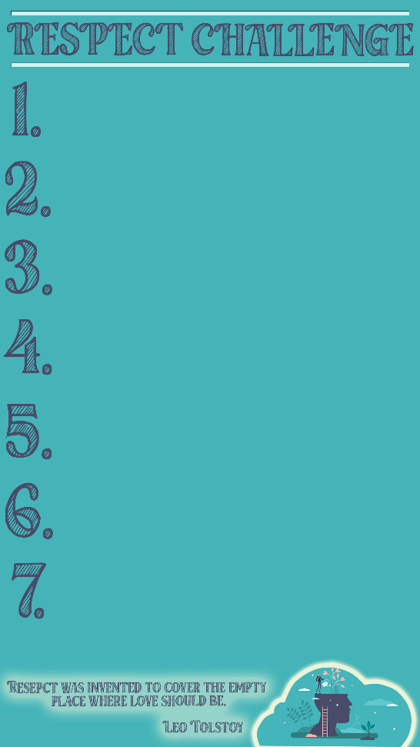
HOMEWORK
It’s important that we appreciate each person for the unique attributes that define us. We need to respect one another regardless of race, religion and ability. There are times the media tries to highlight these differences rather than encourage us to work together. Bring with you ONE example of RACIAL OR GENDER stereotype to class for the next lesson. You can find these in magazines, newspapers or on the internet.

