


Grade 11: Term 1 / Week 4 – 6

Careers and Career Choices

Lesson Plan and Teacher Notes

Dear Life Orientation Teachers,

This Lesson Plan covers the following subtopics as per the GRADE 11 ATP 2023 / 2024:

CONCEPT:
- Research the requirements for admission to additional and higher education courses that you may be interested in:
- National Senior Certificate (NSC) requirements for: Certificate / Diploma / Degree
- Explore and evaluate additional and higher education options
- Research additional and higher education options:
- Admission point score for institutions of higher learning
- Admission requirements for specific programmes or courses
- Calculate Admission Point Score (APS) for the specific programmes /courses based on your Grade 10 results.
- Explain the purpose of the National Benchmark Tests (NBTs)
- Explore options for financial assistance:
- Bursaries (Example: NSFAS, Fundza Lushaka, and other), and
- Sector Education and Training Authorities (SETA)
- Obligations in terms of financial arrangements

This Lesson Plan is made up of the following documents:

- Lesson Preparation (Lesson Plan and Teacher Notes)
- Content Summary
- Lesson 1 - PowerPoint
- Lesson 1 - Worksheet
- Lesson 1 – Worksheet MEMO
- Lesson 2 - PowerPoint
- Lesson 2 - Worksheet
- Lesson 2 – Worksheet MEMO
- Lesson 3 - PowerPoint
- Lesson 3 - Worksheet
- Lesson 3 – Worksheet MEMO

Lesson Content Breakdown:

Lesson 1:
- Research the requirements for admission to additional and higher education courses that you may be interested in:
- National Senior Certificate (NSC) requirements for: Certificate / Diploma / Degree
- Explore and evaluate additional and higher education options

Lesson 2:
- Research additional and higher education options:
- Admission point score for institutions of higher learning
- Admission requirements for specific programmes or courses
- Calculate Admission Point Score (APS) for the specific programmes/courses based on your Grade 10 results.
- Explain the purpose of the National Benchmark Tests (NBTs)

Lesson 3:
- Explore options for financial assistance:
- Bursaries (Example: NSFAS, Fundza Lushaka, and other), and
- Sector Education and Training Authorities (SETA)
- Obligations in terms of financial arrangements

LESSON PREPARATION:
TERM 1: Weeks 4 – 6
3 x 40 minute lessons

Lesson Number | Content | Teaching Plan | Time Allocation | Resources | Assessment | Learner Activities
1 | Research the requirements for admission to additional and higher education courses that you may be interested in  National Senior Certificate (NSC) requirements for: Certificate  Diploma  Degree  Explore and evaluate additional and higher education options | Introduction & Class Discussion | 5 min | Content Summary  Lesson 1 – Worksheet (Activity 1)  Lesson 1 – PowerPoint (Slide 1) |  | Class Discussion with learner input
1 |  | Concept:  South Africa’s Education System | 15-20 min | Content Summary  Lesson 1 – Worksheet (Activity 1)  Lesson 1 - PowerPoint (Slide 2-5) |  | Learner to complete mind map as lesson progresses  (Individual)
1 |  | Concept:  National Senior Certificate | 15-20 min | Content Summary  Lesson 1 – PowerPoint (Slide 6) |  | Class Discussion with learner input  Learner to complete mind map as lesson progresses  (Individual)
1 |  | Video + Discussion | 15-20 min | Content Summary  Lesson 1 - PowerPoint (Slide 7)  South African grade 12 (higher certificate, Diploma and Bachelor) pass requirements (pass mark):  https://www.youtube.com/watch?v=R-PFztLktNs  0min:50sec- 4min:37sec
1 |  | Concept:  Higher Education and Tertiary Institutions | 15-20 min | Lesson 1 - PowerPoint (Slide 8-11)
1 |  | Conclusion and Mind map discussion | 5 min | Lesson 1 – Worksheet (Activity 1)  Lesson 1 – PowerPoint (Slide 12) | Informal | Questions and feedback
1 |  | Activity | 10- 15 min | Lesson 1 - Worksheet (Activity 2) | Informal | Lesson 1 Worksheet  Individual

Lesson Number | Content | Teaching Plan | Time Allocation | Resources | Assessment | Learner Activities
2 | Research additional and higher education options:  Admission point score for institutions of higher learning  Admission requirements for specific programmes or courses  Calculate Admission Point Score (APS) for the specific programmes/  courses based on your Grade 10 results.  Explain the purpose of the National Benchmark Tests (NBTs) | Introduction | 2-3 min | Content Summary  Lesson 2 – PowerPoint (Slide 1–2) |  | Class Discussion with learner input
2 |  | Concept: APS | 5 min | Content Summary  Lesson 2 - PowerPoint (Slide 3-4) |  | Class Discussion with learner input
2 |  | Concept: APS  Video + Discussion  APS Calculator example | 15 min | Content Summary  Lesson 2 - PowerPoint (Slide 5)  How To Calculate Your APS | Careers Portal  https://www.youtube.com/watch?v=5YFvogkUARY  2min 04 sec  Lesson 2 - PowerPoint (Slide 6) |  | Class Discussion with learner input
2 |  | Video + Discussion | 15 min | Content Summary  Lesson 2 - PowerPoint (Slide 7)  Calculating your WITS APS Score  https://www.youtube.com/watch?v=PxvN7xCoShc  2min 47sec |  | Class Discussion with learner input
2 |  | APS Example | 15 min | Lesson 2 - PowerPoint (Slide 8)  Lesson 2 - Worksheet (Activity 1) | Informal – Self Assessment | Lesson 2 Worksheet
2 |  | Concept: National Benchmark Test | 15 min | Content Summary  Lesson 2 - PowerPoint (Slide 9-12) |  | Class Discussion with learner input
2 |  | Concept: TVET Colleges | 15 min | Content Summary  Lesson 2 - PowerPoint (Slide 13-15) |  | Class Discussion with learner input  Questions and feedback
2 |  | Conclusion and Questions | 15 min | Content Summary  Lesson 2 - PowerPoint (Slide 16-17) |  | Class Discussion with learner input  Questions and feedback
2 |  | Activity | 15 min | Lesson 2 - Worksheet (Activity 2)  Lesson 2 – Worksheet MEMO | Informal | Lesson 2 Worksheet Individual

Lesson Number | Content | Teaching Plan | Time Allocation | Resources | Assessment | Learner Activities
3 | Explore options for financial assistance:  Loans, Scholarships,  Bursaries (Example: NSFAS, Fundza Lushaka, and other)  Sector Education and Training Authorities (SETA)  Obligations in terms of financial arrangements | Introduction | 2-3 min | Lesson 3 - PowerPoint (Slide 1) |  | Individual/  Paired  Activity
3 |  | Introduction and brief recap | 5 min | Content Summary  Lesson 3 - PowerPoint (Slide 2-3) |  | Class Discussion with learner input
3 |  | Concept: Scholarship, loan, bursary etc | 15 min | Content Summary  Lesson 3 - PowerPoint (Slide 4-5) |  | Class Discussion with learner input
3 |  | Concept:  SETA | 15 min | Content Summary  Lesson 3 - PowerPoint (Slide 6-7) |  | Class Discussion with learner input
3 |  | Concept: Learnership | 15 min | Content Summary  Lesson 3 - PowerPoint (Slide 8)
3 |  | Video + Discussion | 15 min | Lesson 3 - PowerPoint (Slide 9)  After School | Episode 9 – All About Learnerships and Internships  https://www.youtube.com/watch?v=IPyrYSFkZTc  0min36sec – 5min19sec
3 |  | Concept: Benefits of Learnership | 15 min | Content Summary  Lesson 3 - PowerPoint (Slide 10-11)
3 |  | Concept: financial obligations re – finance options | 15 min | Content Summary  Lesson 3 - PowerPoint (Slide 12-14) |  | Class Discussion with learner input
3 |  | Wrap Up + Conclusion | 15 min | Content Summary  Lesson 3 - PowerPoint (Slide 15-16) |  | Class Discussion with learner input
3 |  | Activity | 17 min | Lesson 3 - Worksheet (Activity 1 - Self Assessment Checklist)  Lesson 3 - Worksheet (Activity 2 – Exam Practice Questions)  Lesson 3 - Worksheet (Activity 3 – Final Reflection)  Lesson 3 - Worksheet MEMO | Informal - Self  Informal - exam style questions | Individual

INTRODUCTORY NOTES:

The Lesson 1 – PowerPoint, Lesson 2 – PowerPoint and Lesson 3 – PowerPoint
documents together cover the THREE lessons and have detailed notes for each slide that will guide you (the teacher) through the activity. Use the below LESSON PREPARATION to assist regarding your time frame.

The following notes will be a summary of the THREE LESSONS:

These lessons have also been set up to create a lot of opportunity for learner interaction during the lessons. Learners can complete the worksheets while working through the respective PowerPoints.

Each Lesson Worksheet (e.g., Lesson 1 - Worksheet) serves as an informal assessment to determine if a learner understands the concepts covered in that lesson.

NOTE: Before teaching this module take time to watch the referenced YouTube clips (links below) and go through each PowerPoint Presentation, Worksheet, Worksheet Memo, and the Content Summary – to prepare yourself thoroughly to teach each lesson. The Content Summary along with the Lesson Preparation will be used to teach this section.

As the educator, make sure:
- Learners must know that the classroom is SAFE PLACE, and everyone must show respect for one another and their differences as well as questions that they may have.
- You could encourage learners to write down all questions that they may have and would like to know about.
- Concepts must be used to consolidate your teaching and you should always monitor the learners’ understanding of the concepts.
- Manage this topic in such a way to accommodate:
- barriers to learning and teaching,
- different age groups and experiences
- language (To accommodate all language levels of learners is not possible, the language competency levels of learners is too diverse however you should aim to facilitate in such a way that meaningful learning does take place.)

YouTube:

If you prefer to, videos can be downloaded beforehand.

Using the link below if you do not have a programme to download from YouTube: https://www.ytddownloader.com/

(this also cuts out ads if you are not using the paid version of YouTube
[Alternatively, cue up the relevant videos so everything is ready to go before the lesson.]

Links:
South African grade 12 (higher certificate, Diploma and Bachelor) pass requirements (pass mark):
https://www.youtube.com/watch?v=R-PFztLktNs
0min 50sec- 4min 37sec

How To Calculate Your APS | Careers Portal
https://www.youtube.com/watch?v=5YFvogkUARY
2min 04 sec

Calculating your WITS APS Score
https://www.youtube.com/watch?v=PxvN7xCoShc
2min 47sec

After School | Episode 9 – All About Learnerships and Internships
https://www.youtube.com/watch?v=IPyrYSFkZTc
0min 36sec – 5min19sec

Lesson 1

Preparation (Prior to Lesson):

- Remind learners to have their notebooks available to make notes where relevant.
- Print copies of Lesson 1 – Worksheet
- Teacher can share Lesson 1 - PowerPoint and Lesson 1 - Worksheet with learners to work through on their own if learners are online.
- Familiarise yourself with the activity portions of the lesson beforehand.
- Watch suggested video clip to familiarise yourself with the content:
South African grade 12 (higher certificate, Diploma and Bachelor) pass requirements (pass mark):
https://www.youtube.com/watch?v=R-PFztLktNs
0min:50sec- 4min:37sec

** Teacher to decide whether to hand out Content Summary at start of Lesson 1 or end of Lesson 3.
Our recommendation would be at the end of Lesson 3.

PowerPoint 1

Lesson  1  1  1  1  1  1 | Breakdown | Slide
Lesson  1  1  1  1  1  1 | Hand out Lesson 1 – Worksheet at start of lesson.  After welcoming the class to the new week, give learners a minute to get themselves ready and settled before commencing the lesson.  During this lesson, fill in Activity 1 (Mind Map) on the Lesson 1 – Worksheet document as we go along, there are spaces and headings for you to write down keywords and short phrases.  This next series of lessons we will be focusing on our CHOICES AFTER HIGH SCHOOL.  There are many options available to us once we leave school, and it is important to consider our options carefully and thoroughly. Some of you may want to go to university or college either here in South Africa or away from home. Maybe you want to take up an apprenticeship or  learn new skills.  For some, University may not appeal to you, as you would prefer to work with your hands and learn a trade.  Alternatively, you may want to study but have many questions and aren’t sure what it is you want to do.  Let’s look at those options and take some time to explore what is available to you.  Last year you took the first step by choosing your subjects that interested you and were related to your passions and skills. We are going to look at where you are now and where you are going next. | 1
Lesson  1  1  1  1  1  1 | All South Africans have the right to a basic education, including adult basic education and further education. According to the Bill of Rights in the Constitution, the state has an obligation, through reasonable measures, to progressively make this education available and accessible.  In South Africa, there are THREE training levels – each one leads to the next. Like steppingstones to YOUR future. | 2
Lesson  1  1  1  1  1  1 | Currently, you find yourself in the FET Band, and having just begun your journey into Grade 11, you’ve already made many decisions along the way  You are part of the way into your three-year National Senior Certificate. What you do this year and next year will play a big role in determining what happens next. | 3
Lesson  1  1  1  1  1  1 | First some important terms that you will be hearing in this lesson:  The National Senior Certificate or NSC is the school-leaving certificate in South Africa.  This certificate is commonly known as the Matric certificate.  Further Education and Training (FET): refers to education and training provided from Grades 10 to 12. This also includes training offered at TVET, community colleges and private colleges.  Higher Education: Studies undertaken after you have successfully written the NSC, qualifying you for further studies.  Tertiary Studies: refers to all formal post-secondary education. It includes both public and private universities, colleges, technical training institutes, and vocational schools.  Postgraduate: People furthering their studies after obtaining a degree – for example: Honours, Masters, PHD or Doctorates. | 4
Lesson  1  1  1  1  1  1 |   Recently you have made a lot of important decisions - you have chosen your subjects and possibly even started some Career Planning (it may come up in conversations more often than you realise).  The stepping stones that we referred to earlier are all part of that. Let’s begin however by looking at your options at the end of Matric.  Think about the decisions you have made so far regarding your future. Did you apply the SMART acronym? Were the choices you made SPECIFIC, MEASURABLE, ATTAINABLE, REALISTIC and TIME EFFICIENT.  If not, you may need to go back and take a second look. | 5
Lesson  1  1  1  1  1  1 | At the end of Matric (i.e. next year), you will write your FINAL NATIONAL SENIOR CERTIFICATE EXAMINATIONS – and as you all know, they are a big deal. The results you get will ultimately determine your path after school.  Depending on those results and the marks you get, will determine the type of Further Studies you can apply for and be accepted to study in.  Does anyone know the different passes you can get in Matric and what the requirements are? | 6
Lesson  1  1  1  1  1  1 | There are FOUR types of Matric Passes, each one has its own requirements.  There is a quick video we are going to watch and then discuss it further in detail:  South African grade 12 (higher certificate, Diploma and Bachelor) pass requirements (pass mark):  https://www.youtube.com/watch?v=R-PFztLktNs  0min:50sec- 4min:37sec  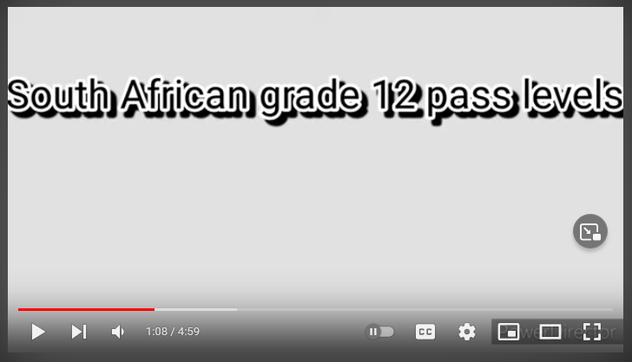 | 7
Lesson  1  1  1  1  1  1 | Let’s unpack what was explained in the video:  Bachelor’s Degree Pass  means you can study at any tertiary institution, as long as you meet the requirements for your chosen field of study.  It is the highest Matric pass. Many students who earn distinctions, usually achieve a Bachelor’s Degree Pass.  The minimum requirements to get a Bachelor’s Degree Pass are as follows:  - Get 40% for your Home Language  - Get 50% for four other Higher Credit subjects  - Get 30% for one other subject for the Senior Certificate (Amended) / Obtain 30% for two other subjects for the National Senior Certificate  Diploma Pass  means you can study at a tertiary institution towards a diploma qualification.  The minimum requirements to get this certificate are as follows:  - Get 40% for your Home Language  - Get 40% for four other Higher Credit subjects  - Get 30% for two other subjects for the National Senior Certificate  Higher Certificate Pass  is the third highest pass of the four Matric pass levels.  Allows students to study for a Higher Certificate at a college or distance learning institution.  The minimum requirements to get this certificate are as follows:  - Get 40% in your Home Language  - Get 40% in two other subjects  - Get 30% for three other subjects for the National Senior Certificate  - One of your Home Languages must be English or Afrikaans to qualify for this certificate  National Senior Certificate Pass  This is an ordinary pass in Matric. Study any course that only requires a pass in Matric.  The minimum requirements to get this certificate are as follows:  - Pass at least 3 subjects with 40%. One of these subjects should be an official Home Language.  - Pass at least 2 subjects with 30%. One of these subjects should be a First Additional Language or Home Language.  - You are allowed to fail 1 subject. The minimum percentage you can get for this subject is 20% | 8
Lesson  1  1  1  1  1  1 | FURTHER STUDIES  Requirements for admission into Further Studies generally depend on the type of qualification as well the educational institution you choose to study at, and the course you choose to study.  Each institution has its own requirements depending on the qualification.  BUT – HIGHER INSTITUTIONS ARE NOT GUARANTEED TO ACCEPT YOU JUST BECAUSE YOU PASSED MATRIC.  For this reason, it is important to do as well as you can and get the best possible marks.  There may be thousands of students applying for a limited number of spots, and universities will take students who are achieving the kind of marks that they are looking for. | 9
Lesson  1  1  1  1  1  1 | HIGHER EDUCATION OPTIONS  In South Africa there are quite a few higher education qualifications both at universities and colleges, thus there are various qualifications which students can obtain after high school. South Africa's National Qualifications Framework (NQF) is responsible for providing the guidelines which higher education systems make use of.  Higher education qualifications begin from level 5 and go in the following order:  (NSC is a Level 4)  - Level 5: Higher Certificates and Advanced National (Vocational) Certificate.  - Level 6: National Diploma and Advanced Certificates.  - Level 7: Bachelor's Degree, Advanced Diplomas.  - Level 8: Honours Degree, Postgraduate Diploma, and Professional Qualifications.  - Level 9: Master's Degree.  - Level 10: Doctor's Degree.  Obtaining a certificate implies that a student has gained a basic level of understanding of higher education knowledge and skills. After completing a Certificate course, students will be able to make use of these skills in the workplace. | 10
Lesson  1  1  1  1  1  1 |   There are many institutions in South Africa to choose from and the best way to know what’s out there is to research and look into your options. | 11
Lesson  1  1  1  1  1  1 | If you have any questions, you are welcome to jot these down and we can explore them in our next lesson.  Complete your Mind Map (Activity 1 on Lesson 1 – Worksheet).  Teacher to see whether learners have any questions regarding their Mind Maps.  Teacher Note: Near completion of Activity 1, ask learners to reflect on: What can you do to achieve your MY MATRIC PASS GOAL?  We are now going to start with Activity 2 (Lesson 1 – Worksheet), looking at your Skills and Self-Assessing your strengths and weaknesses as well as what you can potentially work on. Learners to complete Activity 2 for homework  There is no MEMO for Activity 1 and Activity 2 (Lesson 1 – Worksheet), as each learner’s responses will be different for these activities. | 12

Lesson 2

Preparation (Prior to Lesson):

- Remind learners to have their notebooks available to make notes where relevant.
- Print copies of Lesson 2 - Worksheet
- Teacher can share Lesson 2 - PowerPoint and Lesson 2 - Worksheet with learners to work through on their own if learners are online.
- Familiarise yourself with the activity portions of the lesson beforehand.
- Watch suggested video clips to familiarise yourself with the content:

How To Calculate Your APS | Careers Portal
https://www.youtube.com/watch?v=5YFvogkUARY
2min 04 sec

Calculating your WITS APS Score
https://www.youtube.com/watch?v=PxvN7xCoShc
2min 47sec

PowerPoint 2

Lesson  2  2  2  2  2  2 | Breakdown | Slide
Lesson  2  2  2  2  2  2 | After welcoming the class to the new week, give learners a minute to get themselves ready and settled before commencing the lesson.  This is an ideal opportunity to use the first two minutes to assess / test concepts from the previous lesson. You could ask everyone to stand and if they are able to correctly explain a concept, they may sit.  Alternatively:  With eyes closed (to avoid anyone feeling embarrassed or uncomfortable), ask learners to each raise a hand. You will ask five questions (see below). Learners are to put down a finger – if they know the answer to each question.  You could ask:  - What are the three levels in the South African education system? If you can name all three, put down one finger.  - Can you name the band you are in now? If you can name it, put a finger down.  - What are the different pass levels at the end of Matric? If you know them all, put down a finger.  - What is the best pass? Why? If you can answer that question, put a finger down.  - If you know the importance of your matric pass, put a finger down?  These questions will help you gauge where your learners are at, and if anything from Lesson 1 needs further explanation or consolidation. | 1
Lesson  2  2  2  2  2  2 | The previous lesson helped you to understand the difference between the types of passes at NSC schooling level, and encouraged you to do your research for Higher Education options  Today, we will focus on the admission systems used by various institutions of higher learning.  It is important that you make an informed decision when deciding on your future studies, taking in consideration all these factors that might play a role.  Today’s lesson will focus on TWO key elements of tertiary studies,  1. APS and  2. National Benchmark Tests.  Has anyone heard of these before or know much about them? | 2
Lesson  2  2  2  2  2  2 | An Admission Point Score (APS) is the score universities and colleges use (as a minimum requirement) to determine whether or not your application will be approved. The APS is calculated using your Matric Results.  Students will have to meet a certain APS minimum requirement, depending on the course they would like to study. It should be noted that each university has a different way of determining this score, and each tertiary institution is different and has different pre-requisites and admission requirements. | 3
Lesson  2  2  2  2  2  2 | Why is your APS score so important?  - It is an initial screening method used by almost all universities.  - Helps determine whether a matriculant will be considered for university admission or a course (minimum requirement)  Matriculants can improve their chances of getting in by obtaining good marks for all the subjects that they do. Good marks lead to good APS points.  Thus, your APS score will give you some direction as to what study options are available after school.  Calculating your APS isn’t difficult, but it’s something you need to do before applying to university. Let’s investigate how this works. | 4
Lesson  2  2  2  2  2  2 | 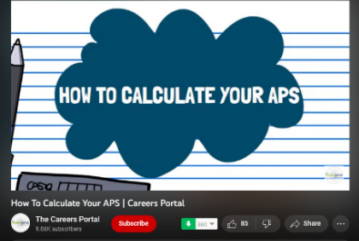  How To Calculate Your APS | Careers Portal  https://www.youtube.com/watch?v=5YFvogkUARY  2min 04 sec | 5
Lesson  2  2  2  2  2  2 | 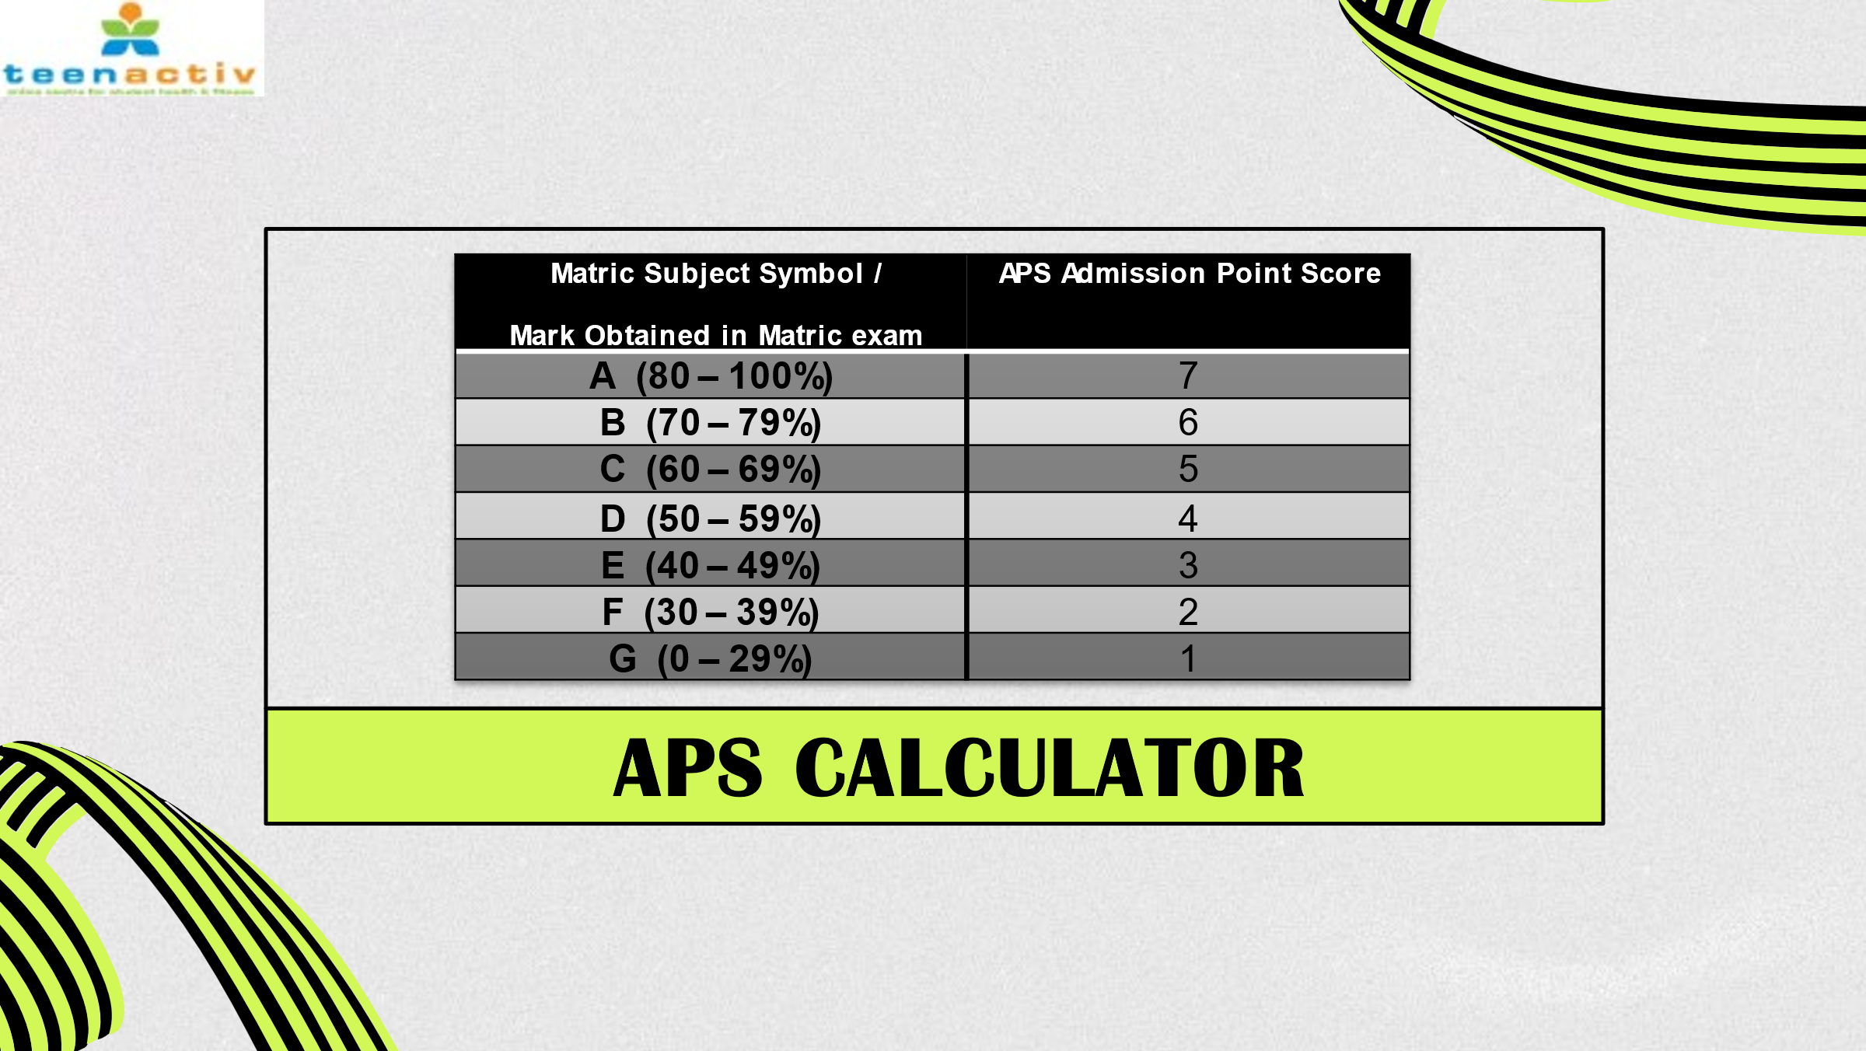  This is the APS CALCULATOR. Each of your marks will be given a certain number of POINTS and those points will determine your total score.  Different courses and qualifications will require a certain score. For example, if you need 35 points and you only score 27 points, then you will not qualify for that course. | 6
Lesson  2  2  2  2  2  2 | 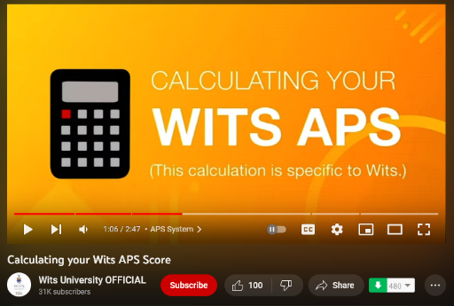  Here is an example of how the University of the Witwatersrand (WITS) will calculate an APS score:  Calculating your WITS APS Score  https://www.youtube.com/watch?v=PxvN7xCoShc  2min 47sec  WITS may calculate things one way, and another institution another way – this is another reason why it important to do the relevant research. | 7
Lesson  2  2  2  2  2  2 | Let us look at an example together.  Kerri, a grade 10 Learner from a nearby school gets the following marks:  Maths 61%  English 82%  Afrikaans 72%  Geography 94%  Accounting 63%  Physics 61%  Looking at our APS CALCULATOR (Go back to slide 6)  Calculate her score:  Maths 5  Geography 7  English 7  Accounting 5  Afrikaans 6  Physics 5  Total Points: 35  Kerri needed 32 Points for application – how do you think she will do?  We are going to take a quick break and complete Activity 1 on Lesson 2 - Worksheet.  Let learners complete the worksheet and calculate their own APS score based on their grade 10 results in 2022.  Teacher Note: Refer to Lesson 2 – Worksheet MEMO for answers to Activity 1 | 8
Lesson  2  2  2  2  2  2 | Our next point in today’s lesson in the National Benchmark Test. | 9
Lesson  2  2  2  2  2  2 | The National Benchmark Tests (NBTs) are required for first-year applicants into higher education institutions.  - NBTs are a series of tests used to assess academic literacy, general knowledge, and mathematical skill.  - The NBTs measure academic readiness for university study.  - Reflects expectations for first year students in university programmes.  - Each test requires you to apply prior learning - what you know and can do.  - South African universities use the NBTs (with NSC results) for access to higher education, while others use the tests to determine the type of learning support a student could need during their studies  These tests determine your readiness and indicate if you will cope with the relevant course work.  **Teacher Note: The function of the NBT – was a MCQ in the CAT for LO QP 2021 | 10
Lesson  2  2  2  2  2  2 | The NBT consists of two tests: the AQL and the MAT.  The AQL (Academic Quantitative Literacy) is one multiple-choice test of three hours of writing time.  The MAT (Core Maths) is also a multiple-choice test with three hours of writing time. Both papers are written on the same day.  The AQL paper consists of two sections:  - The Academic Literacy (AL) section will require reading of various texts with multiple choice questions referring to the text.  It predominantly assesses the ability to understand the meaning and application of various texts as well as understanding and applying the argument or main point of the author.  - The Quantitative Literacy (QL) section assess a student’s capacity to: understand basic numerical concepts, read and interpret graphs, reason logically and identify patterns and trends. It is largely based on the Grade 11 Maths Literacy syllabus.  The MAT paper is only written by learners applying for certain degree programmes and who have done Core Maths at school. It tests proficiency in such areas as problem solving and modelling, functions, trigonometry, spatial perception, and probability.  Both the AQL and MAT are differentiated into cognitive levels, meaning there is a range in difficulty in each section – with the easier applications generally coming first. EACH TEST ASSESSES DIFFERENT SKILLS RELATED TO UNIVERSITY STUDY. | 11
Lesson  2  2  2  2  2  2 | The NBT is fairly easy to register for, these are the steps:  Registration is online: https://nbtests.uct.ac.za/tests/register  You NEED the following to register:  - Your official ID book (if you are not a citizen of South Africa, you will need your passport)  - City and site where you want to write  - NBT requirements from the institutions where you plan to apply  - Date when you want to write (allow 4 weeks to receive results)  - Pen and paper to record your username and EasyPay number | 12
Lesson  2  2  2  2  2  2 | You may or may not have heard of TVET Colleges (or formerly known as FET Colleges), does anyone know about them?  TVET stands for Technical and Vocational Education and Training.  Technical: subject matters that are technical in nature, relating to hardware and software, including trouble shooting practises and engineering processes.  Vocational: an occupation or an employment, often referring to as hands-on skills within professional trades.  Education: formal education, starting in high school and including post-secondary education, such as colleges, polytechnics, and universities.  Training: informal education, also called lifelong learning or continuing education, often used in initiatives of reskilling or upskilling company staff or a wider workforce. | 13
Lesson  2  2  2  2  2  2 | How are TVET colleges different from traditional universities or colleges?  - Type of Training / Skills obtained:  TVET colleges offer vocational and practical training in a wide range of subjects, from engineering and construction to hospitality and business.  This type of education is different from the traditional university education, which focuses more on theoretical knowledge.  - Admission Requirements: While universities require a bachelor's pass at matric level, TVET colleges accept students who have passed Grade 9, 10, 11 or 12. Some colleges offer up to 300 different courses.  TVET Qualifications vs University Degrees  TVET qualifications are not the same as university degrees.  Using the Engineering Field as an example: University degrees are typically aimed at allowing you to work as a professional engineer, whereas TVET qualifications teach you what you need to know about specific occupations within the engineering field.  TVET qualifications in engineering studies can qualify you to study towards a national diploma in engineering and eventually towards a BTech degree, which means you will be able to qualify as a professional engineering technician.  This applies to the various practical fields within the vocational courses. | 14
Lesson  2  2  2  2  2  2 |   As mentioned earlier, there are a great deal of study options out there for you. What works for one person may not be the same for the next. The world needs lots of different people and occupations to function.  Researching the different study and career options is so important, and it will help you make the best decision possible. | 15
Lesson  2  2  2  2  2  2 |   Before we move on to Activity 2 on your Lesson 2 - Worksheet, are there any questions that you would like to ask?  Let us now complete Activity 2 to check what you have learnt today.  Teachers Note: Refer to the Lesson 2 – Worksheet MEMO for answers to the revision questions in Activity 2. | 16

Lesson 3

Preparation (Prior to Lesson):

- Remind learners to have their notebooks available to make notes where relevant.
Print copies Content Summary and Lesson 3 – Worksheet
- Teacher can share Lesson 3 - PowerPoint, Content Summary, Lesson 3 - Worksheet with learners to work through on their own if learners are online.
- Refer to Lesson 3 – Worksheet MEMO for answers to Activity 2
- Familiarise yourself with the activity portions of the lesson beforehand.
- Watch suggested video clips to familiarise yourself with the content:

After School | Episode 9 – All About Learnerships and Internships
https://www.youtube.com/watch?v=IPyrYSFkZTc
0min36sec – 5min19sec

PowerPoint 3

Lesson  3  3  3  3  3  3  3  3 | Breakdown | Slide
Lesson  3  3  3  3  3  3  3  3 | After welcoming the class to the new week, give learners a minute to get themselves ready and settled before commencing the lesson.  We have covered a fair amount of information thus far, and this lesson we will focus on Financial Assistance in terms of further studies. | 1
Lesson  3  3  3  3  3  3  3  3 | One of the biggest factors affecting the study goals of young people today is the lack of finance.  There are high costs required to study, including tuition fees, accommodation, transport, food, books, stationery, device maintenance, airtime etc.  If you do not have the money to study, then financial aid is sometimes an option. | 2
Lesson  3  3  3  3  3  3  3  3 | Let us take a look at some of these Types of Funding Options over the next couple of slides. They include the following:…  THREE main types of funding:  - Student Loans  - Scholarships  - Bursaries  Other types of funding  - Paying yourself  - Funza Lushaka Bursary  - The National Student Financial Aid Scheme (NSFAS)  Indirect …  - How SETA assists  - in general  - via Learnerships | 3
Lesson  3  3  3  3  3  3  3  3 | The three main types of funding are: STUDY LOANS, SCHOLARSHIPS or BURSARIES.  Study Loan: money borrowed to pay for academic tuition (in some instances accommodation too) that must be paid back with interest. Different loans charge interest differently, it is important to know how the loan you intend to take charges interest. A loan should only be given out by a registered financial institution (such as a bank).  Many banks make these loans attractive, with low interests. A parent / guardian must sign surety. Surety is when someone takes responsibility for another person’s debt if they are unable to make payments for any reason.  Scholarship: awarded on merit to students with good / top academic results or outstanding talent and achievement in sport / music. It is a financial reward usually given to students based on achievements – recipients are not always expected to repay or work back the money they receive. It may not necessarily cover the full costs of the student.  In most cases the beneficiary of the scholarship must maintain a certain average in terms of their marks and stick to conditions set by the sponsor. For example, an athletic scholarship may require that you maintain a 60 % average and do very well in athletics.  Bursary: Financial assistance given to a student for further study. Can often cover the full costs of study including study material, tuition, accommodation, and sometimes pocket money for living expenses. Usually awarded on merit but often includes more criteria than only academic achievement. A bursary is paid back in service to the company or entity that sponsored the candidate. Student will have to work for the sponsor for the same number of years they sponsored them or paid for their fees. Although a bursary covers the full costs of study, if there is a module the student fails, they will be expected to pay for it themselves. | 4
Lesson  3  3  3  3  3  3  3  3 | Other types of funding can also include:  Paying yourself: An option If you have decided to work first before studying or working while studying, then you can pay for your own studies. Working part time while you study, allows you to also gain valuable workplace experience. It requires hard work and dedication, as well as excellent time management to balance your time between work and studies.  Funza Lushaka Bursary: is specifically for students who are studying to become teachers and is awarded annually, based on academic ability.  Each year, the Funza Lushaka Bursary is awarded for students towards the following Teaching qualifications:  Undergraduate studies: a 4-year Bachelor of Education degree (BEd), which specialises in any of the following:  - Foundation Phase (Grade R to Grade 3)  - Intermediate Phase (Grade 4 to Grade 6)  - Senior and Further Education and Training Teaching (Grade 7 to Grade 12)  Graduate studies: a 1-year Postgraduate Certificate in Education (PGCE) for:  - Senior and Further Education and Training Teaching (Grade 7 to Grade 12)  The National Financial Aid Scheme (NSFAS): is a South African government student financial aid scheme which provides financial aid to undergraduate students to help pay for the cost of their tertiary education after finishing high school. It is funded by the Department of Higher Education and Training. | 5
Lesson  3  3  3  3  3  3  3  3 | Now let us look at how SETA indirectly creates opportunities for students (and anyone else) to further their studies / skills.  SETA is the Sector Education and Training Authority  Essentially, SETA is there to bridge the gap between the formal education and training system and the workplace, by facilitating and funding learning programmes that build skill sets required by industries. | 6
Lesson  3  3  3  3  3  3  3  3 | Many people don’t have the workplace skills needed to improve their lives. This is where SETA comes in.  The aim is to upskill workers while enhancing our ever growing and changing economy.  i.e. to contribute to the raising of skills, to bring skills to the employed, or to those wanting to be employed in their section.  There are a total of 21 SETAs in South Africa.  Each SETA manages and creates learnerships, skills-based programmes and internships in its sector.  Every industry and job in the country is covered by one of the 21 SETAs.  The SETAs provide information on quality education and training offered by employers within their sectors.  They can help you to find funding options and avenues to gain new skills while you are working | 7
Lesson  3  3  3  3  3  3  3  3 | We mentioned in the previous slide, that each SETA manages and creates learnerships (amongst other things) within their sector.  Does anyone know what a Learnership is?   | 8
Lesson  3  3  3  3  3  3  3  3 | 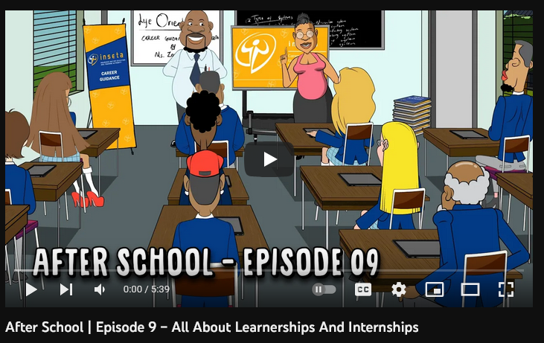  This video will give you some insight.  After School | Episode 9 – All About Learnerships and Internships  https://www.youtube.com/watch?v=IPyrYSFkZTc  0min36sec – 5min19sec  Highly recommend looking at some of the other clips in this series for enrichment | 9
Lesson  3  3  3  3  3  3  3  3 | In a nutshell:  A learnership is a work-based learning programme that leads to an NQF registered qualification. Learnerships are related to an occupation or field of work, for example, electrical engineering, hairdressing or project management.  Learnership programmes can help you to gain the necessary skills and workplace experience that will open better employment or self-employment opportunities.  As mentioned already, Learnerships are managed by Sector Education and Training Authorities (SETAs). They were introduced by government to help skill learners and to prepare them for the workplace. | 10
Lesson  3  3  3  3  3  3  3  3 | Why are learnerships important?  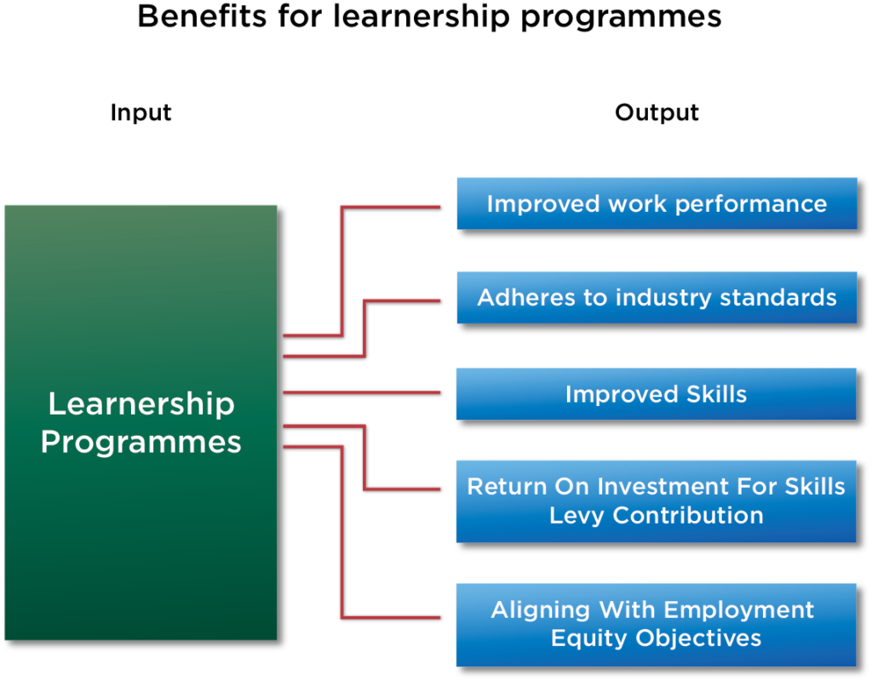  Learnerships promote access to education and training, as they allow you to work and get started on your career while also studying for an educational qualification.  SETAs oversee learnerships and ensure that they offer qualifications related to a specific occupation or sector of the economy. All 21 SETAs have developed NQF-aligned programmes that will help you gain recognised qualifications while getting on-the-job experience.  SETAs manage the registration of learnerships in order to meet the skills development needs across the sectors.  How do learnerships work?  Learnerships require you to complete a theoretical course as well as practical training, which is done at a workplace, to graduate. The workplace component of the qualification involves first hand, practical learning under the guidance of a mentor, while the theoretical component is provided by an education and training provider. Together they form an integrated and comprehensive learning programme.  What are the benefits for learners?  You may have better employment opportunities after completing a learnership;  You have a fixed-term employment contract for the duration of the learnership;  Learnerships improve on the job performance, so you can do things relevant to the job;  You obtain a nationally recognised qualification that is relevant to the sector; and  You earn a learner allowance for the duration of the learnership. | 11
Lesson  3  3  3  3  3  3  3  3 | Recall Slide 3, where we discussed various the types of funding …  What happens AFTER you’ve gotten your funding and finished your studies?  That very much depends on what type of funding you received.  All these funding options come with certain terms and conditions (Ts&Cs).  It is important you are FULLY aware of them.  Let us look at some of these financial obligations: | 12
Lesson  3  3  3  3  3  3  3  3 | Depending on the type of funding received to help you with your studies, will determine what your obligations are.  Possibly, a family member may be in the position to help you with your study fees. Let’s look at the options:  Loans from a bank or financial institutions are paid with interest (interest is the cost of credit). This would involve a legal contract and loan agreement with the bank.  Bursaries: usually do not need to be paid back, (unless you do not pass or drop out). You may be required to work for the company for a set period once studies have been completed. This can be referred to as a contract bursary.  Scholarships: generally, not required to be paid back, but you do need to do well and get good results. | 13
Lesson  3  3  3  3  3  3  3  3 | Study Loan / Student Loan is borrowed money that is repaid over the time once a student has completed their studies and starts a job. In addition to repaying the amount loaned, most loans also require an additional fee called interest. A student loan is used to pay for college or university costs. Once studies are completed, you’ll be responsible for sending out monthly payments to the company or institute that you have taken out a loan with.  Learnerships: do not need to be paid back.  NSFAS: You will only start repaying your loan once you have a salary of R30 000 or more per year. No need to worry as the repayments are worked out at a rate that will not place a great burden on you and is based on your salary. 40% of a general loan is converted into a bursary if you pass all of the courses you were registered for in that year. That is a great incentive!! | 14
Lesson  3  3  3  3  3  3  3  3 | But Remember…  If you are going to apply for financial aid, you need to make sure you read and understand all the terms and conditions (Ts&Cs). You need to know what you are responsible for paying back or what conditions may or may not apply to you not having to pay the money back.  Some companies that provide bursaries or scholarships may require you to work for them for a certain length of time. That may be different from one place to another.  There are general bursaries available or nonspecific bursaries, but there are also specific ones related to certain careers or fields of study.  It is vital to EXPLORE all your financial options CAREFULLY before you accept any offers. | 15
Lesson  3  3  3  3  3  3  3  3 | There is a lot of information out there – however it is up to you to get out there and make things happen for yourself. These things take time and effort, and most of all PERSEVERANCE.  There are many wonderful organisations and places that are willing to help students – RESEARCH, set SMART goals and GO FOR IT!  Teacher to hand out the Content Summary  To finish off, complete Activity 1 on your Lesson 3 – Worksheet. This is a Self-Assessment Checklist.  Go through the list and indicate (for yourself) how comfortable you feel with the different concepts that we have covered over these three lessons.  Now commence working on the Activity 2 – Exam Practice Questions (in Lesson 3 – Worksheet) and finish these for homework.  Use the last 3min of the lesson for the learners to complete Activity 3 – Final Reflection (in Lesson 3 – Worksheet)  Teacher Note: The Lesson 3 – Worksheet MEMO provides answers for Activity 2 – Exam Practice Questions. This can be shared with learners at the start of the next lesson. | 16

