GRADE 8 LIFE ORIENTATION
TOPIC:
HEALTH, SOCIAL AND ENVIRONMENTAL RESPONSIBILITIES (HSER)
Term 3 & 4
60/90 MINUTES 2022 70 MARKS

NOTE TO TEACHERS: Remember, this is a bank of questions and therefore may contain some overlap. Keep this in mind when selecting questions for your paper. Use the table below to help you when choosing your questions.

Weighting (suggested) | Weighting (Actual) | Cognitive level | Bloom’s taxonomy
40% (28 marks) | 28 marks | Lower Order | Level 1&2
40% (28 marks) | 28 marks | Middle Order | Level 3&4
20% (14 marks) | 14 marks | Higher Order | Level 5&6
All essay questions are weighted equally. Learners must complete the full combination related to a particular question.

REMINDER: Teenactiv papers should be considered as a bank of questions from which teachers can choose when creating their own question papers. Controlled Test should include components of each topic covered in terms 1, 2, 3 & 4 for 2022.

NB: Ensure your paper covers EACH topic covered in Terms 1, 2, 3 & 4.
This paper ONLY focusses on the HSER topic covered in Terms 3 & 4.
Marking Grid included at end of MEMORANDUM

______________________________________________________________
INSTRUCTIONS AND INFORMATION
- The question paper consists of THREE sections, namely SECTION A, SECTION B and SECTION C.
- The questions in SECTION A and SECTION B are compulsory.
- Answer any TWO questions in SECTION C.
- Read ALL the questions carefully.
- Number the answers correctly according to the numbering system used in this question paper. Start each question on a new page.
- Write neatly and legibly.
- This paper consists of 8 pages and 6 questions.

SECTION A (Compulsory)
Answer all the questions in this section.
Question 1.1
Various options are provided as possible answers to the following questions.
Choose the correct answer and write only the letter (A-D) next to the question number
(1.1.1 to 1.1.5) in the answer book, for example 1.1.6. D.

1.1.1 HIV is spread by …
- shaking hands with someone who has HIV/AIDS
- sharing food or water with someone that has the virus
- sharing of crockery with someone who is HIV positive
- sharing syringes with someone who has HIV/AIDS

1.1.2 One can build up your immune system when you are HIV-positive through:
- Eating healthy foods
- Pushing yourself with exercise
- Smoking and drinking
- Smoking, but not drinking

1.1.3 The following is an example of a law and/or policy that South Africa has to address environmental health problems:
- Environmental Act
- Food and Water Act
- Health and Safety Act (1972)
- National Health Act (2003)

1.1.4 Deciding not to engage in sexual intercourse is known as:
- Abstinence
- Aberrance
- Absence
- Abortiveness

1.1.5 Ways to decrease one’s carbon footprint include:
- Eating more meat on Mondays
- Using a fireplace to keep warm
- Buying the latest clothing
- Buying local plant-based foods
(5 x 1) [5]
(All Lower Order)

Question 1.2

Complete the following sentences by filling in the missing word(s). Write only the word(s)
next to the question number (1.2.1 to 1.2.5) in the answer book.

1.2.1 (Driving / Carpooling) to work is the most effective way to significantly reduce carbon emissions.

1.2.2 (Sustainable / Suitable) development means that it will last for future generations.

1.2.3 People are encouraged not to eat (meat / vegetables) on a Monday to reduce their carbon footprint.

1.2.4 A person’s carbon (emission / footprint) refers to the total amount of greenhouse gases they contribute towards in their lifetime.

1.2.5 The removal of forestry or vegetation for human use is known as (afforestation / deforestation).
(5 x 1) [5]
(All Lower Order)

Question 1.3
Choose a description from COLUMN B that matches an item in COLUMN A. Write only
the letter (A-G) next to the question number (1.3.1 to 1.3.5) in the answer book.

Column A |  | Column B
1.3.1 | STI’s | A | Can be treated but not cured with ARV’s
1.3.2 | HIV | B | Earth Day
1.3.3 | White blood cells | C | Observe World AIDS Day
1.3.4 | 1st December | D | Localised infection because of risky behaviour
1.3.5 | 22nd April | E | Youth Day
 |  | F | Cells invaded by HIV
 |  | G | Can be treated with antibiotics
(5 x 1) [5]
(All Lower Order)

Question 1.4

Answer the following questions by writing the answer next to the question number
(1.4.1 to 1.4.3) in the answer book. Write your answers in full sentences.

1.4.1 Define the term ‘asymptomatic’ and list ONE danger of being asymptomatic whilst having Covid-19.
(1 + 1) (2)
(Lower Order)

1.4.2 Discuss TWO ways that a Covid-19 positive patient can ensure that they do not spread the virus.
(2 x 2) (4)
(Middle Order)

1.4.3 Explain TWO practical ways that communities can show care and support to people living with sicknesses like Covid-19. (2 x 2) (4)
(Middle Order)
[10]
[TOTAL SECTION A: 25 MARKS]

SECTION B (Compulsory)
Answer all the questions in this section.
Write your answers in full sentences.

Question 2
Study the image below and answer the questions that follow.

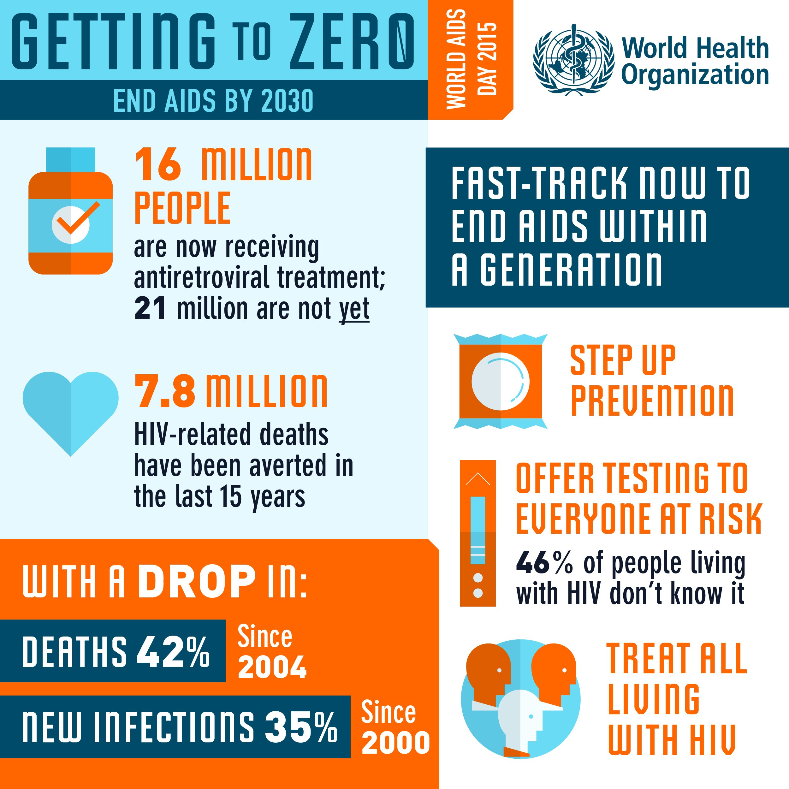
(https://www.who.int/images/default-source/wpro/campaigns/world-aids-day/infographic1-large.jpg?sfvrsn=f60317c4_5
Accessed on 01/09/2022)

2.1 Define the term “ARV” and provide TWO purposes of ARVs. (1 + 2) (3)
(Lower Order)

2.2 Explain why people living with HIV might struggle with mental illnesses. (1 x 2) (2)
(Middle Order)

2.3 Discuss TWO reasons why World Aids Day is observed. (2 x 2) (4)
(Middle Order)

2.4 Describe TWO ways that friends and family members can care for and support people living with HIV. (2 x 2) (4)
(Middle Order)

2.5 Recommend ONE possible strategy to decrease the chances of contracting HIV. (1 x 2) (2) (Higher Order)
[15]

Question 3
Refer to the extract below and answer the questions that follow.
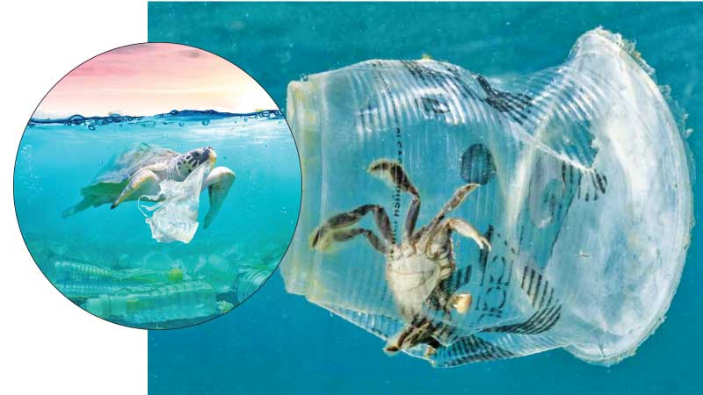
Plastics may only account for about 10% of
man-made waste, but plastic production has
ballooned by 650% since 1975, reaching 270
million tons in 2010. “As plastics take hundreds
to thousands of years to degrade, we are still
living with every piece of plastic ever made
Estimates are that by 2050 there will be more
plastic (by weight) than fish in the ocean,” says
WWF-SA.
“Plastics are found throughout food webs in every
known marine ecosystem. While it is tempting to brush
over this problem as something that occurs out of sight,
as consumers we need to recognise that over 80% of the plastic pollution in our oceans is generated on land by ordinary people like us.”

(Adapted from: https://www.iol.co.za/saturday-star/news/earth-day-highlights-plastic-pollution-suffocating-marine-life-14623618
Accessed on 26/08/2022)

3.1 Explain the concept of Earth Day. (1 x 1) (1)
(Lower Order)

3.2 Name the environmental issue being addressed in this article. (1 x 1) (1)
(Lower Order)

3.3 Discuss TWO reasons why the issue identified above is becoming such a problem. (2 x 2) (4)
(Middle Order)

3.4 Suggest TWO ways to combat the issue of single use plastic at home. (2 x 2) (4)
(Higher Order)
[10]

[TOTAL SECTION B: 25 MARKS]

SECTION C (Choice)
Answer any TWO questions in this section.
Your responses must consist of paragraphs.
Marks will only be allocated for responses written in full sentences.

Question 4

Study the image and text below and answer the questions that follow.
There is no Planet B
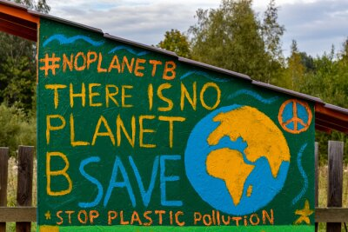

We must act together to secure the one planet we have — because there is No Planet B.
We must act because, in the very near future, the costs of inaction will far exceed those of acting.

(https://noplanetb.org/
https://myloview.com/sticker-environmental-concepts-there-is-no-planet-b-save-the-planet-no-AD4426B
Accessed on 20/08/2022)

Write paragraphs on environmental issues and Earth Day.

Use the following as a guideline:

- On which date do we celebrate Earth Day and give ONE reason why it is important to celebrate Earth Day. (1 + 1) (2)
(Lower Order)

- Discuss TWO consequences that our environment will face if we continue to NOT honour Earth Day.
(2 x 2) (4)
(Middle Order)
- Recommend TWO practical strategies that a school community can implement to become
more caring school. Indicate in EACH of the strategies how the earth will benefit. (2 x 2) (4)
(Higher Order)
[10]

Question 5

Study the image below and answer the questions that follow.
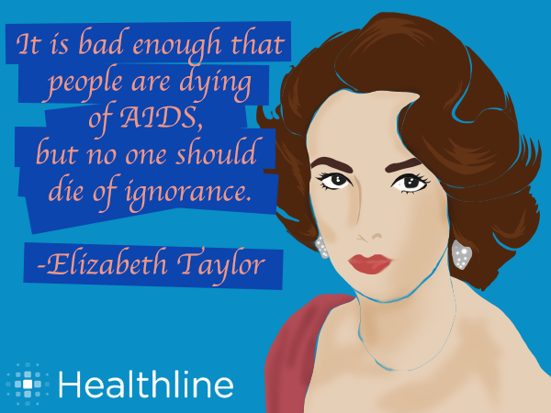

(https://www.quotemaster.org/images/bd/bda44252d0cb6cc9394a1054b5a77aa5.png
Accessed on 20/08/2022)

Write paragraphs on safety and preventative measures against HIV.

Use the following as guideline:
- Explain the difference between HIV and AIDS (2 x 1) (2)
(Lower Order)
- Describe TWO factors that can assist a patient when starting an ARV regimen? (2 x 2) (4)
(Middle Order)

- Assess how a teenager can increase their risk of becoming infected with HIV. (2 x 2) (4)
(Higher Order)
[10]

PLEASE NOTE – THERE IS NO QUESTION 6

[TOTAL SECTION C: 20 MARKS]
TOTAL = 25 + 25 + 20 = 70

