GRADE 8 LIFE ORIENTATION
TOPIC:
CONSTITUTIONAL RIGHTS AND RESPONSIBLITIES (CRR)
Term 3 & 4
60/90 MINUTES 2022 70 MARKS

NOTE TO TEACHERS: Remember, this is a bank of questions and therefore may contain some overlap. Keep this in mind when selecting questions for your paper. Use the table below to help you when choosing your questions.

Weighting (suggested) | Weighting (Actual) | Cognitive level | Bloom’s taxonomy
40% (28 marks) | 32 marks | Lower Order | Level 1&2
40% (28 marks) | 26 marks | Middle Order | Level 3&4
20% (14 marks) | 12 marks | Higher Order | Level 5&6
All essay questions are weighted equally. Learners must complete the full combination related to a particular question.

REMINDER: Teenactiv papers should be considered as a bank of questions from which teachers can choose when creating their own question papers. Controlled Test should include components of each topic covered in terms 1, 2, 3 & 4 for 2022.

NB: Ensure your paper covers EACH topic covered in Terms 1, 2, 3 & 4.
This paper ONLY focusses on the CRR topic covered in Terms 3 & 4.
Marking Grid included at end of MEMORANDUM

______________________________________________________________
INSTRUCTIONS AND INFORMATION
- The question paper consists of THREE sections, namely SECTION A, SECTION B and SECTION C.
- The questions in SECTION A and SECTION B are compulsory.
- Answer any TWO questions in SECTION C.
- Read ALL the questions carefully.
- Number the answers correctly according to the numbering system used in this question paper. Start each question on a new page.
- Write neatly and legibly.
- This paper consists of 9 pages and 6 questions.

SECTION A (Compulsory)
Answer all the questions in this section.

Question 1.1
Various options are provided as possible answers to the following questions.
Choose the answer and write only the letter (A-D) next to the question number
(1.1.1 to 1.1.5) in the answer book, for example 1.1.6 D.

1.1.1 The Constitution is:
- The Bill of Rights and how people should do things
- The Human Rights Bill that states rules and regulations for daily life
- A document that states how government should be made up
- A document of Human Rights from the United Nations

1.1.2 Extreme dislike or prejudice against others from other countries is referred to as:

- Discrimination
- Apartheid
- Xenophobia
- Genocide

1.1.3 The symbol that represents South Africa’s multicultural diversity:

- Rainbow
- Protea
- Springbok
- Coat of Arms

1.1.4 South Africa is often referred to as the Rainbow Nation because …

- it has a rich and diverse cultural landscape
- it has a wide variety of natural landscapes
- it has a long and complex history
- it is a country full of traditions and stories

1.1.5 The motto on the South African Coat of Arms translates to:

- Difference in diversity
- Unity in diversity
- Together we unite
- United we stand

(5 x 1) [5]
(All Lower Order)

Question 1.2
Complete the following sentences by filling in the missing word(s). Write only the word(s)
next to the question number (1.2.1 to 1.2.5) in the answer book.

Equality; | Discriminated; | Fair; | Responsibilities; | Equal; | Government; | Bill of Rights

Gender equity is the ___1.2.1___ and ___1.2.2___ treatment of both men and women. This means that neither sexes should be ___1.2.3___ against because of their gender. The ___1.2.4___ is built on the principle of ___1.2.5___.

(5 x 1) [5]
(All Lower Order)

Question 1. 3
Choose a description from COLUMN B that matches an item in COLUMN A. Write only
the letter (A-G) next to the question number (1.3.1 to 1.3.5) in the answer book.

Column A |  | Column B
1.3.1 | Cultural Diversity | A | The societal norms and expectations attached to being a woman or a man.
1.3.2 | Gender Roles | B | The quality of different cultures and can also refer to having different cultures respect each other's differences.
1.3.3 | Human Rights | C | Creating a national pride; encouraging cohesion.
1.3.4 | Nation | D | The basic freedoms and rights we are all entitled to simply because we are people.
1.3.5 | Nation Building | E | A rule, usually made by a government, that is used to order the way in which a society behaves
 |  | F | A large body of people united by common descent, history, culture, or language, inhabiting a particular state or territory.

(5 x 1) [5]
(All Lower Order)

Question 1.4

Answer the following questions by writing the answer next to the question number
(1.4.1 to 1.4.4) in the answer book. Write your answers in full sentences.

1.4.1 Define the following terms:
a) xenophobia
b) equality
c) discrimination
d) values (4 x 1) (4)
(Lower Order)

1.4.2. What are “human rights”? (1 x 1) (1)
(Lower Order)

1.4.3 Human dignity is a human right. State THREE responsibilities necessary to uphold this right.
(3 x 1) (3)
(Lower Order)

1.4.4 Explain the term ‘social justice’. (1 x 2) (2)
(Middle Order)
[10]

[TOTAL SECTION A: 25 MARKS]

SECTION B (Compulsory)
Answer all the questions in this section.
Write your answers in full sentences.

Question 2

Read the extract below and answer the questions that follow.

NOT “FAIR PLAY”
It has been reported that in some instances sports players, club owners and school sports coaches will do just about anything to win.
Match-fixing and age-cheating are just a few actions they may take to win a game or match.

(Adapted from: https://www.goal.com/en-za/news/south-africa-match-fixing-fans-want-ban-extended-to-players-club-and-match-officials/blt7451b9b9b79ba608
Accessed on 20/08/2022)

2.1 List TWO examples of unethical practices mentioned in the above extract. (2 x 1) (2)
(Lower Order)

2.2 State ONE reason why cheating in sport is unacceptable. (1 x 1) (1)
(Lower Order)

2.3 Provide an explanation of the term ‘match-fixing’. (1 x 2) (2)
(Middle Order)
[5]

Question 3

Read the extract below and answer the questions that follow.
It is a well-known fact that the youth of any country is a great asset. They are indeed the future of the country and represent it at every level. The role of youths in nation-building is more important than you might think. In other words, the intelligence and work of the youth will take the country on the pathway of success. As every citizen is equally responsible, the youth is too. They are the building blocks of a country.
The development of any country requires active participation from the youth. It does not matter which field we want to progress in, whether it is the technical field or sports field, youth is needed. It is up to us how to help the youth in playing this role properly. We must make all the youth aware of their power and the role they have to play in nation-building.
(Adapted from: https://www.toppr.com/guides/essays/essay-on-role-of-youths-in-nation-building/
Accessed on 28/08/2022)

3.1 Outline TWO ways that teenagers can be positive about nation building in their community.
(2 x 1) (2)
(Lower Order)

3.2 Discuss TWO reasons why human rights are an important component of nation building.
(2 x 2) (4)
(Middle Order)

3.3. Explain TWO ways South African teens can appreciate and celebrate diversity to help with nation building. (2 x 2) (4)
(Middle Order)
[10]
Question 4
Refer to the quote below and answer the questions that follow.

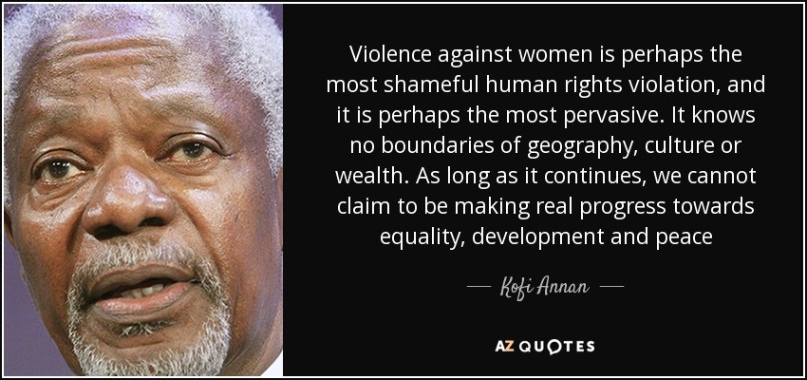

https://www.azquotes.com/quote/811874
Accessed o 20/08/2022

4.1 Define the term ‘gender-based violence’. (1 x 2) (2)
(Lower Order)

4.2 Discuss whether gender-based violence occurs exclusively against woman? (1 x 2) (2)
(Middle Order)

4.3 Discuss how the concept of gender-based violence should be more inclusive. (1 x 2) (2)
(Middle Order)

4.4 Determine TWO ways that acts of violence could have an emotional impact on individuals.
(2 x 2) (4)
(Higher Order)
[10]
[TOTAL SECTION B: 25 MARKS]

SECTION C (Choice)
Answer any TWO questions in this section.
Your responses must consist of paragraphs.
Marks will only be allocated for responses written in full sentences.

Question 5

Read the extract below and answer the questions that follow.
A national Coat of Arms, or state emblem, is the highest visual symbol of the State. In South Africa, we have a diverse number of people and cultures, but we are all South African. National symbols such as the coat of arms unite the people of a country and make them proud to be a part of that country and all its achievements. The new coat of arms reflected government's aim to highlight the democratic change in South Africa and a new sense of patriotism.

(Adapted from: https://www.sahistory.org.za/article/national-symbols-such-coat-arms-and-national-anthem
Accessed on 25/08/2022)

Write paragraphs on Nation Building.

Use the following as guideline:

- Define the term ‘nation building’ within the South African context and list ONE
other national symbol (apart from the Coat of Arms) (1 + 1) (2)
(Lower Order)

- Discuss TWO reasons why human rights are an important component of nation building. (2 x 2) (4)
(Middle Order)

- Suggest TWO practical strategies to increase nation building in your school community. (2 x 2) (4)
(Higher Order)
[10]

Question 6

Study the extract below and answer the questions that follow.
WOMEN in SPORT – we need TRANSFORMATION
We need to speak about how badly sports women are paid. Women already deal with misogyny and discrimination in all sectors of society solely by virtue, well, of them being women. And for women in sports, it’s just that much harder.

Transformation is one of the buzzwords of the moment it was announced that no sports tournament bids could be launched by sport associations until the transformation quota went up. This was no doubt an important and much-needed decision, but one conversation around transformation seems to be side-lined – that of the sexism that exists in sports.

Some will even go as far as to say that some Women’s teams perform even better than their male counterparts. Just look at what Banyana Banyana has accomplished in recent months

(Adapted from https://www.thedailyvox.co.za/race-transformation-agenda-gender-transformation-sports/
Accessed on 29/08/2022)

Adapted Text

Write paragraphs on gender equity.

Use the following as guideline:

- Briefly explain what ‘gender inequity’ means and give an example of gender inequity in sport.
(1 + 1) (2)
(Lower Order)

- Discuss TWO examples of gender bias towards women in sport. (2 x 2) (4)
(Middle Order)

- Suggest TWO ways how the media can promote gender equity in sport to make positive
changes and minimise gender bias in sport. (2 x 2) (4)
(Higher Order)
[10]

PLEASE NOTE – THERE IS NO QUESTION 7

[TOTAL SECTION C: 20 MARKS]
TOTAL = 25 + 25 + 20 = 70

