GRADE 10 LIFE ORIENTATION
TOPIC:
Development of the Self in Society
Term 3 & 4
2 HOURS 2022 100 MARKS

NOTE TO TEACHERS: Remember, this is a bank of questions and therefore may contain some overlap. Keep this in mind when selecting questions for your paper. Use the table below to help you when choosing your questions.

Weighting (suggested) | Weighting (Actual) | Cognitive level | Bloom’s taxonomy
30% (30 marks) | 30 marks | Lower Order | Level 1&2
40% (40 marks) | 40 marks | Middle Order | Level 3&4
30% (30 marks) | 30 marks | Higher Order | Level 5&6
Paper is aligned with the 2021 Grade 12 Examination Guideline

All essay questions are weighted equally. Learners must complete the full combination related to a particular question.

REMINDER: Teenactiv papers should be considered as a bank of questions from which teachers can choose when creating their own question papers. Controlled Test should include components of each topic covered in terms 1, 2, 3 & 4 for 2022.

NB: Ensure your paper covers EACH topic covered in Terms 1, 2, 3 & 4.
This paper ONLY focusses on the DSS topic covered in Terms 3 & 4.
Marking Grid included at end of MEMORANDUM

_____________________________________________________________________________
INSTRUCTIONS AND INFORMATION
- The question paper consists of THREE sections, namely SECTION A, SECTION B and SECTION C.
- The questions in SECTION A and SECTION B are compulsory.
- Answer any TWO questions in SECTION C.
- Read ALL the questions carefully.
- Number the answers correctly according to the numbering system used in this question paper. Start each question on a new page.
- Write neatly and legibly.
- This paper consists of 8 pages and 6 questions.

SECTION A (Compulsory)
Answer all the questions in this section.
Question 1
Various options are provided as possible answers to the following questions. Choose the correct answer and write only the letter (A-D) next to the question number
(1.1.1 to 1.1.5) in the answer book, for example 1.1.6. D.
1.1.1 Why is it important to examine our values on sexual intercourse?
- We are less likely to go against our values in a moment of passion.
- It provides our loved ones with a chance to change our minds.
- Even though values are important, they can change very easily.
- This allows us the opportunity to learn from our past mistakes.

1.1.2 Which of the following is true about sexual intercourse?
- We can assume that if someone had sex once, they will want sex again.
- Someone always has the right to say no at any point in the sexual act.
- People can only have sexual intercourse with people of the opposite sex.
- When someone gets married, they cannot say no to sex with their spouse.

1.1.3 When someone takes on the following life role they could assume the responsibility of caregiver.
- First-time employer
- Older brother or sister
- Brand new employee
- First-year student
1.1.4 Which of the following behaviours could help one avoid sexual behaviours that they don’t feel are safe.
- Saying no assertively, respecting one’s self and self-control.
- Self-control, asserting right to privacy and respecting others.
- Respecting others, saying no and asserting right to privacy.
- Respecting one’s self, self-control and rapid physical change.

1.1.5. Which of the following is an emotional change associated with adolescence?

- Insecurity over physical changes.
- Need for peers’ social acceptance.
- Hormonal changes and imbalances.
- Disagreements with their parents.
(5x1) [5]
(All Lower Order)

- Give ONE word/term for EACH of the following descriptions. Write only the
word/term next to the question number (1.2.1 to 1.2.5) in the ANSWER BOOK.

  - The basic human right that guarantees the protection of every individual from invasion of their personal space. (1)
(Lower Order)

  - The biological process where a female discharges blood and other material
from the uterine lining roughly once a month. (1)
(Lower Order)

  - When one makes the decision to restrain themselves from having sexual intercourse. (1)
(Lower Order)

  - The typical person or gender that someone is emotionally, romantically or
physically attracted to. (1)
(Lower Order)

  - When a person’s sense of self and gender expression or identity does not
align with the gender they were assigned at birth. (1)
(Lower Order)
(5x1) [5]
- Answer the following questions by writing the answer next to the question number
(1.3.1 to 1.3.5) in the ANSWER BOOK/ FOLIO provided.
Write your answers in full sentences.

- Provide TWO ways in which someone can take responsibility for an unhealthy
lifestyle choice. (2x1) (2)
(Lower Order)

- Explain why adolescents could feel the need to challenge authority figures
in their lives. (1x2) (2)
(Middle Order)
- Describe what adolescents could do to find help for their sexuality challenges. (1x2) (2)
(Middle Order)

- Discuss how young people could assume responsible leadership roles when
engaging in a team’s project, as part of maturing. (1x2) (2)
(Middle Order)

- Recommend how adolescents can deal with the mood swings that may be
associated with being in the adolescent stage. (1x2) (2)
(Higher Order)
[10]

[TOTAL SECTION A: 20 MARKS]

SECTION B (Compulsory)
Answer all the questions in this section.
Write your answer in full sentences.
Question 2
Read the extract below and answer the questions that follow.

Under 18 clubs and party venues

Effective strategies to assist in making responsible decisions regarding sexuality and lifestyle

Sifiso’s friends have found an under 18 party taking place over the weekend. According to the information, this party will have a similar atmosphere to an over 18 club, with a dance floor and DJ but no one under the age of 13 or over the age of 18 will be allowed in for the safety of the party goers. There will also be no alcohol sold at the bar at all. Sifiso hopes that this will be a positive experience where he can be social with his friends in a safe and healthy way as so much has changed in their relationships recently.

When Sifiso asks his parents, they are very hesitant but discuss their concerns with Sifiso. They are worried that there will be dangers that Sifiso hasn’t thought about or that he might give into peer pressure and behave in a way that he usually wouldn’t. Sifiso reassures his parents that this party is safe and he and his friends will act responsibly. His parents agree that he can go, provided that he puts strategies in place to keep himself safe.
[Adapted from https://www.news24.com Accessed:22 September 2022]

- Define the term ‘lifestyle choices’ and mention THREE possible dangers which
could make attending under 18 party events an unhealthy lifestyle choice. (1+3) (4)
(Lower Order)

- Provide TWO ways in which attending a safe party could help Sifiso navigate social changes associated with adolescence. (2x1) (2)
(Lower Order)

- Discuss TWO social changes that adolescents could face within their peer groups.
(2x2) (2)
(Middle Order)

- Describe THREE problem-solving thinking skills that Sifiso could use to help him
make successful decisions about attending a party. (3x2) (6)
(Middle Order)

- Advise Sifiso on TWO safety strategies that he could use if his parents allow him to
go to the party. In your answer also indicate how EACH strategy could help him
remain safe at the party. (2x3) (6)
(Higher Order)
\
[20]
Question 3
Read the extract below and answer the questions that follow.
All about early puberty in girls and boys

While all children are different, puberty usually begins in girls between 8 - 13 years of age, and in boys between 9 -14 years of age. However, some children hit puberty earlier, before 8 or 9 years of age. This is sometimes called “precocious puberty” which is when a child’s body physically matures to that of an adolescent at a higher and earlier rate than usual.

Children as young as six have sexually developed bodies long before their minds are able to understand what is happening. Their social and emotional development cannot keep up with their bodies. This can be dangerous, as it can leave children more ¹susceptible to unhealthy relationships, unsafe sexual behaviour and sexual abuse due to lack of decision-making skills. Children are now struggling to deal with physical changes associated with puberty and must find new ways to achieve ²resilience.
Glossary:
¹Susceptible- likely or liable to be influenced or harmed by a particular thing
²Resilience- the capacity to recover quickly from difficulties; toughness

[Adapted from https://lowvelder.co.za Accessed: 19 September 2022]

- Give a definition for the term ‘adolescence’ and state THREE reasons
why adolescents are often misunderstood. (1+3) (4)
(Lower Order)

- Explain TWO physical changes that could lead to emotional challenges for
young adolescents / children experiencing puberty too early. (2x2) (4)
(Middle Order)

- Describe THREE ways in which early onset of physical changes could affect young teenagers’ social relationships with their peers. (3x2) (6)
(Middle Order)

- Suggest THREE coping strategies that could be used if young adolescents were
to struggle with the physical changes associated with puberty. (3x2) (6)
(Higher Order)
[20]
[TOTAL SECTION B: 40 MARKS]

SECTION C (Choice)
Answer any TWO questions in this section.
Your responses must consist of paragraphs.
Marks will only be allocated for responses written in full sentences.

Question 4

Read the extract below and answer the questions that follow.
How does adolescence change our life roles?

Changes in a teen's development come with big changes in their relationships with family and friends. Family relationships are often reorganized during puberty, resulting in new responsibilities associated with being a child and family member.

[Adapted from: https://www.stanfordchildrens.org Accessed:22 September 2022]

Write paragraphs on changing life roles.
Use the following as a guideline:

- Define the term ‘life roles’ and give THREE reasons why life roles and responsibilities
in the family may change during adolescence. (1+3) (4)
(Lower Order)

- Analyse how relationships between teenagers and their family could change during adolescence. (2x4) (8) (Middle Order)

- Evaluate the effect that new responsibilities within the family may have on a teenager’s well-being. (2x4) (8)
(Higher Order)
[20]

Question 5

Study the following image and answer the questions that follow.
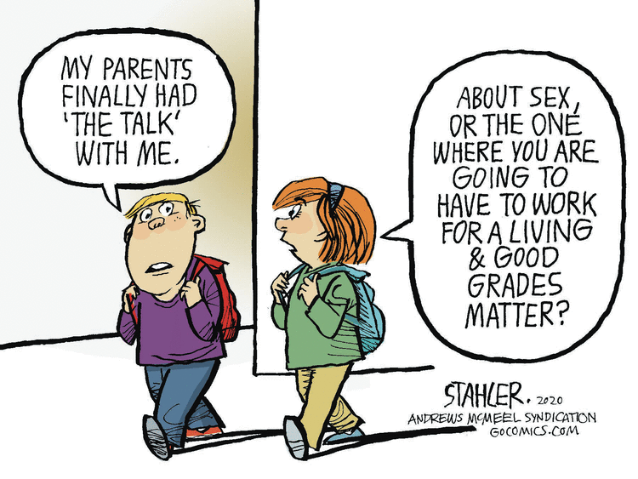
[Adapted from https://community.creations.mattel.com Accessed: 25 September 2022]

Write paragraphs on teenagers and sexual intercourse.
Use the following as a guideline.

- Define the term ‘sexual intercourse’ and state THREE behaviours which could lead teenagers to have sexual intercourse before they are ready. (1+3) (4)
(Lower Order)

- Analyse negative physical effects unsafe sexual intercourse could have on teenagers.
(2x4) (8)
(Middle Order)
- Evaluate the impact modern society’s more open view on sexual education has had
on teenagers’ sexual behaviours. (2x4) (8)
(Higher Order)
[20]
Question 6

Study the image below and answer the questions that follow.
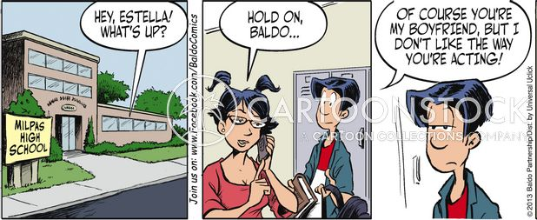
[Adapted from https://www.cartoonstock.com Accessed 26 September 2022]

Write paragraphs on teenage relationships.

Use the following as a guideline.

- Define the concept ‘respect for one’s self’ and provide THREE ways in which one
can demonstrate self-respect within a romantic relationship. (1+3) (4)
(Lower Order)

- Analyse how teenagers’ need for acceptance could lead them to tolerate
unacceptable actions within their romantic relationships. (2x4) (8)
(Middle Order)

- Critically discuss the positive impact assertive communication about boundaries
could have on teenagers’ romantic relationships. (2x4) (8)
(Higher Order)
[20]

[TOTAL SECTION C: 40 MARKS]
TOTAL = 20 + 40 + 40 = 100

