GRADE 11 LIFE ORIENTATION
TOPIC:
DEMOCRACY AND HUMAN RIGHTS &
STUDY SKILLS
Term 3 & 4
2 HOURS 2022 100 MARKS

NOTE TO TEACHERS: Remember, this is a bank of questions and therefore may contain some overlap. Keep this in mind when selecting questions for your paper. Use the table below to help you when choosing your questions.

Weighting (suggested) | Weighting (Actual) | Cognitive level | Bloom’s taxonomy
30% (30 marks) | 30 marks | Lower Order | Level 1&2
40% (40 marks) | 40 marks | Middle Order | Level 3&4
30% (30 marks) | 30 marks | Higher Order | Level 5&6
Paper is aligned with the 2021 Grade 12 Examination Guideline

All essay questions are weighted equally. Learners must complete the full combination related to a particular question.

REMINDER: Teenactiv papers should be considered as a bank of questions from which teachers can choose when creating their own question papers. Controlled Test should include components of each topic covered in terms 1, 2, 3 & 4 for 2022.

NB: Ensure your paper covers EACH topic covered in Terms 1, 2, 3 & 4.
This paper ONLY focusses on the DHR and SS topics covered in Terms 3 & 4.
Marking Grid included at end of MEMORANDUM

_____________________________________________________________________________
INSTRUCTIONS AND INFORMATION
- The question paper consists of THREE sections, namely SECTION A, SECTION B and SECTION C.
- The questions in SECTION A and SECTION B are compulsory.
- Answer any TWO questions in SECTION C.
- Read ALL the questions carefully.
- Number the answers correctly according to the numbering system used in this question paper. Start each question on a new page.
- Write neatly and legibly.
- This paper consists of 8 pages and 6 questions. (28 pages including Memo)

SECTION A (Compulsory)
Answer all the questions in this section.
Question 1
Various options are provided as possible answers to the following questions. Choose the correct answer and write only the letter (A-D) next to the question number (1.1.1 to 1.1.5) in the answer book, for example 1.1.6. D.
1.1.1 Identify a study strategy that will help learners learn effectively.
- Plan breaks that are longer than study sessions.
- Stick to one study method for consistency.
- Avoid all social obligations in order to study.
- Create and stick to a study timetable.

1.1.2 During an exam, learners should avoid…
- moving onto the next question if they don't know an answer.
- asking invigilators for help with answering their questions.
- answer questions according to the mark allocation provided.
- squeezing a stress ball to help channel their nervous energy.

1.1.3 Symptoms of chronic stress could include:
- Headaches, muscle aches, insomnia, increased energy.
- Increased energy, insomnia, headaches, upset stomach.
- Muscle aches, upset stomach, chest pains, headaches.
- Insomnia, increased energy, chest pains, muscle aches.
1.1.4 Having to be right and win an argument is a characteristic of a(n)______ personality.
- Avoidant
- Competitive
- Collaborative
- Assertive

1.1.5. Which of the following is a negative aspect of change?

- Increased flexibility in decisions.
- Opportunities for personal growth.
- The constant nature of change.
- Feelings of losing of control.
(5x1) [5]
(All Lower Order)

- Give ONE word/term for EACH of the following descriptions. Write only the
word/term next to the question number (1.2.1 to 1.2.5) in the ANSWER BOOK.

  - The techniques we use to take in and retain new information. (1)
(Lower Order)
  - The ability to effectively make use of the hours in the day, so as to allocate
a balanced amount of time to work, studies and other pursuits. (1)
(Lower Order)

  - The belief that all human beings are morally and legally entitled to be
alive and no other human should take that right away. (1)
(Lower Order)

  - A set of principles that guide the way people interpret reality which may
form the basis of our religion, life philosophy or moral code. (1)
(Lower Order)

  - When there is conflict between personal views related to what is right
or wrong. (1)
(Lower Order)
(5x1) [5]

- Answer the following questions by writing the answer next to the question number
(1.3.1 to 1.3.3) in the ANSWER BOOK/ FOLIO provided. Write your answers in full sentences.

- Provide TWO ways in which individuals could clarify their own beliefs. (2x1) (2)
(Lower Order)

- Discuss THREE reasons why it is important for learners to develop
appropriate study strategies when they are about to sit for their end
of the year exams (3x2) (6)
(Middle Order)

- Recommend ways in which to soothe/calm a person who is terminally ill and
contemplating euthanasia so that they may regain hope. (1x2) (2)
(Higher Order)
[10]

[TOTAL SECTION A: 20 MARKS]

SECTION B (Compulsory)
Answer all the questions in this section.
Write your answer in full sentences.

Question 2
Read the extract below and answer the questions that follow.
Questioning our traditions

Every social and cultural grouping in the world has specific traditional practices and beliefs, some of which are beneficial to all members of a community, while others may be harmful to a specific group. These harmful traditional practices could include the usage of traditions and culture to conduct irresponsible and careless activities such as early and forced marriages, unguided virginity testing, harmful rituals for widows and or unhygienic female genital mutilation (FGM).

Such practices persist because some unscrupulous individuals value money than the potential danger they may put their victims. Communities are also hesitant to question them because it may sound as if they were actually questioning the ¹core of such traditional practices. That may then open an opportunity for ²bogus traditionalist who don’t respect the laws or who careless about human life/health to carry on with their inhumane practices.

Glossary:
Core – basic/essential element of something/main thrust of something
Bogus – questionable/fake
[Adapted from http://www.scielo.org.za Accessed:12 August 2022]

- Define the term ‘traditional practices’ and mention THREE reasons why traditional
practices are beneficial to a community. (1+3) (4)
(Lower Order)

- Mention TWO groups who could be most at risk of being harmed by bogus
traditional practices. (2x1) (2)
(Lower Order)

- Discuss ONE reason why people may not want to challenge harmful practices
of bogus traditionalists. (1x2) (2)
(Middle Order)

- Describe THREE ways in which harmful traditional practices could harm individuals
within a society. (3x2) (6)
(Middle Order)

- Recommend TWO strategies that community leaders could use to encourage
others to discontinue harmful traditional practices. In your answer, also indicate
how each recommendation could lead to fewer harmful practices in the future. (2x3) (6)
(Higher Order)
[20]

Question 3
Read the extract below and answer the questions that follow.
Euthanasia cases on the rise

Very few countries allow legal euthanasia. Of those countries that do, doctors have noted that there is an increase in requests for euthanasia as well as assisted dying and assisted suicide. Those who seek out euthanasia are giving similar motivations.

Not all doctors are comfortable with euthanasia while others feel it is part of their duties. Despite personal feelings, doctors have been debating reasons for the rate of euthanasia cases has increased over the past couple of years. Are there external factors that need to be addressed?

[Adapted from https://parentinghub.co.za Accessed: 12 May 2022]

- Give a definition for the term ‘euthanasia’ and state THREE reasons why
someone could disagree with the practice of euthanasia. (1+3) (4)
(Lower Order)

- Discuss TWO reasons which could motivate someone to seek out euthanasia. (2x2) (4)
(Middle Order)

- Explain THREE negative psychological impacts euthanasia could have on doctors. (3x2) (6)
(Middle Order)

- Suggest THREE external factors which could account for the increased rates of
euthanasia. (3x2) (6)
(Higher Order)

[20]
[TOTAL SECTION B: 40 MARKS]

SECTION C (Choice)
Answer any TWO questions in this section.
Your responses must consist of paragraphs.
Marks will only be allocated for responses written in full sentences.

Question 4

Study the extract below and answer the questions that follow.

Managing Religious Diversity in the South African workspace

Religion plays a ¹pivotal role in the lives of the majority of South Africans. During the apartheid era, religious freedom and accommodation within the workplace was restricted. In 1994, with the election of a democratic government, South Africa witnessed an increase in the number of diverse religions in the workspace, contributing towards harmony at work. For the first time in South African history, religious freedom was guaranteed by the constitution.

Glossary:
¹Pivotal – something important for achievement of something

[Adapted from: https://www.researchgate.net on 12 September 2022]

Write paragraphs on diverse religions and harmony within the workplace
Use the following as a guideline:

- Define the term ‘harmonious society’ and give THREE characteristics of a harmonious society within the workplace. (1+3) (4)
(Lower Order)

- Analyse how diverse religions could help to create a harmonious society within the workspace. (2x4) (8) (Middle Order)

- Critically discuss how the workspace could accommodate diverse religious beliefs and practices. (2x4) (8)
(Higher Order)
[20]

Question 5

Study the following cartoon and answer the questions that follow.

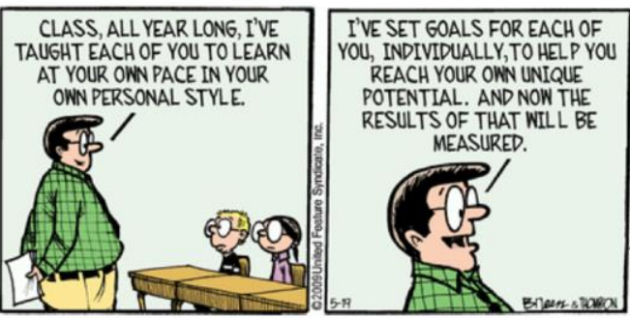
[Accessed from https://pdfs.semanticscholar.org on 19 September 2022]

Write paragraphs on the debate over learning styles and study goals.
Use the following as a guideline.

- Define the term ‘learning styles’ and state THREE of the different learning styles
that have been identified. (1+3) (4)
(Lower Order)

- Analyse how learners could set healthy study goals to achieve academic
success. (2x4) (8)
(Middle Order)
- Critically discuss how prioritising personal physical health can help improve the effectiveness of a learner’s study strategy. (2x4) (8)
(Higher Order)
[20]

Question 6

Study the image below and answer the questions that follow.

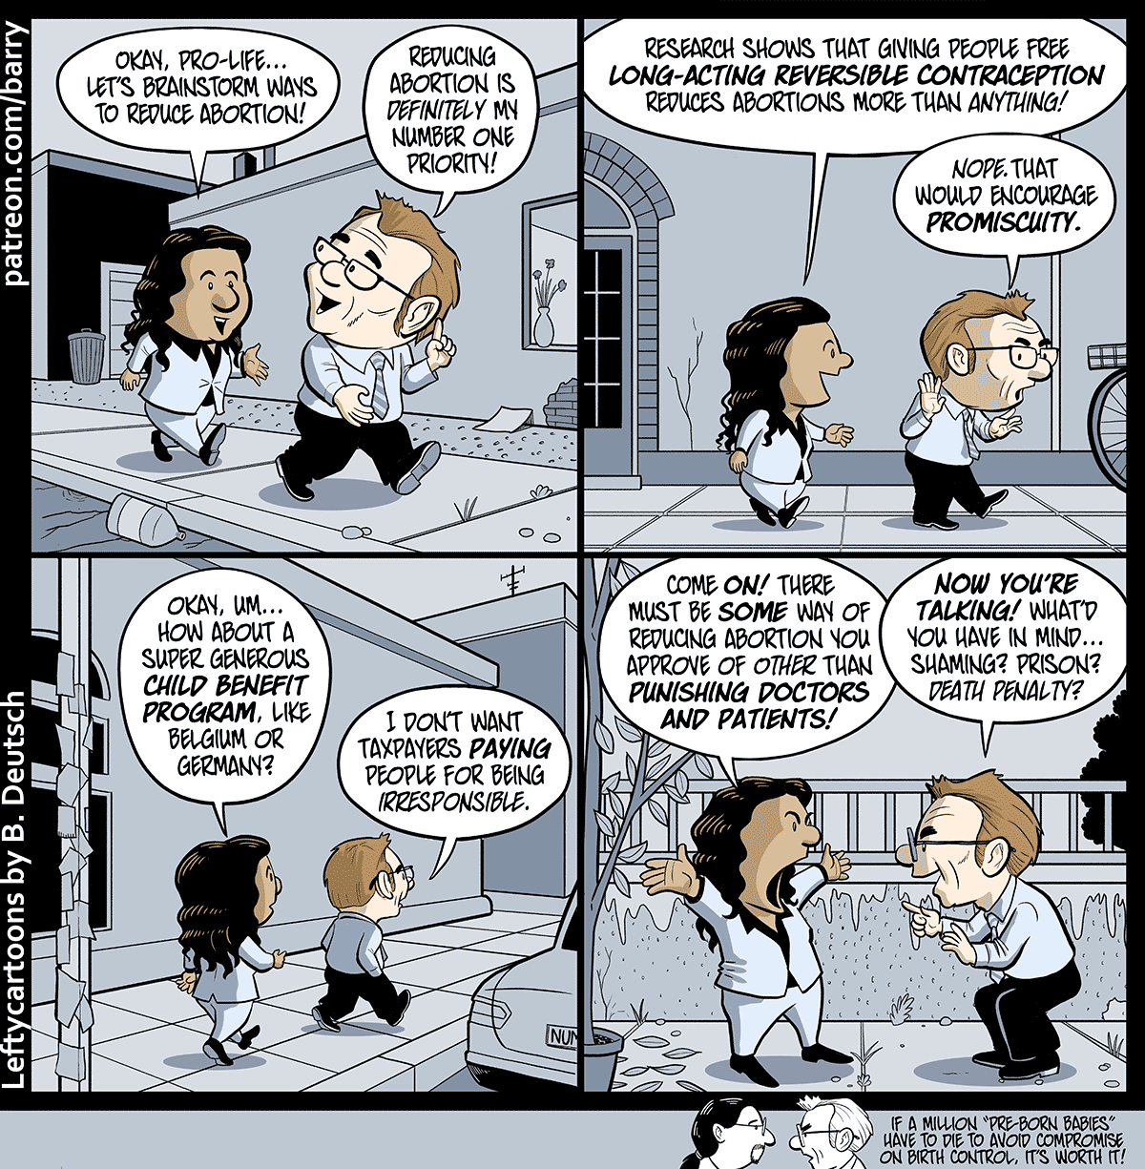

[Adapted from: https://amptoons.com on 13 September 2022]

Write paragraphs on differing opinions about abortion.

Use the following as a guideline.

- Define the term ‘values' and provide THREE factors that could influence value
formation around abortion. (1+3) (4)
(Lower Order)

- Analyse how differing opinions about abortion could cause disharmony in our society. (2x4) (8)
(Middle Order)

- Critically discuss how people can demonstrate respect for the opinions of others about
abortion, even if they don't agree with them. (2x4) (8)
(Higher Order)
[20]

[TOTAL SECTION C: 40 MARKS]
TOTAL = 20 + 40 + 40 = 100

