GRADE 11 LIFE ORIENTATION
TOPIC:
CAREERS AND CAREER CHOICES
Term 3 & 4
2 HOURS 2022 100 MARKS

NOTE TO TEACHERS: Remember, this is a bank of questions and therefore may contain some overlap. Keep this in mind when selecting questions for your paper. Use the table below to help you when choosing your questions.

Weighting (suggested) | Weighting (Actual) | Cognitive level | Bloom’s taxonomy
30% (30 marks) | 30 marks | Lower Order | Level 1&2
40% (40 marks) | 40 marks | Middle Order | Level 3&4
30% (30 marks) | 30 marks | Higher Order | Level 5&6
Paper is aligned with the 2021 Grade 12 Examination Guideline

All essay questions are weighted equally. Learners must complete the full combination related to a particular question.

REMINDER: Teenactiv papers should be considered as a bank of questions from which teachers can choose when creating their own question papers. Controlled Test should include components of each topic covered in terms 1, 2, 3 & 4 for 2022.

NB: Ensure your paper covers EACH topic covered in Terms 1, 2, 3 & 4.
This paper ONLY focusses on the CCC topic covered in Terms 3 & 4.
Marking Grid included at end of MEMORANDUM

_____________________________________________________________________________
INSTRUCTIONS AND INFORMATION
- The question paper consists of THREE sections, namely SECTION A, SECTION B and SECTION C.
- The questions in SECTION A and SECTION B are compulsory.
- Answer any TWO questions in SECTION C.
- Read ALL the questions carefully.
- Number the answers correctly according to the numbering system used in this question paper. Start each question on a new page.
- Write neatly and legibly.
- This paper consists of 8 pages and 6 questions. (28 pages including Memo)

SECTION A (Compulsory)
Answer all the questions in this section.
Question 1
Various options are provided as possible answers to the following questions. Choose the correct answer and write only the letter (A-D) next to the question number (1.1.1 to 1.1.5) in the answer book, for example 1.1.6. D.
1.1.1 Identify an unethical practice when applying for a job.
- Refusing to disclose marital status if asked by hiring agent.
- Not using a specific past employer as a potential referee.
- Lying about work experience to make a CV more impressive.
- Forgetting to correct spelling and grammar in the cover letter.

1.1.2 During an online video interview, job seekers should avoid…
- Dressing slightly less formally than an in-person interview.
- Requesting permission to take notes during the interview.
- Remaining formal in the way they address the interviewer.
- Asking the interviewer questions about the potential job.

1.1.3 Which of the following is an example of inappropriate dress for the workplace?

- A chef that wears a hair net, comfy shoes and an apron.
- An informal trader wearing a t-shirt, tackies and jeans.
- An attorney wearing a business suit, tie and court robe.
- A doctor wearing a mask and rings under their gloves.
1.1.4 Which of the following is an example of a job containing physical labour?
- Construction worker
- Administration clerk
- Research assistant
- Primary school teacher

1.1.5. Which of the following jobs would require additional higher education after matric?

- Informal trader
- Certified plumber
- Retail assistant
- Gardener
(5x1) [5]
(All Lower Order)

- Give ONE word/term for EACH of the following descriptions. Write only the
word/term next to the question number (1.2.1 to 1.2.5) in the ANSWER BOOK.

  - A formal statement recommending someone’s character or work ethic. (1)
(Lower Order)
  - A formal correspondence written by a job seeker that accompanies their CV
and states why they are best suited for the job. (1)
(Lower Order)

  - Work that doesn’t require a formal contract and usually isn’t taxed. (1)
(Lower Order)

  - A person’s social and financial status that affects their living experience is
known as their _______________ condition. (1)
(Lower Order)

  - Physically handed in application form/letter, instead of it being submitted online. (1)
(Lower Order)

- Answer the following questions by writing the answer next to the question number
(1.3.1 to 1.3.3) in the ANSWER BOOK/ FOLIO provided. Write your answers in full sentences.

- Provide TWO ways in which job seekers could provide evidence of job shadowing
and part-time work. (2x1) (2)
(Lower Order)

- Explain THREE reasons why employers could want to hire candidates who
display accountability. (3x2) (6)
(Middle Order)

- Recommend how job seekers could ensure high levels of satisfaction in the
working world. (1x2) (2)
(Higher Order)
[10]

[TOTAL SECTION A: 20 MARKS]

SECTION B (Compulsory)
Answer all the questions in this section.
Write your answer in full sentences.

Question 2
Read the extract below and answer the questions that follow.

Creating a Curriculum Vitae (CV) at school

Tashriq has just learned how to create a Curriculum Vitae (CV) in his Life Orientation (LO) class, and has decided to put this skill into practice. He learned that a good CV is not just for adults applying for jobs. High school students need to avoid common mistakes and develop high quality CVs to apply to tertiary education, for scholarships, employment, and internships. Tashriq’s teacher has advised him to get started on creating his CV while he is still in high school.

A CV is an important marketing tool that helps us provide an idea of who we are, both personally and professionally. Tashriq knows that the more effort he puts in to create a well-rounded and high-quality CV, the more likely he will be to gain part-time employment. He is looking forward to next week’s lesson on application letters and hopes that he can ask his teacher how he could overcome his lack of work experience when he decides to apply for jobs.

[Adapted from https://www.asvabprogram.com Accessed:25 July 2022]

- Define the term ‘Curriculum Vitae’ and mention THREE reasons why starting a
CV during high school is a good idea. (1+3) (4)
(Lower Order)

- Provide TWO ways in which an application letter differs from a CV. (2x1) (2)
(Lower Order)

- Discuss ONE way in which job seekers could submit a CV so as to make the
best impression to their future employer. (1x2) (2)
(Middle Order)

- Describe THREE mistakes that job seekers should avoid when creating their CV. (3x2) (6)
(Middle Order)

- Advise Tashriq on TWO practical strategies that he can use to overcome his lack
of work experience. In your answer also indicate how EACH strategy could make
him more employable. (2x3) (6)
(Higher Order)

\
[20]

Question 3
Preparing Generation Z for an Interview is Key to Success!

It is not doubted that with the influx of ¹Generation Z entering the job market currently, we’re seeing the most technologically advanced group of professionals applying to jobs that have all these amazing dreams and ambitions about what they can do in the working world.

Where a lot of Generation Z’ers are failing though within the interview process and this is because they simply don’t get the basics right. There are challenges that they don’t see coming until it is too late. We should be educating young candidates on the formalities of an interview process to help them achieve success and satisfaction in the working world.

Glossary:
¹Generation Z - the generation born in the late 1990s or the early 21st century, perceived as being familiar with the use of digital technology, the internet, and social media from a very young age.

[Adapted from https://parentinghub.co.za Accessed: 12 May 2022]
Read the extract below and answer the questions that follow.

- Give a definition for the term ‘interview’ and state THREE challenges
Generation Z might face regarding the interview process. (1+3) (4)
(Lower Order)
- Explain TWO ways in which knowledge of themselves in relation to the world of
work could help Generation Z be more effective in interviews. (2x2) (4)
(Middle Order)

- Discuss THREE ways in which Generation Z could portray a positive personal
appearance in an interview. (3x2) (6)
(Middle Order)

- Advise your friends as members of Generation Z on how they can prepare
themselves for success in their interviews. (3x2) (6)
(Higher Order)
[20]
[TOTAL SECTION B: 40 MARKS]

SECTION C (Choice)
Answer any TWO questions in this section.
Your responses must consist of paragraphs.
Marks will only be allocated for responses written in full sentences.

Question 4

Study the cartoon below and answer the questions that follow.
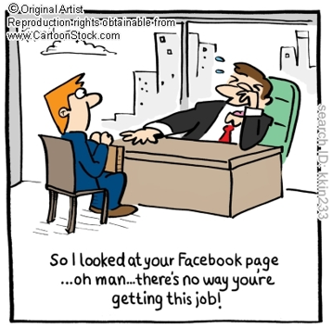

[Adapted from: https://www.cartoonstock.com Accessed:12 June 2022]

Write paragraphs on competencies and social media usage in the job application process.
Use the following as a guideline:

- Define the term ‘competencies’ and give THREE examples of positive ethics that
are part of required workplace competences to enhance employability. (1+3) (4)
(Lower Order)

- Analyse the impact of unethical usage of social media on high schoolers’ attempt
to be taken seriously in the world of work (2x4) (8) (Middle Order)

- Critically discuss how certain work ethics such as irresponsible usage of social
media could harm an employee’s attempts to develop his/her career. (2x4) (8)
(Higher Order)
[20]

Question 5

Study the following image and answer the questions that follow.
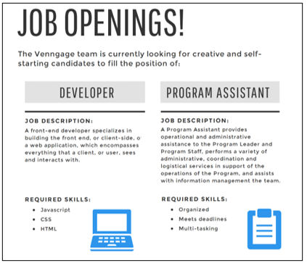

[Accessed from: www.http://rin-bee.com/. 11 July 2022]

Write paragraphs on job advertisements and application.
Use the following as a guideline:

- Define the term ‘job advertisement’ and state THREE points that job seekers could
take note of when studying a job advertisement. (1+3) (4)
(Lower Order)

- Analyse good practices that job seekers could use when filling in application forms.
(2x4) (8)
(Middle Order)
- Evaluate the effects of online job application on prospective employees. (2x4) (8)
(Higher Order)
[20]
Question 6

Study the image and text below and answer the questions that follow.
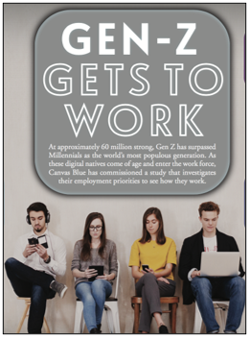

[Accessed from: https://fireflies.ai Accessed: 12 July 2022]
Gen-Z is starting to make up a large percentage of the workplace. Their unique perspective about careers and life goals makes them the best fit for the post-pandemic workforce. Called the 'change generation,' Gen-Z and the second half of millennials prioritize purpose over money.
An empowering work culture and constant change and growth within their career are two of many factors which help increase Generation Z's work ethic.

Write paragraphs on Generation Z’s expectations in the world of work.

Use the following as a guideline:

- Define the term ‘personal expectations’ and provide THREE ways in which new
entrants into the working world can ensure that they have realistic personal
expectations of the working world. (1+3) (4)
(Lower Order)

- Analyse how Gen Z’s tech knowledge could increase their chances of success
in the workplace. (2x4) (8)
(Middle Order)

- Evaluate the impact Gen Z’s unique expectations will have on the future of the world
of work. (2x4) (8)
(Higher Order)
[20]

[TOTAL SECTION C: 40 MARKS]
TOTAL = 20 + 40 + 40 = 100

