MEMORANDUM
GRADE 8 LIFE ORIENTATION
TOPIC:
DEVELOPMENT OF THE SELF IN SOCIETY (DSS)
Term 1 & 2
60/90 minutes 2022 70 marks
________________________________________________________________________________
SECTION A (Compulsory)
Answer all the questions in this section.

Question 1.1
1.1.1 A
1.1.2 B
1.1.3 C
1.1.4 D
1.1.5 A
[5x1][5]
(All Lower Order)
Question 1.2
1.2.1 empathy ✔
1.2.2 accommodating ✔
1.2.3 interpersonal ✔
1.2.4 peers ✔
1.2.5 esteem ✔
[5x1][5]
(All Lower Order)
Question 1.3
Choose a description from COLUMN B that matches an item in COLUMN A. Write only the letter
(A-G) next to the number (1.3.1 to 1.3.5) in the answer book.

1.3.1 D
1.3.2 C
1.3.3 A
1.3.4 B
1.3.5 F [5x1][5]
(All Lower Order)

Question 1.4
Answer the following questions by writing the answer next to the question numbers (1.4.1 to 1.4.5)
in the answer. Write your answers in full sentences.
1.4.1 Define the term ‘lockdown’ in terms of the COVID-19 pandemic. (1x1)(1)
(Lower Order)
- The state restricted movement to keep citizens safe from COVID ✔

1.4.2 Provide TWO ways to decrease the spread of COVID-19. (2x1)(2)
(Lower Order)
Any TWO of the below:
- Wear masks ✔
- Social distancing ✔
- Sanitising hands ✔
- Ventilation in shared areas ✔
- Only go into public spaces when needed ✔
- Getting vaccinated ✔

1.4.3 What is meant by the term ‘compromise’ in terms of problem-solving skills in relationships? (1x1)(1)
(Lower Order)
Any ONE of the below for ONE mark
- Find a mutually acceptable solution that partially satisfies each of the parties ✔
- Give-and-take so that the resulting agreement partially satisfies each of the parties ✔
- A problem-solving strategy which brings out and satisfies the important concerns of each of the parties✔
1.4.4 Contrast between a relationship and a friendship. (2x1)(2)
(Lower Order)
Any ONE of the below for TWO marks
- A relationship is when two people are dependent on each other ✔ whereas a friendship is when two individual share their time but are not dependant on each other ✔
- Friendships are deliberate ✔ whereas relationships (eg with family) are given to us as a result of blood/marriage ties ✔
- A relationship is where people share a commitment to each other✔ whereas a friendship is where people share common interests✔
1.4.5 Explain TWO negative consequences of sexting. (2x2)(4)
(Middle Order)
Any TWO of the below for TWO marks each
(i.e. ONE mark for statement and ONE mark for qualifier / explanation)

- The person receiving the photos might brag about them and show them to other people✔ This might be very embarrassing for the person who the photos are of✔
- If they are dating, they may break up and the person could share them ✔ this can be humiliating✔
- It also could lead to bullying, shaming, and name-calling ✔ which could lead to low self-esteem ✔
- These images can even ruin the person’s reputation✔ resulting in people possibly forming opinions about them just by seeing the photos✔

[10]
[TOTAL SECTION A: 25 MARKS]

SECTION B: (Compulsory)
Answer all questions in this section.
Write your answers in full sentences.
Question 2
Read the extract below and answer the questions that follow.
We all experience moments of self-doubt and uncertainty. Even the most confident and happy people have moments where they think, “I’m such a failure.”
It’s a part of being human. However, if you find yourself having these kinds of negative thoughts frequently or letting these feelings get in the way of living a healthy and happy life, it may be time to do something about it.
Luckily, there are many ways to increase your self-concept. It probably won’t be easy, but it can certainly be done.
Adapted from https://positivepsychology.com/self-esteem-worksheets/
(Accessed 5 November 2021)

2.1 Define the term ‘self-concept’. (1x1)(1)
(Lower Order)
- An idea of the self-constructed from the beliefs one holds about oneself and the responses of others.✔
2.2 Discuss TWO factors within the home environment that could result in a teen formulating a
negative self-concept. (2x2)(4) (Middle Order)

Any TWO of the below for TWO marks each
(i.e. ONE mark for statement and ONE mark for qualifier / explanation)
- Stressful life events such as divorce✔ develops feelings of guilt as though it is their fault✔
- Unsupportive parents or carers✔, therefore feeling unloved or unwanted✔
- Unrealistic comparison to others✔ develops a feeling of not being good enough ✔
- Being insulted or bullied by family members / siblings✔ develops feelings of inferiority or worthlessness✔
- Social media messages on the phone or TV depicting unrealistic standards of perfection ✔ develops a feeling of not being good enough✔
- Peer pressure from loved ones✔ placing burden of guilt and/or tension on the teen✔

2.3 Explain TWO negative consequences that a weak self-concept may have on teens
emotionally. (2x2)(4)
(Middle Order)
Any TWO of the below for TWO marks each
(i.e. ONE mark for statement and ONE mark for qualifier / explanation)

- Relationship troubles or difficulty making friends✔ as they do not feel confident enough to approach people ✔
- Negative moods such as feeling sad, anxious, ashamed or angry ✔ as they do not feel worthy ✔
- Low motivation ✔ because they do not feel that anything they do is good enough ✔
- Negative or defeatist attitude✔ as they expect things not to work out well ✔

2.4 Recommend TWO ways in which one can develop a positive self-concept (2x2)(4)
(Higher Order)
Any TWO of the below for TWO marks each
(i.e. ONE mark for statement and ONE mark for qualifier / explanation)

- Identify and challenge negative beliefs ✔ This will assist in being logical about your accomplishments✔
- Identify the positive about yourself ✔ This shines light on what you are good at ✔
- Build positive relationships✔ that build you up and accept you as you are ✔
- Engage in positive self-talk ✔ as this will reaffirm your strengths and abilities to yourself✔
[13]

Question 3
Examine the information below and answer the questions that follow.
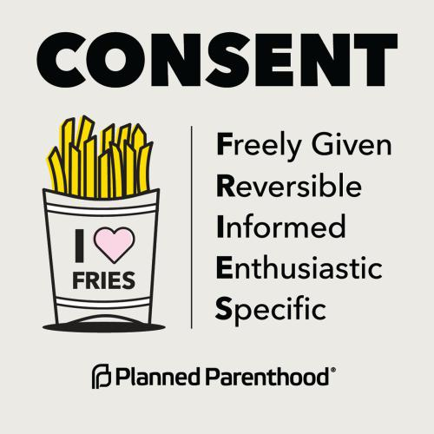
It is the responsibility of the person that initiates any type of sexual activity to obtain the other person's consent. Silence does not imply consent.
Consent is never implied by things like your past behaviour and previous sexual activities.
Adapted from https://www.plannedparenthood.org/learn/
relationships/sexual-consent
(Accessed 5 November 2021)

3.1 Besides sexual activities, identify TWO situations where one should ask for consent. (2x1)(2)
(Lower Order)
Any TWO of the below for ONE mark each
- When wanting to use someone's possessions ✔
- Asking your parents if you may do something like go to a friend’s house ✔
- If you are going to touch someone to show them how to do something✔

3.2 Discuss TWO reasons why consent is important in a relationship. (2x2)(4)
(Middle Order)
Any TWO of the below for TWO marks each
(i.e. ONE mark for statement and ONE mark for qualifier / explanation)

- So that both parties know what they are agreeing to ✔ this ensures that they are both comfortable ✔
- Asking for consent shows respect ✔ this is fundamental to a relationship as it builds trust ✔
- It ensures that no one can get into trouble with the law✔ if sexual activities happen without consent a person can be charged ✔

3.3 Explain why “Silence does not imply consent” in any relationship (1x2)(2)
(Middle Order)
Any ONE of the below for TWO marks
(i.e. ONE mark for statement and ONE mark for qualifier / explanation)

- As you do not know if your partner wants to participate ✔ As they have not actively said “yes” to something ✔
- Silence can indicate that a person is scared / worried✔ This may show that they are too worried to disagree ✔
3.4 Recommend TWO ways how consent in a relationship can help you and your partner respect
each other’s boundaries. (2x2)(4)
(Higher Order)
Any TWO of the below for TWO marks each
(i.e. ONE mark for statement and ONE mark for qualifier / explanation)

- Ensure that you do not threaten or guilt your partner at all ✔ if your partner does not want to do something that has to be ok✔
- Ensure that what they are saying and their body language match✔ if your partner is hesitant in their body language they probably do not want to do something ✔
- Check in throughout any sexual activity ✔ this allows your partner to change their mind / withdraw consent if they want to ✔
- Ensure that your partner says “yes” enthusiastically before doing something✔ this shows you that they are consenting as they are agreeing ✔
[12]
[TOTAL SECTION B: 25 MARKS]

SECTION C (Choice)

Answer any TWO questions in this section.
Your responses must consist of paragraphs.
Marks will only be allocated for responses written in full sentences.
Question 4
Read the scenario below and answer the questions that follow.
Sadie and Alyssa have been friends since junior school. When they started in Grade 8 Alyssa started to feel that Sadie has become mean when they are around other people, often bringing Alyssa down to make herself look better. This has had a negative impact on Alyssa’s , as she is building her self-concept
Alyssa has tried to bring this up with Saide, but she is ignored or brushed off.
Source: Anonymous
Write paragraphs on how to maintain positive relationships.
Use the following as a guideline.
- Identify TWO things that could indicate that you are not in a healthy friendship. (2x1)(2)
(Lower Order)
Any TWO of the below for ONE mark each
- Controlling people✔
- Peer pressure to do things that you normally would not do✔
- People being rude and unkind✔
- Disrespectful✔
- No support ✔

- Explain TWO appropriate ways how Alyssa can make Sadie aware of her mean behaviour.
(2x2)(4)
(Middle Order)
Any TWO of the below for TWO marks each
(i.e. ONE mark for statement and ONE mark for qualifier / explanation)
  - Alyssa can speak to her calmly ✔ this can draw Sadie’s attention to what is not appreciated ✔
  - She can message / write a letter to Sadie ✔ this can ensure that Sadie has to read what the situation is ✔
  - Alyssa can decide to end the friendship and explain to Sadie why she has taken this decision✔ this can help Alyssa’s mental health and ensure that Sadie realises her behaviour has led to the end of their friendship✔
- Recommend TWO ways in which Alyssa can ensure she builds positive friendships. (2x2)(4)
(Higher Order)
Any TWO of the below for TWO marks each
(i.e. ONE mark for statement and ONE mark for qualifier / explanation)
- Make friends with people who share her interests✔ this will ensure they have something to bond over✔
- Be around people who build her up ✔ These people will make Alyssa feel good about herself ✔
- Be around people who are invested in her✔ These people will motivate her and have her best interests at heart✔
- Do things that both of them enjoy✔, in this way she gets to know the friends really well and builds trust. ✔
[10]

Question 5
Study the below image and text before answering the questions that follow.

The development of a positive and healthy self-concept is extremely important to the happiness and success of children and teenagers.

Adapted from https://childdevelopmentinfo.com/child-psychology/
self-esteem/#gs.ezegso | Child Development Institute
(Accessed on 15 December 2021)
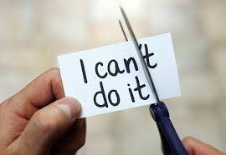

Write paragraphs on self-concept.
Use the following as a guideline.
- Identify TWO ways how the media can have a negative impact on a teenager’s self-concept (2x1)(2)
(Lower Order)
Any TWO of the below for ONE mark each
The media (including social media) is an environment in which teens can be exposed to:
  - Cyberbullying ✔
  - Negative comments from other users / people ✔
  - Unrealistic standards (beauty, physical health, relationships) ✔
  - Trying to be like people see online✔
  - Constant need for comparison which robs of all joy✔
  - Success but without the need for hard work / sacrifice / effort✔
  - Loneliness from pursuing virtual friends as opposed to real friendships✔

- Explain TWO reasons why having a positive self-concept is important when being a teen.
(2x2)(4)
(Middle Order)
Any TWO of the below for TWO marks each
(i.e. ONE mark for statement and ONE mark for qualifier / explanation)

  - Being responsible in situations where they feel pressured ✔ as they will have a higher regard for themselves / find it easier to say NO✔
  - Feeling confident and comfortable to make wise choices (decision making) ✔ thereby choosing outcomes that will be happy with in the future. ✔
  - It will assist teens in being independent✔ this will ensure that they make mature decisions ✔
  - When they accomplish / achieve something ✔ they will feel pride in themselves ✔
  - It will assist them with accepting frustration ✔ as they will know that they are capable of dealing with difficult situations ✔
  - Trying new things and challenges ✔ as they will have faith in their abilities ✔
  - Helping others where possible✔ as they will have a higher level of maturity ✔

- Recommend TWO practical ways how teens can ensure they build a positive self-concept. (2x2)(4)
(Higher Order)
Any TWO of the below for TWO marks each
(i.e. ONE mark for statement and ONE mark for qualifier / explanation)
- Be with people who treat you well ✔ so choose friends who help you feel OK about yourself/ be yourself around ✔
- Say positive things to yourself ✔ because engaging in positive self-talk will ensure you build yourself up✔
- Accept what's not perfect ✔ because then you will accept your flaws and still feel good about yourself✔
- Set goals and work toward them ✔ If you want to feel good about yourself, do things that are good for you. Be proud of what you've done so far ✔
- Focus on what goes well✔ Reflect on things that went well during the day, rather than complaining about the things that went wrong✔
- Find a service-related activity that brings you joy ✔ and it will make you proud of the kind of person you are ✔
[10]

Question 6

Study the below image and text before answering the questions that follow.

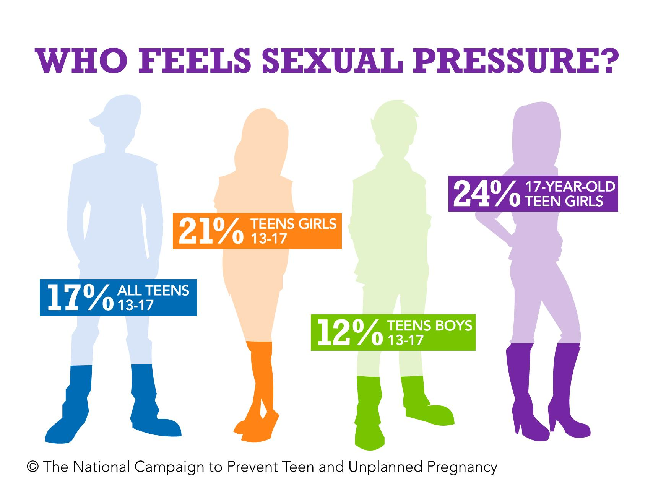
Helping Teens Resist Sexual Pressure
“The pressure on teenagers to have sex is enormous,” says paediatrician Dr. Ron Eagar, adding that kids often feel as if they’re caught in a difficult situation.

Adapted from https://www.healthychildren.org/English/ages-stages/
teen/dating-sex/Pages/Helping-Teens-Resist
-Sexual-Pressure.aspx
(Accessed 15 December 2021)

Write paragraphs on sexual pressure.
Use the following as a guideline.
- Identify two emotional dangers that teens face if they engage in sexual activity from
an early age (2x1)(2)
(Lower Order)
Any TWO of the below for ONE mark each
  - Depression ✔
  - Anxiety ✔
  - Lowered self-esteem ✔
  - Feelings of restlessness and worry ✔
  - Isolation and / withdrawal from friends and family ✔

- Explain TWO reasons why the media (including social media) may make teens feel pressured to engage in sexual activities. (2x2)(4)
(Middle Order)
Any TWO of the below for TWO marks each
(i.e. ONE mark for statement and ONE mark for qualifier / explanation)
  - The media displays sexual behaviour ✔ This may make teens believe this is what they have to do in order to be cool ✔
  - The media portrays various types of sexual relationships ✔ reinforcing a relatively consistent set of sexual and relationship norms that may influence teens✔
  - The media rarely depicts sexually responsible role-models✔ having sex seems like something that is normal in all teen relationships ✔
  - Social media often glorifies sexual activity✔ causing teens to possibly make that the purpose for being in a relationship✔

- Assess how a healthy relationship could assist in making wise choices around sexual activity. (2x2)(4)
(Higher Order)
Any TWO of the below for TWO marks each
(i.e. ONE mark for statement and ONE mark for qualifier / explanation)

- Healthy relationships are built on respect ✔ If one is respected, then their boundaries around sexual activities will be acknowledged and respected to✔
- Communication is essential in a healthy relationship ✔ Partners who openly communicate are likely to know where the other person stands when it comes to sexual activities therefore no misunderstandings can take place✔
- Trust is important in a healthy relationship ✔ Having trust ensures that partners will remain loyal to each other and therefore not engage in sexual activities with other people ✔
[10]

