GRADE 8 LIFE ORIENTATION

TOPIC:
WORLD OF WORK (WOW)
Term 1 & 2
2021

2 HOURS 70 MARKS

NOTE TO TEACHERS: Remember, this is a bank of questions and therefore may contain some overlap. Keep this in mind when selecting questions for your paper. Use the table below to help you when choosing your questions.

Weighting (suggested) | Weighting (Actual) | Cognitive level | Bloom’s taxonomy
40% (28 marks) | 28 marks | Lower Order | Level 1&2
40% (28 marks) | 28 marks | Middle Order | Level 3&4
20% (14 marks) | 14 marks | Higher Order | Level 5&6
All essay questions are weighted equally. Learners must complete the full combination related to a particular question.

REMINDER: Teenactiv papers should be considered as a bank of questions from which teachers can choose when creating their own question papers. Control test should include components of each topic covered in terms 1 & 2 for 2021.
______________________________________________________________
INSTRUCTIONS AND INFORMATION
- The question paper consists of THREE sections, namely SECTION A, SECTION B and SECTION C.
- The questions in SECTION A and SECTION B are compulsory.
- Answer any TWO questions in SECTION C.
- Read ALL the questions carefully.
- Number the answers correctly according to the numbering system used in this question paper. Start each question on a new page.
- Write neatly and legibly.
- This paper consists of 10 pages and 7 questions. (23 pages including Memo)

SECTION A (Compulsory)
Answer all the questions in this section.
Question 1.1
Various options are provided as possible answers to the following questions. Choose the correct answer and write only the letter (A–D) next to the question number (1.1.1 – 1.1.5) in the answer book, for example 1.1.6. E

    - People who like to lead and love taking risks falls in the following career

A. Realistic
B. Investigative
C. Enterprising
D. Conventional (1)
(Lower Order)

1.1.2 Which of the following jobs falls in the conventional career category?

A. Dancer
B. Engineer
C. Accountants
D. Nurse (1)
(Lower Order)

1.1.3 Which of the following is an example of a kinesthetic learning style:

A. Doing summaries that are neatly organized
B. Doing summaries just by listening to teachers
C. Doing experiments and participate actively
D. Doing mind maps and diagrams when they learn. (1)
(Lower Order)

1.1.4. Example of an activity in the Artistic career category:

A. Drawing mind maps
B. Doing calculations
C. Singing and dancing
D. Making lots of lists (1) (Lower Order)

1.1.5. Which of the following would be an ideal way for a visual learner to learn?

- Drawing charts and diagrams
- Singing rhymes and chants
- Doing and enjoying touching
- Reading their class notes (1)
(Lower Order)
(5x1)(5)
Question 1.2

Provide a definition or explanation of the concept:

1.2.1 Explain what is meant by the term “unemployed”. (1)
(Lower Order)
1.2.2 Explain the concept ‘pandemic’? (1)
(Lower Order)
1.2.3 Explain what it means to “social distance”. (1)
(Lower Order)
1.2.4 Define the concept of “symptomatic”. (1)
(Lower Order)
1.2.5 Explain the term “economic needs”. (1)
(Lower Order)
(5x1)(5)
Question 1.3
Match the concept in COLUMN A that best matches each statement in Column B. Write only the appropriate letter (A - G) next to the number (1.3.1 – 1.3.5).

Column A | Column B
1.3.1. Realistic | A. Dance Studies, Design, Dramatic Arts, Engineering and Graphic Design, History, Visual Arts
1.3.2. Investigative | B. Geography, Equine Studies; Consumers Studies, Agricultural Management Practices, Agricultural Sciences, Civil Technology, Agricultural Technology, Engineering and Graphic Design
1.3.3. Conventional | C. Accounting, Business Studies, Computer Application, Consumer Studies, Economics, Hospitality Studies, Mathematical Literacy, Business Science
1.3.4. Social | D. Civil Technology, History, Information Technology, Life Sciences, History, Mathematics, Mechanical Technology, Physical Sciences
1.3.5. Enterprising | E. Accounting, Computer Applications, Economics, Mathematical Literacy, Mathematics, Business Studies
 | F. Consumer Studies, History, Hospitality Studies, Life Orientation, Religious Studies, Tourism
(5x1)(5)
(All Lower Order)

Question 1.4

1.4.1 List THREE abilities of a person in the SOCIAL career category. (3x1)(3)
(Lower Order)

1.4.2 Why is it important to identify the social and economic needs of your
community when you enter the world of work? (2x1)(2)
(Lower Order)
(5)

Question 1.5
Indicate whether the following statements are TRUE or FALSE. Write only 'true' or 'false' next to the question number (1.5.1 – 1.5.3). Give a reason if the statement is FALSE

1.5.1 Learning skills in the realistic career category are skills like observation,
language and mathematical skills.

1.5.2 Analyzing is the critical thinking skill which means breaking something down into
parts, and then seeing how it fits together.

1.5.3 Learning style is not influenced by your personality, and everybody has one style
of learning.

(5)
(All Lower Order)
[TOTAL SECTION A: 25 MARKS]

SECTION B (Compulsory)
Answer all the questions in this section.
Write your answers in full sentences.
Question 2
Study the picture below and answer the questions that follow.
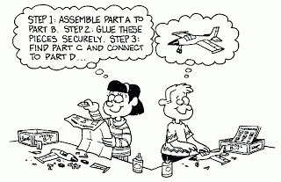

Image accessed from https://www.pinterest.ca/pin/196610339955959021/ [Accessed April, 17 2021]

Write paragraphs on learning styles.

Use the following as a guideline:

2.1. Identify and explain the type of learning style that would suit the boy. (2x1)(2)
(Lower Order)

2.2 Discuss TWO reasons why it is important to know your learning style. (2x2)(4)
(Middle Order)

2.3 Recommend TWO ways how the boy should study for exams. (2x2)(4)
(Higher Order)

(10)

Question 3
Read the following scenario and answer the questions that follow:

Themba is a Grade 8 learner at Park High School, he is very distressed because he is not sure what he wants to do in the future. His best friend Becky is really good at Dance studies and dramatic art and wants to be an artist when she grows up.

Themba is concerned because it seems like everyone else know exactly what they want to do.
Source: Anonymous

3.1. Name the career category that Becky fits into. (1)
(Lower Order)

3.2. List TWO ways how Themba can identify his interests and abilities. (2x1)(2)
(Lower Order)

3.3. Explain to Themba TWO links between learning styles and career categories. (2x2)(4)
(Middle Order)

3.4. Advise ONE way that can help students identify which career category would
work best for them. (1x2)(2)
(Higher Order)
(9)

Question 4
Study the following extract and answer the questions that follow.

Is online the future of higher education in South Africa
Slow and steadily, global education prepared for a staged transition into online learning. The defined time frame was a decade in order to maximise efficiencies and tweak technology to suit the makeup of the digital natives.
While in South Africa, public higher education saw a suspension of all courses and programmes for a period of 10 weeks in order to train staff on online platforms and teaching models, as well as the transition of existing curricula to online, private higher education seamlessly transitioned with no time lost in the academic year.
[Adapted from https://www.mancosa.co.za/blog/is-online-learning-the-future-of-higher-education-in-south-africa/ Accessed March, 7 2021]

4.1. Briefly explain what is “online learning”. (1x2)(2)
(Lower Order)
4.2. Discuss TWO tips for effective learning. (2x2)(4)
(Middle Order)
(6)

[TOTAL SECTION B: 25 MARKS]

SECTION C (Choice)
Answer any TWO questions in this section.
Your responses must consist of paragraphs. Marks will only be allocated for responses written in full sentences.

Question 5
Examine the extract below and answer the questions that follow.
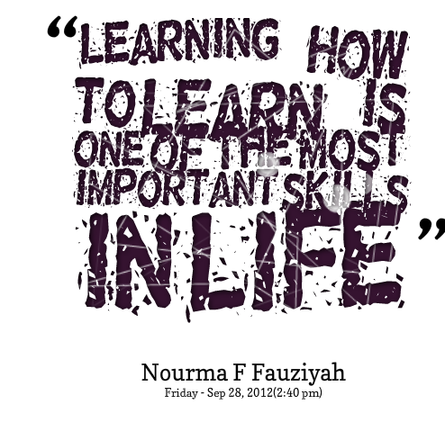

[Adapted from https://www.quotemaster.org/images/71/713544c398e1ef123911a8db6843b1c9.jpg Accessed March, 5 2021]

Write paragraphs on learning styles.

Use the following as a guideline:

- Briefly explain the term “learning style”. (1x2)(2)
(Lower Order)

- Discuss TWO types of learning styles a learner can use to study and learn effectively. (2x2)(4)
(Middle Order)

- Recommend TWO ways how knowing your learning style can help reduce stress levels during exams. (2x2)(4)
(Higher Order)

(10)

Question 6
Study the below advertisement and answer the questions that follow:

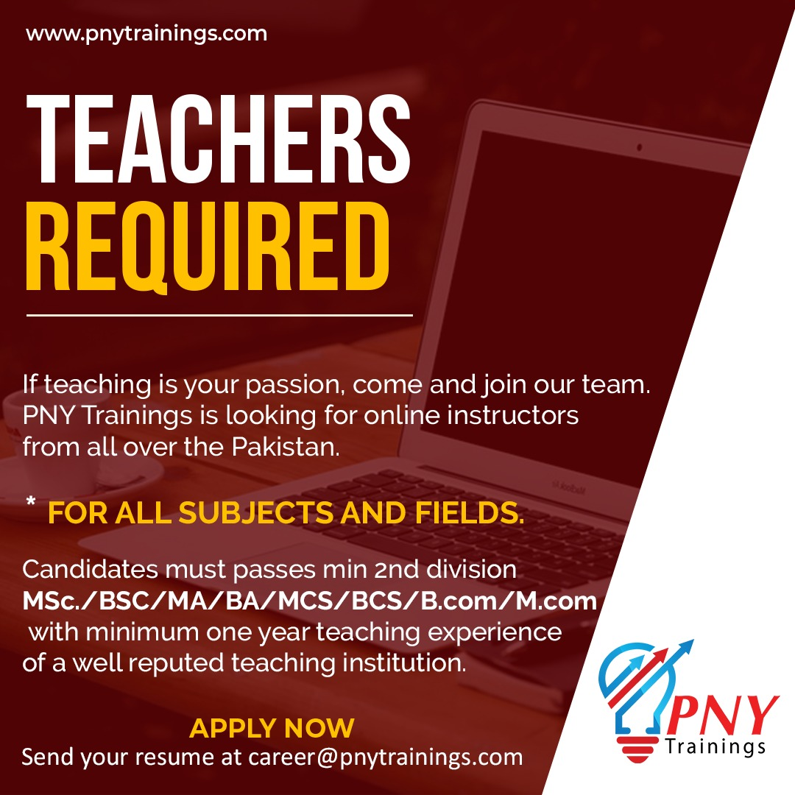
[Adapted from https://ceo.jobshut.pk/upload/WhatsApp-Image-2020-07-15-at-12-13996993925f0ec32b8e949.jpeg Accessed March, 6 2021]

Write paragraphs on career category

Use the following as a guideline:

- Name and explain the career category in which this job falls. (1+1)(2)
(Lower Order)

- Discuss TWO reasons why you think it is necessary for learners to know their career categories. (2x2)(4)
(Middle Order)
- Recommend TWO other jobs to a fellow learner that would fit with the specific career category. Motivate your recommendation (2x2)(4)
(Higher Order)
(10)
Question 7
Read the extract below and answer the questions that follow.

COVID-19 highlights South Africa’s need for local level social data

South Africa’s government took radical action when the virus was detected in the country. Its scientists, advisors and politicians were able to draw on the experiences of other countries, combined with local data, to evaluate the risks and make enormously difficult decisions. Strong initial containment efforts were followed with a nationwide lockdown as community transmission began to increase. Globally, South Africa’s rapid and evidence-based action has been lauded.

Unfortunately, this necessary strategy has come with massive and multi-dimensional costs, which have fallen hardest on the poor, who are least able to absorb them.
[Adapted from https://theconversation.com/covid-19-highlights-south-africas-need-for-local-level-social-data-137804 Accessed 6 March 2021]

- Briefly explain the term “social needs”. (1x2)(2)
(Lower Order)
- Discuss TWO negative effects that lockdown had on the communities’ needs in South Africa. (2x2)(4)
(Middle Order)
- Suggest TWO ways how work can meet the social needs in South Africa. (2x2)(4)
(Higher Order)

(10)

[TOTAL SECTION C: 20 MARKS]

MEMORANDUM
SECTION A (Compulsory)
Answer all the questions in this section.

Question 1.1
1.1.1 C
1.1.2 C
1.1.3 C
1.1.4 C
1.1.5 A
(5x1)(5)
(All Lower Order)

Question 1.2

Provide a definition or explanation of the concept:

1.2.1 Explain what is meant by the term “unemployed”. (1)
(Lower Order)
Unemployed means someone that does not have a paid work. ✓

1.2.2 Explain the concept ‘pandemic’? (1)
(Lower Order)
A pandemic is a disease outbreak that spreads across countries or continents. ✓
1.2.3 Explain what it means to “social distance”. (1)
(Lower Order)
The physical distance maintained between individuals in social contexts. ✓

1.2.4 Define the concept of “symptomatic”. (1)
(Lower Order)
Showing symptoms of a disease. ✓
1.2.5 Explain the term “economic needs”. (1)
(Lower Order)
The income of its people and the ability for a country to grow in financial terms
(5x1)(5)
Question 1.3
Match the concept in COLUMN A that best matches each statement in Column B. Write only the appropriate letter (A - G) next to the number (1.3.1 – 1.3.5).

Column A | Column B
1.3.1. Realistic (B) | A. Dance Studies, Design, Dramatic Arts, Engineering and Graphic Design, History, Visual Arts
1.3.2. Investigative (D) | B. Geography, Equine Studies; Consumers Studies, Agricultural Management Practices, Agricultural Sciences, Civil Technology, Agricultural Technology, Engineering and Graphic Design
1.3.3. Conventional (E) | C. Accounting, Business Studies, Computer Application, Consumer Studies, Economics, Hospitality Studies, Mathematical Literacy, Business Science
1.3.4. Social (F) | D. Civil Technology, History, Information Technology, Life Sciences, History, Mathematics, Mechanical Technology, Physical Sciences
1.3.5. Enterprising (C) | E. Accounting, Computer Applications, Economics, Mathematical Literacy, Mathematics, Business Studies
 | F. Consumer Studies, History, Hospitality Studies, Life Orientation, Religious Studies, Tourism
(5x1)(5)
(All Lower Order)

Question 1.4

1.4.1 List THREE abilities of a person in the SOCIAL career category. (3x1)(3)
(Lower Order)
Any THREE relevant answers for ONE mark each
- Enjoy helping others
- Like working with other people
- Are good listeners
- Are good at showing understanding

1.4.2 Why is it important to identify the social and economic needs of your
community when you enter the world of work? (2x1)(2)
(Lower Order)
Any TWO relevant answers for ONE mark each
- Your chances of getting a job become higher
- Your skills will be needed in the community
- If the chances are greater of getting a job, then you contribute towards the improvement of family, community and country
(5)

Question 1.5
Indicate whether the following statements are TRUE or FALSE. Write only 'true' or 'false' next to the question number (1.5.1 – 1.5.3). Give a reason if the statement is FALSE

1.5.1 Learning skills in the realistic career category are skills like observation,
language and mathematical skills.

FALSE, Investigative category OR Technological skills and physical skills (2)

1.5.2 Analyzing is the critical thinking skill which means breaking something down into
parts, and then seeing how it fits together.

TRUE (1)

1.5.3 Learning style is not influenced by your personality, and everybody has one style
of learning.

FALSE, it is influenced by your personality and people could prefer more than one style of learning. (2)
(5)
(All Lower Order)

[TOTAL SECTION A: 25 MARKS]

SECTION B (Compulsory)
Answer all the questions in this section.
Write your answers in full sentences.
Question 2
Study the picture below and answer the questions that follow.

Image accessed from https://www.pinterest.ca/pin/196610339955959021/ [Accessed April, 17 2021]

Write paragraphs on learning styles.

Use the following as a guideline:

2.1. Identify and explain the type of learning style that would suit the boy. (2x1)(2)
(Lower Order)

Kinesthetic/ tactile learning style✓, because he learns by doing. That is why he is building the plane with his hands. ✓

2.2 Discuss TWO reasons why it is important to know your learning style. (2x2)(4)
(Middle Order)

Any TWO of the below or any relevant answers for TWO marks each
(i.e. ONE mark for statement and ONE mark for qualifier / explanation)

- Would help you when studying your work✓, and result in you getting better marks. ✓
- It will make you pay attention✓ on how you study, and this would maximize the amount of work you memorize. ✓
- It would ensure that you are studying optimally✓, resulting in you not getting frustrated as you know what works best for you. ✓

2.3 Recommend TWO ways how the boy should study for exams. (2x2)(4)
(Higher Order)

Any TWO of the below or any relevant answers for TWO marks each
(i.e. ONE mark for statement and ONE mark for qualifier / explanation)

- The boy should learn by imaging things while he reads them✓, as this would help him to see them clearly. ✓
- He should walk up and down while he learns✓ - by doing something he will take in more information. ✓
- He should make use of flash cards, ✓ this would help him to be active while studying which means that he will concentrate more. ✓
- He should make notes in class to help him concentrate✓ since he is actively listening then. ✓
(10)

Question 3
Read the following scenario and answer the questions that follow:

Themba is a Grade 8 learner at Park High School, he is very distressed because he is not sure what he wants to do in the future. His best friend Becky is really good at Dance studies and dramatic art and wants to be an artist when she grows up.

Themba is concerned because it seems like everyone else know exactly what they want to do.
Source: Anonymous

3.1. Name the career category that Becky fits into. (1)
(Lower Order)
Artistic category✓

3.2. List TWO ways how Themba can identify his interests and abilities. (2x1)(2)
(Lower Order)
Any TWO relevant answers for ONE mark each
- Themba could go for an assessment with a career counsellor who can advise him✓
- He could speak to people that know him well and ask them for their suggestions ✓
- He could perform an activity / exercise that would highlight his interests and abilities ✓

3.3. Explain to Themba TWO links between learning styles and career categories. (2x2)(4)
(Middle Order)

Any TWO of the below or any relevant answers for TWO marks each
(i.e. ONE mark for statement and ONE mark for qualifier / explanation)

- Your learning style will show you your strengths and weaknesses✓ and thus making it easier to identify the right career category. ✓
- Your learning style will show your interest and abilities✓ and thus making it easier to identify the right career category. ✓

3.4. Advise ONE way that can help students identify which career category would
work best for them. (1x2)(2)
(Higher Order)

Any ONE of the below or any relevant answer for TWO marks
(i.e. ONE mark for statement and ONE mark for qualifier / explanation)

- Personality test✓: as this would help a student determine his/her skills and abilities. ✓
- Aptitude test✓: as this would help a student determine which subjects would work best for him/her as well as their personality. ✓
- Identify their learning style✓ as this would highlight more about his/her personality and therefore allow him/her to better identify his/her career category ✓
(9)

Question 4
Study the following extract and answer the questions that follow.

Is online the future of higher education in South Africa
Slow and steadily, global education prepared for a staged transition into online learning. The defined time frame was a decade in order to maximise efficiencies and tweak technology to suit the makeup of the digital natives.
While in South Africa, public higher education saw a suspension of all courses and programmes for a period of 10 weeks in order to train staff on online platforms and teaching models, as well as the transition of existing curricula to online, private higher education seamlessly transitioned with no time lost in the academic year.
[Adapted from https://www.mancosa.co.za/blog/is-online-learning-the-future-of-higher-education-in-south-africa/ Accessed March, 7 2021]

4.1. Briefly explain what is “online learning”. (1x2)(2)
(Lower Order)
Online learning is a modern educational approach where students and teachers follow a structured curriculum programme using advanced information technology that is mediated via the Internet. ✓

4.2. Discuss TWO tips for effective learning. (2x2)(4)
(Middle Order)
Any TWO of the below or any relevant answers for TWO marks each
(i.e. ONE mark for statement and ONE mark for qualifier / explanation)

- Use the learning style that works best for you when studying✓: as this will help you retain more information. ✓
- Get enough sleep✓, as cramming will not work and your brain will be fresh. ✓
- Choose the right time to study✓, so that you are awake and not tired or falling asleep. ✓
- Choose the right place to study✓, so that your attention is focused on your studies and not on other distractions. ✓
- Eat properly✓, as this will give you enough energy to study. ✓
- Use a study timetable✓, so that it gives you guidance, direction and a strategy to get through all the work
(6)
[TOTAL SECTION B: 25 MARKS]
SECTION C (Choice)
Answer any TWO questions in this section.
Your responses must consist of paragraphs. Marks will only be allocated for responses written in full sentences.

Question 5
Examine the extract below and answer the questions that follow.

[Adapted from https://www.quotemaster.org/images/71/713544c398e1ef123911a8db6843b1c9.jpg Accessed March, 5 2021]

Write paragraphs on learning styles.

Use the following as a guideline:

- Briefly explain the term “learning style”. (1x2)(2)
(Lower Order)

A learning style is the way that different students learn.✓ A style of learning refers to an individual's preferred way to absorb, process, comprehend and retain information. ✓

- Discuss TWO types of learning styles a learner can use to study and learn effectively. (2x2)(4)
(Middle Order)

Any TWO of the below or any relevant answers for TWO marks each
(i.e. ONE mark for statement and ONE mark for qualifier / explanation)

- Visual learner✓ - learns best through pictures, diagrams and spatial understanding✓
- Auditory learner✓ - learns best through sound, music and hearing the work✓
- Kinesthetics learner ✓- learns best through doing, demonstrating, hands on approach. ✓

- Recommend TWO ways how knowing your learning style can help reduce
stress levels during exams. (2x2)(4)
(Higher Order)

Any TWO of the below or any relevant answers for TWO marks each
(i.e. ONE mark for statement and ONE mark for qualifier / explanation)

- Ensure that you get adequate sleep✓ so that you are not exhausted and can focus on the exams. ✓
- Ensure you start your studying well in advance✓ so that you don’t put yourself under pressure. ✓
- Adopt healthy eating habits✓ so that you have the energy to study. ✓

(10)

Question 6
Study the below advertisement and answer the questions that follow:

[Adapted from https://ceo.jobshut.pk/upload/WhatsApp-Image-2020-07-15-at-12-13996993925f0ec32b8e949.jpeg Accessed March, 6 2021]

Write paragraphs on career category

Use the following as a guideline:

- Name and explain the career category in which this job falls. (1+1)(2)
(Lower Order)

Social career✓: are people who like to facilitate the development of people. ✓

- Discuss TWO reasons why you think it is necessary for learners to know their career categories. (2x2)(4)
(Middle Order)

Any TWO of the below or any relevant answers for TWO marks each
(i.e. ONE mark for statement and ONE mark for qualifier / explanation)

- Knowing your strengths and weakness✓, would make it easier to work on yourself and to improve. ✓
- You will have a better idea of which subjects to take✓, and also what you will enjoy and do better in. ✓
- You will know the career field that you need to go in✓ and also what you will enjoy and be good at. ✓

- Recommend TWO other jobs to a fellow learner that would fit with the specific career category. Motivate your recommendation (2x2)(4)
(Higher Order)

Any TWO of the below or any relevant answers for TWO marks each
(i.e. ONE mark for statement and ONE mark for qualifier / explanation)

- Because people in this career category like to facilitate the development of people✓, a counsellor/social worker would be an appropriate job. ✓
- Because they care about other people and their wellbeing✓, a nurse would be an appropriate job. ✓
- Because people in this career category like to see people develop and excel✓, a fitness trainer would be an appropriate job. ✓
- Because people in this career category like to help people✓, a food server would be an appropriate job. ✓
- Because people in this career category like to facilitate the development of people✓, customer service work would be an appropriate job. ✓

(10)

Question 7
Read the extract below and answer the questions that follow:
COVID-19 highlights South Africa’s need for local level social data

South Africa’s government took radical action when the virus was detected in the country. Its scientists, advisors and politicians were able to draw on the experiences of other countries, combined with local data, to evaluate the risks and make enormously difficult decisions. Strong initial containment efforts were followed with a nationwide lockdown as community transmission began to increase. Globally, South Africa’s rapid and evidence-based action has been lauded.

Unfortunately, this necessary strategy has come with massive and multi-dimensional costs, which have fallen hardest on the poor, who are least able to absorb them.

[Adapted from https://theconversation.com/covid-19-highlights-south-africas-need-for-local-level-social-data-137804 Accessed 6 March 2021]

- Briefly explain the term “social needs”. (1x2)(2)
(Lower Order)
Social needs refer to the need to have relationships with others✓ once the physiological and safety needs have been fulfilled.✓

- Discuss TWO negative effects that lockdown had on the communities’ needs in South Africa. (2x2)(4)
(Middle Order)
Any TWO of the below or any relevant answers for TWO marks each
(i.e. ONE mark for statement and ONE mark for qualifier / explanation)

- Lockdown highlighted the inequality in communities✓, for this reason some communities were really struggling to survive and their needs were not met. ✓
- Due to job losses during lockdown✓, some communities had to solely survive on the social grants and meals handed out by NGO’s. ✓
- The poor communities were left behind✓, they struggled to make ends meet and substance abuse increased. ✓
- NGO’s also struggled because of the amount of people depending on them✓, this left some communities without support as the NGO’s were not able to meet demand. ✓
- Because a lot of people did not have an income✓, people turned to crime in the community to meet their needs, this raised the issue of safety within communities. ✓
- A lot of corruption happened during lockdown✓, this meant that some people in the communities never received their social grants and had to depend on NGO’s. ✓

- Suggest TWO ways how work can meet the social needs in South Africa. (2x2)(4)
(Higher Order)

Any TWO of the below or any relevant answers for TWO marks each
(i.e. ONE mark for statement and ONE mark for qualifier / explanation)

- If more job opportunities were available, people would have an income✓ and would not depend on NGO’s or social grants, this would mean that they are less anxious / stressed about life. ✓
- With more employment✓, less crimes to meet social needs would happen. ✓
- With more employment, less inequality✓ would hopefully take place as people have a sense of worth and belonging. ✓
- With more people working ✓ and being employed, it would hopefully enable people to help others within their community and rebuild those relationships. ✓

(10)

[TOTAL SECTION C: 20 MARKS]

