Grade 8 Life Orientation Exam
World of Work Term 3&4
2020

Reminder: This Question Paper includes components of WOW
from terms THREE and FOUR. The NOVEMBER Grade 8
Question Paper should include questions from each
topic.
LIFE ORIENTATION GRADE 8
November Exam 2020
Possible examination questions: Topic – The World of Work
For Grade 8: Ensure Cognitive Levels in final paper are 40% LO, 40% MO and 20% HO

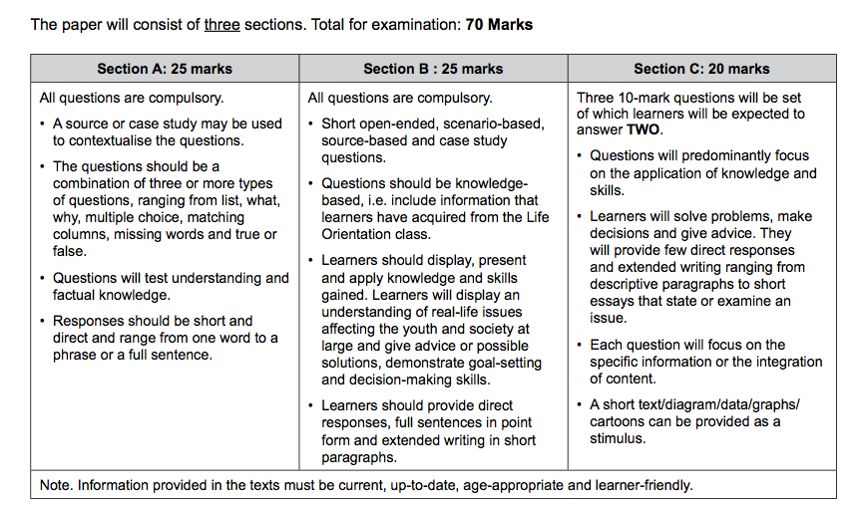
NOTE: This examination will comprehensively address the content, knowledge and skills covered during the first and second terms (CAPS, Outline for
Examinations, pg. 28)

SECTION A: 25 MARKS
Answer ALL the questions in this section.
Question 1: Multiple Choice (5 marks)
Choose the correct answer and write down the letter only.
1.1. Which of the following is an example of a ‘practical activity’:

A. Doing homework
B. Listening to your teacher
C. Doing experiments
D. Doing mind maps (1)

1.2. ‘Analytical skills’ refers to:

A. Using information to solve problems
B. Working out how things work
C. Seeing how different ideas fit together
D. Saying what you think about something (1)

1.3. ‘Evaluations skills’ refers to:

A. Using information to solve problems
B. Working out how things work
C. Seeing how different ideas fit together
D. Giving a judgement about something (1)

1.4. If a learner wanted to take Design as a subject in Grade 10, it would be
expected for him / her to enjoy the following learning area in Grades 8
and 9:

A. Life Orientation
B. Social Science
C. Natural Science
D. Arts and Culture (1)

1.5. If a learner wanted to take History as a subject in Grade 10, it would be
expected for him / her to enjoy the following learning area in Grades 8
and 9:

A. Life Orientation
B. Social Science
C. Natural Science
D. Arts and Culture
(1)
(5x1)(5)
(All Lower Order)

Question 2: Give an explanation of a concept: (5 marks)

Provide a definition or explanation of the concept:

2.1 Explain what is meant by a “compulsory” subject (1)
2.2 What does the term “comprehension skills” mean? (1)
2.3 Explain what it means to “evaluate” something. (1)
2.4. What does it mean when you are able to master a particular skill? (1)
2.5. What is the “decision-making process” with regards to career choice? (1)
(5)
(All Lower Order)

Question 3: Matching Columns (5 marks)
Match the statements in COLUMN A that best matches each concept in Column B. Write only the appropriate letter (A - G) next to the number (3.1 – 3.5).

Column A | Column B
3.1. Practical learning activities | A. Something that you have to do and is not optional, you have no choice.
3.2. Theoretical learning activities | B. Learn facts and knowledge before you can apply them.
3.3. Individual activities | C. Taking part in ‘hands-on’ tasks and learning by experimenting
3.4. Group activities | D. Allow you to work at your own pace and apply your own learning style to your work
3.5. Compulsory activities | E. To become good at something
 | F. Interactive, where you learn how to work with others and from others
 | G. Using mind maps and other thinking skills
(5x1)(5)
(All Lower Order)

Question 4: Answer the following questions based on the Case Study below:
(10 marks)

Relationships between interests and abilities and performance in subjects:

I have a very curious mind and I like to solve problems. I like to understand how things work and am quite happy to take things apart to figure that out. I think that this has helped me in Technology.

Source: Anonymous

4.1 Identify ONE reason why the person in the case study above enjoys
Technology related subjects (1x2)(2)
(Middle Order)

4.2 Name TWO compulsory subjects that you will need to take up until
Grade 12. (2x1)(2)
(Lower Order)
4.3 Discuss the relationship between interests and abilities and the performance
in school subjects. (2x2)(4)
(Middle Order)
4.4. Recommend ONE way how someone can improve their performance in a
subject that they don’t enjoy. (1x2)(2)
(Higher Order)
(10)
TOTAL SECTION A: 25 MARKS

SECTION B: 25 MARKS

Answer ALL the questions in this section. Write your answers in full sentences.
Question 5: Provide the Term (5 marks)
Give the term for EACH of the following descriptions. Write only the term next to the question numbers (5.1. to 5.5.).
5.1. Type of academic skill where you are able to see how different ideas
fit together. (1)
5.2. Concentrating, reading, comprehension, listening is referred to as? (1)
5.3. Groupings of jobs or work that is similar in nature and / or scope. (1)
5.4. Intense emotion and strong feeling towards a particular activity. (1)
5.5. Process of thorough examination of who you are and what your abilities and
interests are (1)
(5)
(All Lower Order)

Question 6: (5 marks)
Fill in the missing words or concepts from the following statements or sentences:

6.1. An important part of succeeding in your school studies is to identify
your interests and ____________ and apply them to your school work. (1)
6.2. It is not always easy to ____________ yourself to study subjects that you
find boring or difficult but the amount of time and effort you put into it will
definitely pay off. (1)
6.3. At school you learn different types of thinking and learning _________
and you apply them to your subjects. (1)
6.4. Individual activities allow you to work at your own pace and apply your
own learning ____________ . (1)
6.5. It is much better to plan your ____________ so that you can be
in charge of your life and know where you are heading (1)
(5)
(All Lower Order)

Question 7: (10 marks)

7.1. Give TWO reasons why it might be important for you to work out your abilities
and interests with regards to your school subjects . (2x1)(2)
(Lower Order)
7.2. List TWO ways how a person can identify his or her abilities and interests. (2x1)(2)
(Lower Order)
7.3. Discuss ONE way how to master your skills in a particular subject. (1x2)(2)
(Middle Order)

7.4. Determine why it is important to figure out your strengths and abilities as it
relates to your school subjects. (1x2)(2)
(Higher Order)
7.5. Advise ONE way to improve your performance in subjects that you do not
enjoy. (1x2)(2)
(Higher Order)
(10)
Question 8: Give advice (5 marks)
How to make Difficult Decisions
Your decisions make you - Whether you’re selling them as an entrepreneur, marketer, writer, or any other kind of knowledge worker, or facing a serious crossroads in your personal life, the choices you make today define your future.
So it’s no wonder that when it comes to our growth and success, few skills are more important than the ability to make good decisions. Trivial decisions like what shirt to wear or what brand of toothpaste to buy may be easy enough to make—though some of us spend hours on research to make those decisions. It's the gray area problems that are the hardest to resolve—ones where despite all the research you’ve done and experts you’ve spoken to, the answer is still unclear.
[Adapted from https://zapier.com/blog/difficult-decisions/ Accessed June, 9 2020]

8.1. Briefly explain one step you would follow to apply the decision making
process to choosing a career category (1)
(Lower Order)

8.2. Discuss TWO practical strategies that can assist you with the decision making
process. (2x2)(2)
(Middle Order)
(5)

[TOTAL SECTION B: 25 MARKS]

SECTION C: 20 MARKS

Remember to answer any TWO questions in this section. Write your answers in full sentences
Question 9: (10 marks)
Examine the extract below and follow the instructions below.

Understanding Decision Making
Despite the far-reaching nature of the decisions, not all decisions have major consequences or even require a lot of thought. For example, before you come to class, you make simple and habitual decisions such as what to wear, what to eat, and which route to take as you go to and from home and school. You probably do not spend much time on these mundane decisions. These types of straightforward decisions are termed programmed decisions, or decisions that occur frequently enough that we develop an automated response to them. On the other hand we also have important, life changing decisions that we need to make and these require less of a programmed response and require a more thoughtful process.
[Adapted from https://saylordotorg.github.io/text_human-relations/s12-01-understanding-decision-making.html Accessed June 09, 2020]

- Name TWO reasons why people struggle with decision-making. (2x1)(2)
(Lower Order)

- Discuss TWO reasons why it is important to make use of the decision
making process when you choose a career. (2x2)(4)
(Middle Order)

- Suggest TWO strategies that can assist someone who struggles to make decisions. (2x2)(4)
(Higher Order)
(10)

Question 10: (10 marks)
Read the extract below and use the bullet points that follow to write your essay:

Why practical knowledge is more important than theoretical knowledge?

Can you imagine someone teaching you to swim or drive a vehicle, within four walls of a classroom? It is impossible!! You have to get into the water to learn swimming and you have to be out on the road to learn driving. Some subjects are skill based and practice oriented. Practical work includes experiments in laboratories, study tours, projects, assignments etc.

[Adapted from https://medium.com/@srespune/why-practical-knowledge-is-more-important-than-theoretical-knowledge-f0f94ad6d9c6 Accessed 09 June 2020]

- Explain the difference between practical and theoretical subjects (1+1)(2)
(Lower Order)

- Discuss TWO benefits how practical subjects / practical components
of subjects may assist learners to learn (2x2)(4)
(Middle Order)
- Determine TWO reasons why theoretical knowledge and practical
abilities are of equal importance. (2x2)(4)
(Higher Order)
(10)

Question 11: (10 marks)
Study the image on Bloom's Taxonomy below and answer the questions that follow:
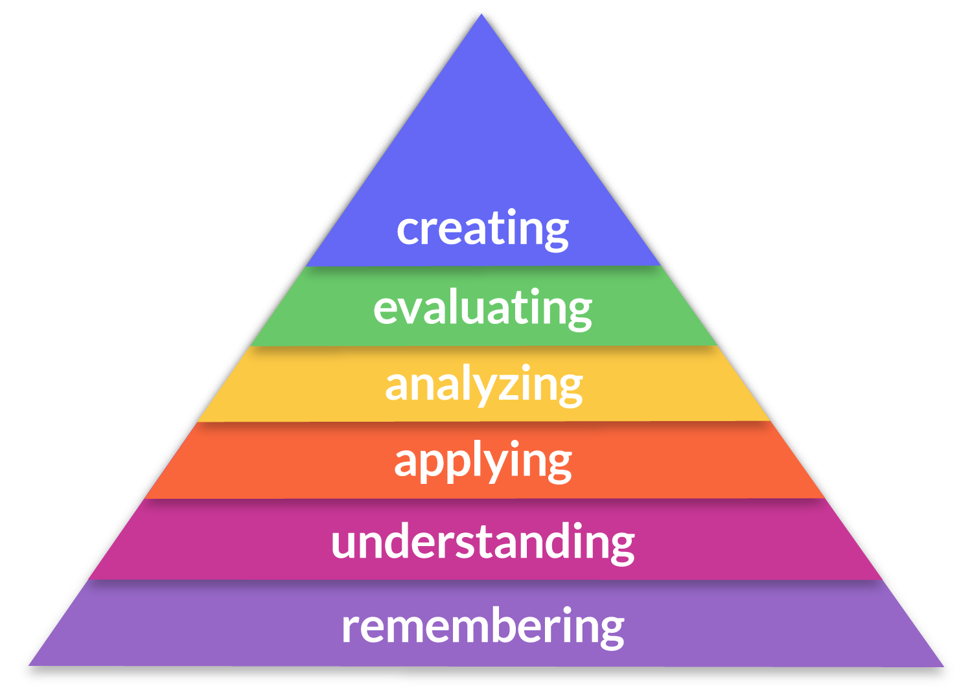

https://medium.com/@theo_dawson/blooms-taxonomy-vcol-the-lectical-scale-d7851729ab2b [Accessed 09 June 2020]

- Define “applying / application” as an examination question action word.
(1x2)(2)
(Lower Order)
- Discuss TWO reasons why it is important to know the different
examination question instruction words in your examinations. (2x2)(4)
(Middle Order)

- Evaluate TWO reasons why you think teachers give you different
types of examination questions and different levels of questions in your
examinations. (2x2)(4)
(Higher Order)

(10)

[TOTAL SECTION C: 20 MARKS]

MEMORANDUM
SECTION A: 25 MARKS
Answer ALL the questions in this section.
Question 1: Multiple Choice (5 marks)
Choose the correct answer and write down the letter only.
1.1. Which of the following is an example of a ‘practical activity’:

A. Doing homework
B. Listening to your teacher
C. Doing experiments
D. Doing mind maps (1)

1.2. ‘Analytical skills’ refers to:

A. Using information to solve problems
B. Working out how things work
C. Seeing how different ideas fit together
D. Saying what you think about something (1)

1.3. ‘Evaluations skills’ refers to:

A. Using information to solve problems
B. Working out how things work
C. Seeing how different ideas fit together
D. Giving a judgement about something (1)

1.4. If a learner wanted to take Design as a subject in Grade 10, it would be
expected for him / her to enjoy the following learning area in Grades 8
and 9:

A. Life Orientation
B. Social Science
C. Natural Science
D. Arts and Culture (1)

1.5. If a learner wanted to take History as a subject in Grade 10, it would be
expected for him / her to enjoy the following learning area in Grades 8
and 9:

A. Life Orientation
B. Social Science
C. Natural Science
D. Arts and Culture (1)
(5x1)(5)
(All Lower Order)

Question 2: Give an explanation of a concept: (5 marks)

Provide a definition or explanation of the concept:

2.1 Explain what is meant by a “compulsory” subject (1)
There is no choice option ✓
OR
It is part of subject pack up until Grade 12 that are not optional / something that you have to do ✓
2.2 What does the term “comprehension skills” mean? (1)
Ability to explain and understand in your own words what something means ✓

2.3 Explain what it means to “evaluate” something. (1)
To examine and judge carefully / taking the pro’s and con’s into consideration ✓
2.4. What does it mean when you are able to master a particular skill? (1)
That you are able to do it really / exceptionally well ✓
OR
To become really good at it ✓
OR
You are an expert in that skill ✓
2.5. What is the “decision-making process” with regards to career choice? (1)
It refers to the steps we need to take when faced with a big decision ✓
OR
Different options about something and we need to make choice ✓ (5)
(All Lower Order)

Question 3: Matching Columns (5 marks)
Match the statements in COLUMN A that best matches each concept in Column B. Write only the appropriate letter (A - G) next to the number (3.1 – 3.5).

Column A | Column B
3.1. Practical learning activities (C) | A. Something that you have to do and is not optional, you have no choice.
3.2. Theoretical learning activities (B) | B. Learn facts and knowledge before you can apply them.
3.3. Individual activities (D) | C. Taking part in ‘hands-on’ tasks and learning by experimenting
3.4. Group activities (F) | D. Allow you to work at your own pace and apply your own learning style to your work
3.5. Compulsory activities (A) | E. To become good at something
 | F. Interactive, where you learn how to work with others and from others
 | G. Using mind maps and other thinking skills
(5x1)(5)
(All Lower Order)

Question 4: Answer the following questions based on the Case Study below:
(10 marks)

Relationships between interests and abilities and performance in subjects:

I have a very curious mind and I like to problem-solve. I like to understand how things work and am quite happy to take things apart to figure that out. I think that this has helped me in Technology.

Source: Anonymous

4.1 Identify ONE reason why the person in the case study above enjoys
Technology related subjects (1x2)(2)
(Lower Order)
Any relevant answer for TWO marks
Technology related subjects involves figuring how things fit together ✓ which is in line with the person’s ability and interests ✓

4.2 Name TWO compulsory subjects that you will need to take up until
Grade 12. (2x1)(2)
(Lower Order)
Any TWO of the below or any relevant answers for ONE mark each
- Home language ✓ and an additional language ✓
- Life Orientation ✓
- Mathematics or Mathematical Literacy ✓
4.3 Discuss the relationship between interests and abilities and the performance
in school subjects. (2x2)(4)
(Middle Order)
Any TWO of the below or any relevant answers for TWO marks each
(i.e. ONE mark for statement and ONE mark for qualifier / explanation)
You are more likely to do well in subjects that match your interests and abilities ✓ If you have natural ability then work is often easier to understand and obtain good marks ✓
if your abilities and interests is not in line with your natural ability or interests✓ you may struggle with the subject and it may be hard to be motivated and do well. ✓
If you have a particular interest in a subject then you are more likely to enjoy it ✓ and be more motivated to work hard and achieve good marks ✓
4.4. Recommend ONE way how someone can improve their performance in a
subject that they don’t enjoy. (1x2)(2)
(Higher Order)
Any ONE of the below or any relevant answer for TWO marks
(i.e. ONE mark for statement and ONE mark for qualifier / explanation)
Take it in small steps ✓ by trying to identify small goals that you can achieve and slowly build up your confidence ✓

Think about the reasons why you chose the subject and motivate yourself to do as well as possible✓ because these marks can affect your overall year mark ✓

Consider extra lessons / tutorials or something similar to improve your skills in that subject ✓ if you do better you might start being more motivated and enjoy it more ✓
(10)
[TOTAL SECTION A: 25 MARKS]

SECTION B: 25 MARKS

Answer ALL the questions in this section. Write your answers in full sentences.
Question 5: Provide the Term (5 marks)
Give the term for EACH of the following descriptions. Write only the term next to the question numbers (5.1. to 5.5.)
5.1. Type of academic skill where you are able to see how different ideas
fit together. (1)
Synthesis / synthesising skills ✓

5.2. Concentrating, reading, comprehension, listening is referred to as? (1)

Learning skills ✓

5.3. Groupings of jobs or work that is similar in nature and / or scope. (1)

Career categories ✓

5.4. Intense emotion and strong feeling towards a particular activity. (1)

Passion ✓

5.5. Process of thorough examination of who you are and what your abilities and
interests are (1)

Exploration / self discovery / self awareness / self reflection ✓
(5)
(All Lower Order)

Question 6: (5 marks)
Fill in the missing words or concepts from the following statements or sentences:

6.1. An important part of succeeding in your school studies is to identify
your interests and ____________ and apply them to your school work. (1)
abilities / talents / strengths / aptitudes ✓

6.2. It is not always easy to ____________ yourself to study subjects that you
find boring or difficult but the amount of time and effort you put into it will
definitely pay off. (1)
motivate / push ✓
6.3. At school you learn different types of thinking and learning _________
and you apply them to your subjects. (1)
Skills ✓
6.4. Individual activities allow you to work at your own pace and apply your
own learning ____________ . (1)
Style ✓
6.5. It is much better to plan your ____________ so that you can be
in charge of your life and know where you are heading. (1)
goals ✓
(5)
(All Lower Order)
Question 7: (10 marks)

7.1. Give TWO reasons why it might be important for you to work out your abilities
and interests with regards to your school subjects . (2x1)(2)
(Lower Order)

Any TWO of the below or any relevant answers for ONE mark each
- They can affect your performance in the subjects that you are doing ✓
- You are more likely to excel in subjects that you are good at and enjoy and vice versa ✓
- Subjects that you have a natural ability in might be easier to do well in ✓

7.2. List TWO ways how a person can identify his or her abilities and
interests. (2x1)(2)
(Lower Order)
Any TWO of the below or any relevant answers for ONE mark each
- Do an activity / exercise that highlights your interests and abilities ✓
- Go for an assessment with a career counsellor who can advise you ✓
- Speak to people that know you well and ask them for their suggestions ✓

7.3. Discuss ONE way how to master your skills in a particular subject. (1x2)(2)
(Middle Order)
Any ONE of the below or any relevant answer for TWO marks
(i.e. ONE mark for statement and ONE mark for qualifier / explanation)

Practice ✓ the more you do something the better one gets at it ✓

Ask for help or have extra lessons or assistance✓ with a particular skill that you may to improve in ✓

7.4. Determine why it is important to figure out your strengths and
abilities as it relates to your school subjects. (1x2)(2)
(Higher Order)
Any ONE of the below or any relevant answer for TWO marks
(i.e. ONE mark for statement and ONE mark for qualifier / explanation)
It is important so that you can apply your strengths and abilities to your school work ✓ It will help you to identify which subjects you do well in and which ones you will need to put in a little more effort ✓
It is important to realise that not everyone is good at all subjects✓ and that each person has their own unique abilities and strengths which relates to certain subjects✓
Your subject choices often determines your career choice, ✓ so it is important to know where your strengths and weaknesses lie✓

7.5. Advise ONE way to improve your performance in subjects that you do not
enjoy. (1x2)(2)
(Higher Order)
Any ONE of the below or any relevant answer for TWO marks
(i.e. ONE mark for statement and ONE mark for qualifier / explanation)

Motivate yourself to do as well as possible ✓ because these marks can affect your overall year mark ✓
Identify small goals that you can achieve✓ and slowly build up your confidence ✓
Take it in small steps ✓, small successes leads to bigger accomplishment and better performance ✓
(10)

Question 8: Give advice (5 marks)
How to make Difficult Decisions
Your decisions make you - Whether you’re selling them as an entrepreneur, marketer, writer, or any other kind of knowledge worker, or facing a serious crossroads in your personal life, the choices you make today define your future.
So it’s no wonder that when it comes to our growth and success, few skills are more important than the ability to make good decisions. Trivial decisions like what shirt to wear or what brand of toothpaste to buy may be easy enough to make—though some of us spend hours on research to make those decisions. It's the gray area problems that are the hardest to resolve—ones where despite all the research you’ve done and experts you’ve spoken to, the answer is still unclear.
[Adapted from https://zapier.com/blog/difficult-decisions/ Accessed June, 9 2020]

8.1. Briefly explain one step you would follow to apply the decision making
process to choosing a career category (1)
(Lower Order)
Any ONE of the below or any relevant answer for ONE mark
- Identify what you need to decide - what career category you’d like to pursue ✓
- Gather information about your option - do research on what categories exist and how they link up with your interests ✓
- Evaluate your options and decide which suits you - choose the option that best suits your interests and abilities after your research ✓

8.2. Discuss TWO practical strategies that can assist you with the decision
making process. (2x2)(4)
(Middle Order)

Any TWO of the below or any relevant answers for TWO marks each
(i.e. ONE mark for statement and ONE mark for qualifier / explanation)
Complete activity sheets at school✓ that help identify strengths and abilities ✓
Research online to find out about the different career categories ✓ so that you are more informed about the options that are available and the ones you might prefer ✓

Consult with an adult / counselor / teacher ✓ to gather as much information as possible✓
Go through all the information that you have researched ✓ and take out the categories that apply to you ✓
(5)
[TOTAL SECTION B: 25 MARKS]

SECTION C: 20 MARKS

Remember to answer any TWO questions in this section. Write your answers in full sentences
Question 9: (10 marks)
Examine the extract below and follow the instructions below.

Understanding Decision Making
Despite the far-reaching nature of the decisions, not all decisions have major consequences or even require a lot of thought. For example, before you come to class, you make simple and habitual decisions such as what to wear, what to eat, and which route to take as you go to and from home and school. You probably do not spend much time on these mundane decisions. These types of straightforward decisions are termed programmed decisions, or decisions that occur frequently enough that we develop an automated response to them. On the other hand we also have important, life changing decisions that we need to make and these require less of a programmed response and require a more thoughtful process.
[Adapted from https://saylordotorg.github.io/text_human-relations/s12-01-understanding-decision-making.html Accessed June 09, 2020]

- Name TWO reasons why people struggle with decision-making. (2x1)(2)
(Lower Order)
Any TWO of the below or any relevant answers for ONE mark each
- They are fearful of making the wrong decision ✓
- They are worried they might make a mistake and live with regret ✓
- Some people are afraid of the impact or effect that their decision might have on other people ✓
- Some people are worried about other people’s thoughts and opinions on their decision making ✓
- They feel overwhelmed because they don’t have enough information to make the right decision for them ✓

- Discuss TWO reasons why it is important to make use of the decision
making process when you choose a career. (2x2)(4)
(Middle Order)
Any TWO of the below or any relevant answers for TWO marks each
(i.e. ONE mark for statement and ONE mark for qualifier / explanation)
It is important to make this decision carefully and not just automatically ✓ so that you make sure that it is the right decision for you ✓
It is important to do the reflection and research so that you know what is available and what is the best option for your interests and abilities ✓ so that you are informed in your decision making and feel confident with your choice ✓
Likelihood to make the right choice for you is greater✓ when you have gone through the steps and know all of your options and relate those to what is best for you✓

- Suggest TWO strategies that can assist someone who struggles to make decisions. (2x2)(4)
(Higher Order)
Any TWO of the below or any relevant answers for TWO marks each
(i.e. ONE mark for statement and ONE mark for qualifier / explanation)
Teach them on the decision making process and help them to apply it ✓ so that they feel like they have given this decision a lot of thought and research and are happy with their final outcome ✓
Practice making decisions✓ the more you practice decision making the less anxious about decision making you will become ✓
Talk about the “what if scenarios”✓ so that you can verbalise what concerns you may have about making decisions✓
Get an objective opinion from someone that knows you✓ but who is also emotionally detached from the situation and who can look at the decision from all angles and help you✓
Learn to back your decisions - once you’ve made a decision stick to it and learn to see it through ✓ so that you can gain more confidence in the choices that you have made ✓ (10)
Question 10: (10 marks)
Read the extract below and use the points that follow to write your essay:

Why practical knowledge is more important than theoretical knowledge?

Can you imagine someone teaching you to swim or drive a vehicle, within four walls of a classroom? It is impossible!! You have to get into the water to learn swimming and you have to be out on the road to learn driving. Some subjects are skill based and practice oriented. Practical work includes experiments in laboratories, study tours, projects, assignments etc.

[Adapted from https://medium.com/@srespune/why-practical-knowledge-is-more-important-than-theoretical-knowledge-f0f94ad6d9c6 Accessed 09 June 2020]

- Explain the difference between practical and theoretical subjects (1+1)(2)
(Lower Order)

Any relevant answer for ONE mark each
(i.e. ONE mark for practical and ONE mark for theoretical)
Practical - is more hands on / skills based and application of knowledge, where you are required to do something to learn ✓ whereas
Theoretical subjects - are more theory / factual / knowledge based / they are more academic in nature and require more traditional learning ✓
- Discuss TWO benefits how practical subjects / practical components
of subjects may assist learners to learn. (2x2)(4)
(Middle Order)
Any TWO of the below or any relevant answers for TWO marks each
(i.e. ONE mark for statement and ONE mark for qualifier / explanation)
The practical components help consolidate that which you have learnt in theory ✓ students can grow in confidence, gaining understanding which often lead to independent thinkers✓
It promotes experiential learning ✓ which aids a person with remembering and the mastery of skill ✓
It allows learners to apply that which they have learnt ✓ practical work compliments theory work ✓
Practical work often involves group work ✓ which encourages collaboration and teamwork skills✓

- Determine TWO reasons why theoretical knowledge and practical
abilities are of equal importance. (2x2)(4)
(Higher Order)
Any TWO of the below or any relevant answers for TWO marks each
(i.e. ONE mark for statement and ONE mark for qualifier / explanation)
Theory creates a strong basis for practical work ✓ all practical work requires some basis of theory in order to be effective and to create a foundation of understanding for practice / application ✓

Theory and practical knowledge should work hand in hand ✓ they each have a role to play and one is not more important than the other ✓

Having just theoretical knowledge but the inability to apply that is not the ideal ✓ you need to have balance with the two together ✓

Some people excel more with theoretical knowledge and others practical ✓ each of these have a practical use and role to play in society in a variety of jobs and needs - therefore we should not place more emphasis on one than the other ✓

(10)

Question 11: (10 marks)
Study the image on Bloom's Taxonomy below and answer the questions that follow:

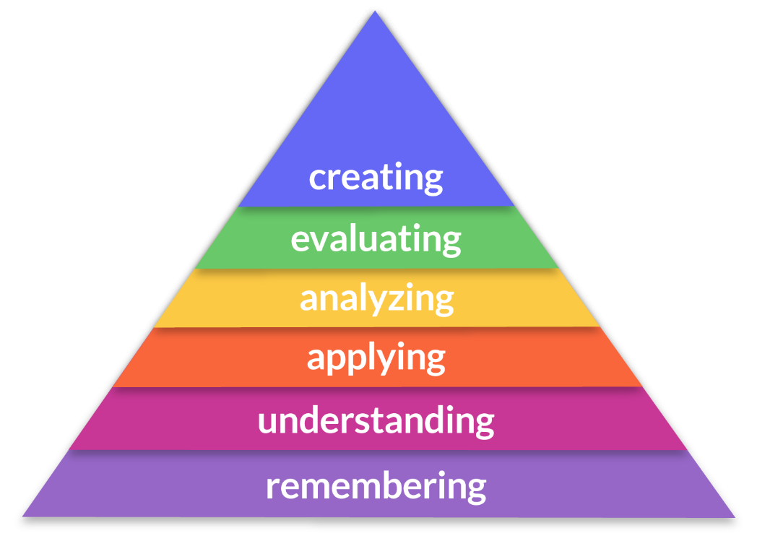

https://medium.com/@theo_dawson/blooms-taxonomy-vcol-the-lectical-scale-d7851729ab2b [Accessed 09 June 2020]

- Define “applying / application” as an examination question action verb.
(1x2)(2)
(Lower Order)
Any valid answer for TWO marks
It refers to the ability to apply or use the knowledge / content ✓ and using information to solve problems in certain contexts or situations ✓

- Discuss TWO reasons why it is important to know the different
examination question instruction words in your examinations. (2x2)(4)
(Middle Order)

Any TWO of the below or any relevant answers for TWO marks each
(i.e. ONE mark for statement and ONE mark for qualifier / explanation)
So that you can fully understand the question ✓ and therefore understand what the examiner is asking and give the appropriate response ✓

It is important to understand the meaning of the instruction verb that the question is asking ✓ so that you don’t lose marks and get the full marks allocated to the question ✓
The examination question might be asking for a different level of thinking ✓ knowing what the questions is asking helps you to answer at the level that is being asked ✓

To avoid confusion or misinterpreting the question ✓ and giving the incorrect answer ✓

You will be more confident in answering the questions, ✓ that will help you to cope better in taking an exam. ✓

- Evaluate TWO reasons why you think teachers give you different
types of examination questions and different levels of questions in your
examinations. (2x2)(4)
(Higher Order)

Any TWO of the below or any relevant answers for TWO marks each
(i.e. ONE mark for statement and ONE mark for qualifier / explanation)
It helps to measure how much you have learned✓ as well as how well you are able to use that content in different situations and contexts in a variety of ways ✓

It gives the teacher an idea where the possible gaps are ✓ and create opportunities for you to practice again. ✓

It is important to test different levels of one’s thinking skills ✓ and shows a more thorough understanding of the content ✓

It helps teachers identify where learners are at in terms of their understanding of the content ✓ which learners require further assistance or have mastered the higher order thinking content ✓

Different levels are asked to cater for different learning abilities ✓ it shows which levels learners are able to do and which levels the teacher still needs to work on with the class ✓
Examinations have the major role in providing necessary qualities in life such as hard work, patience, creativeness✓ - different levels and types of questions prepare you just for that. ✓
(10)
[TOTAL SECTION C: 20 MARKS]

