GRADE 8 LIFE ORIENTATION
TOPIC:
WORLD OF WORK (WOW)
Term 3 & 4
60 / 90 MINUTES 2021 70 MARKS
NOTE TO TEACHERS: This Teenactiv paper should be considered as a bank of questions for one topic from which teachers can choose when creating their own paper. Remember, this is a bank of questions and therefore may contain some overlap. Please keep this in mind when selecting questions for your paper.
Ensure your paper covers EACH topic covered in terms 3 & 4.
The controlled test will comprehensively address the content, knowledge and skills covered during the third and fourth terms and in the Recovery ATP.
Use the table below to help you when choosing your questions.

Weighting (suggested) | Weighting (Actual) | Cognitive level | Bloom’s taxonomy
40% (28 marks) | 28 marks | Lower Order | Level 1&2
40% (28 marks) | 28 marks | Middle Order | Level 3&4
20% (14 marks) | 14 marks | Higher Order | Level 5&6
Section A: 25 marks | Section B: 25 marks | Section C: 20 marks
All questions are compulsory.  - A source or case study may be used to contextualize the questions.  - The questions should be a combination of three or more types of questions ranging from list, what, why, multiple choice, matching columns and missing words.  - Questions will test understanding and factual knowledge.  - Responses should be short and direct and rage from one word to a phrase or a full sentence. | All questions are compulsory  - Short open ended, scenario based, source based and case study questions.  - Questions should be knowledge based i.e. include information that learners have acquired from the Life Orientation class  - Learners should display, present and apply knowledge and skills gained. Learners will display an understanding of real-life issues affecting the youth and society at large and give advice of possible solutions, demonstrate goal setting and decision-making skills  - Learners should provide direct responses, full sentences in point form and extended writing in short paragraphs. | Three 10-mark questions will be set of which learners will be expected to answer TWO.  - Questions will predominantly focus on the application of knowledge and skills  - Learners will solve problems, make decisions and give advice. They will provide few direct responses and extended writing ranging from descriptive paragraphs to short essays that state or examine an issue.  - Each question will focus on the specific information or the integration of content.  - A short text/diagram/  data/graphs/cartoons can be provided as stimulus.
Note. Information provided in the texts must be current, up-to-date, age-appropriate and learner- friendly.
The paper will consist of three sections. Total for Controlled Test: 70 Marks

SECTION A (Compulsory)
Answer all the questions in this section.
Question 1
Various options are provided as possible answers to the following questions. Choose the correct answer and write only the letter (A-D) next to the question number (1.1 to 1.5) in the answer book, for example 1.1.6. D.
1.1. Evaluation skills are:

A. skills used to make a judgement about something
B. skills used to think practically about something.
C. skills used to solve a problem by creating something.
D. skills used to figure out how things work together. (1)

1.2. If a learner enjoys Arts and Culture in Grade 9, what subject would you advise
them to take in Grades 10, 11 and 12?

A. Business Studies
B. Life Science
C. Consumer Studies
D. Design (1)

1.3. Practical learning involves

A. studying information in order to apply it.
B. taking part in hands-on activities
C. working at one’s own pace and level.
D. group work with other learners.
(1)
1.4. This subject is compulsory up to matric:

A. Accounting
B. Life Orientation
C. Business Studies
D. Consumer Studies
(1)
1.5. Aptitude refers to

A. A learner’s personal learning style.
B. A learner’s knack for something.
C. A learner’s ability to make decisions.
D. A learner’s ability to study effectively.
(5x1)[5]
(All Lower Order)

Question 2

Complete the following sentences by filling in the missing word(s). Write only the word(s) next to the question number (2.1 to 2.5) in the answer book.

career categories; investigative; practical; allowed;
artistic; synthesis; informed; abilities; evaluate;

2.1 _________ is a type of academic skill where you are able to see how different ideas
fit together. (1)
2.2 Consumer Studies is a school subject that includes both a ________ component and
a theoretical component. (1)
2.3 A / An _________ career would include fields of study such as: Information
Technology, Life Sciences, History, Mathematics, Mathematical Technology and
Physical Sciences. (1)

2.4. A / An ___________ decision is a decision based on research and advice. (1)
2.5. A learner is generally more motivated in subjects that are aligned with his / her
______________ and interests. (1)
(5x1)[5]
(All Lower Order)

Question 3
Choose a description from COLUMN B that matches the item / phrase in Column A. Write only the letter (A - G) next to the question number (3.1 to 3.5) in the answer book.

Column A | Column B
3.1 Practical learning  activities | A. Activities that involve interviewing others for their opinions.
3.2 Theoretical learning  activities | B. Activities often included in subjects such as Consumer Studies  where hands-on learning is a component.
3.3 Group activites | C. Activities that learners complete on their own.
3.4 Individual activities | D. Activities that involve learning content and information from  textbooks.
3.5 Experimental  activities | E. Activities that involve the use of social media.
F. Activities where one is expected to work with others to achieve a
learning outcome.
 | G. Activities done to test a theory or scientific procedure.
(5x1)[5]
(All Lower Order)

Question 4
Answer the following questions by writing the answer next to the question numbers
(4.1 to 4.6) in the answer book. Write your answers in full sentences.
4.1 Give TWO reasons why it is important to adhere to the COVID-19 protocols (2x1)(2)
(Lower Order)
4.2 What is a career category? (1)
(Lower Order)
4.3 What is the difference between having an ability and having a talent? (2x1)(2)
(Lower Order)
4.4 Explain the term passion as used in the career choices process (1x1(1)
(Lower Order)

4.5 Explain why self-exploration is important when you choose subjects which often lead
to a future career (1x2)(2)
(Middle Order)

4.6 Explain ONE benefit of the decision making process when it comes to choosing
a career. (1x2)(2)
(Middle Order)
[10]

[TOTAL SECTION A: 25 MARKS]

SECTION B (Compulsory)
Answer all the questions in this section. Write in full sentences

Question 5
Study the cartoon and answer the questions that follow.
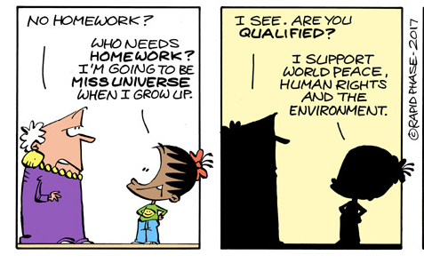
http://personal.ee.surrey.ac.uk/cgi-bin/L.Wood/madam-and-eve-comic.cgi?shown=4&comic=6554
[Accessed on 9 Sep 2021]

5.1 Provide a definition of the social career category. (1)
(Lower Order)
5.2 List TWO reasons why Thandi would be suited to work in the social career category.
(2x1)(2)
(Lower Order)
5.3 Describe ONE other social career that Thandi could choose (1x2)(2)
(Middle Order)
[5]

Question 6
Read the extract below and answer the questions that follow.


South Africa ranked last out of 50 countries in the 2016 Progress in International Reading Literacy (PIRLS) study which tested reading comprehension of learners in their fourth year of primary schooling. The study found that 78% of South African pupils at this level could not read for meaning. South Africa’s reading crisis is a topic of ongoing debate and several strategies for improvement have been proposed: promoting a culture of reading; encouraging parents to read to their children; making books accessible in schools and improving initial teacher education.

Reading for meaning is important for improved performance in both practical and theoretical subjects taught at high schools.

[Adapted from: https://theconversation.com/south-africas-reading-crisis-focus-on-the-root-cause-not-the-peripherals-96129
Accessed on 9 Sep 2021]
6.1 Identify TWO ways you can master your skills in reading. (2x1)(2)
(Lower Order)
6.2 Explain why someone who takes theoretical subjects should ensure they
are able to read for meaning. (1x2)(2)
(Middle Order)
6.3 Discuss how practical subjects and theoretical subjects are both important. (2x2)(4)
(Middle Order)
6.4 Advise ONE way to improve your performance in a subject that you do not enjoy.
(apart from developing your reading skills). (1x2)(2)
(Higher Order)
[10]

Question 7
Read to the extract below and answer the questions that follow.
DECISION MAKING AND CAREERS


The career decision-making process could be made simpler by implementing well-known career development theories that are applicable even to this day.

The theory of career development seeks to help individuals identify their potential vocation by helping them consider their talents, shortcomings, opportunities, and threats. It also focuses on where, why, and for what reasons career counseling, education, guidance, and other career interventions are needed.

https://www.indiatoday.in/education-today/featurephilia/story/how-to-make-a-career-decision-using-three-career-development-theories-1768950-2021-02-13
[Accessed on 9 Sep 2021]

7.1 Identify TWO of the decision-making steps that you could apply when choosing a career.
(2x1)(2)
(Lower Order)
7.2 Explain TWO reasons why it is important to gather information about careers
before making a final decision. (2x2)(4)
(Middle Order)
7.3 Discuss ONE negative outcome if one does not take interest and passion into
consideration when deciding on a career. (1x2)(2)
(Middle Order)
7.4 Recommend ONE way you could improve your ability to make an informed decision
about your career choice. (1x2)(2)
(Higher Order)
[10]

[TOTAL SECTION B: 25 MARKS]

SECTION C (Choice)
Answer any TWO questions in this section.
Your responses must consist of paragraphs. Marks will only be allocated for responses written in full sentences.

Question 8

Study the diagram below and answer the questions that follow.

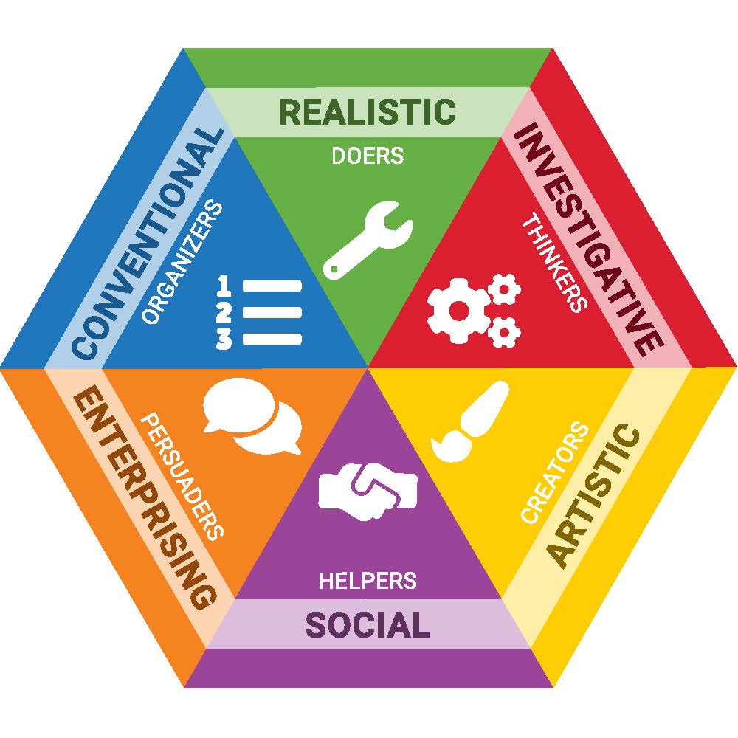

https://nccareers.org/find-career/career-cluster-match/education-and-training [Accessed on 9 Sep 2021]

Write paragraphs on career categories.
Use the following as guideline:

- Define the artistic career category. (1x2)(2)
(Lower Order)

- Discuss TWO reasons why you think it is necessary for learners to know
their career category. (2x2)(4)
(Middle Order)

- Critically discuss TWO careers that will suit people who want to work in the artistic field. (2x2)(4)
(Higher Order)
[10]

Question 9

Study the scenario below and answer the questions that follow.


Assume the role of the career counsellor at your school and offer advice to Grade 8 learners regarding subject and career choices.

https://unsplash.com/photos/LQ1t-8Ms5PY
[Accessed on 9 Sep 2021]

Write paragraphs on subject and career choices.
Use the following as guideline.

- Identify TWO personal aspects you should consider when deciding on a career.
(2x1)(2)
(Lower Order)

- Explain the relationship between knowledge of various school subjects and
potential careers. (2x2)(4)
(Middle Order)

- What advice do you have for Grade 9 learners on choosing subjects for Grade 10?
(2x2)(4)
(Higher Order)

[10]

Question 10

Read the extract below and answer the questions that follow.

The National Curriculum Statement Grades R-12 gives expression to the knowledge, skills and values worth learning in South African schools. This curriculum aims to ensure that children acquire and apply knowledge and skills in ways that are meaningful to their own lives.

https://www.education.gov.za/Curriculum/NationalCurriculumStatementsGradesR-12.aspx
[Accessed on 01 Sep 2021]

Write an paragraphs on the skills for different subjects.

Use the following as guideline.

- Identify TWO learning skills that mathematics or maths literacy require. (2x1)(2)
(Lower Order)

- Discuss how the skills taught in Life Orientation can equip one for life. (2x2)(4)
(Middle Order)

- Recommend how a learner who is battling with learning skills needed for
a specific subject can deal with the problem. (2x2)(4)
(Higher Order)
[10]

[TOTAL SECTION C: 20 MARKS]
TOTAL = 25 + 25 + 20 = 70

MEMORANDUM

SECTION A

Question 1
  - A ✓
  - D ✓
  - B ✓
  - B ✓
  - B ✓ (5x1)[5]
(All Lower Order)
Question 2

2.1. synthesis✓
2.2. practical ✓
2.3. investigative ✓
2.4. informed ✓
2.5. abilities ✓
(5x1)[5]
(All Lower Order)
Question 3

Column A | Column B
3.1 Practical learning  activities B | A. Activities that involve interviewing others for their opinions.
3.2 Theoretical learning  activities D | B. Activities often included in subjects such as Consumer Studies  where hands-on learning is a component.
3.3 Group activites F | C. Activities that learners complete on their own.
3.4 Individual activities C | D. Activities that involve learning content and information from  textbooks.
3.5 Experimental  activities G | E. Activities that involve the use of social media.
F. Activities where one is expected to work with others to achieve a
learning outcome.
 | G. Activities done to test a theory or scientific procedure.

(5x1)[5]
(All Lower Order)
Question 4
Answer the following questions by writing the answer next to the question numbers
(4.1 to 4.6) in the answer book. Write your answers in full sentences.
4.1 Give TWO reasons why it is important to adhere to the COVID-19 protocols (2x1)(2)
(Lower Order)
Any TWO of the below or any relevant answer for ONE mark each
- These protocols ensure that we reduce the risk of overwhelming the health care system with infected people. ✓
- Coronavirus spreads mainly from person to person. Social distancing helps reduce the risk of spreading the virus to others. ✓
- You need to take responsibility to protect your own health and wellbeing and following protocols helps you to do this. ✓

4.2 What is a career category? (1)
(Lower Order)
Career category: A group of jobs that are similar in nature ✓

4.3 What is the difference between having an ability and having a talent? (2x1)(2)
(Lower Order)
Talent: is something that one is born with; it is your natural ability to do something
without really thinking about it. ✓
Ability is something that you can do after acquiring knowledge and skills. ✓

4.4 Explain the term passion as used in the career choices process. (1x1(1)
(Lower Order)

Passion: Intense emotion and strong feeling towards a particular activity ✓

4.5 Explain why self-exploration is important when you choose subjects which often lead
to a future career (1x2)(2)
(Middle Order)

Any ONE of the below or any relevant answer for TWO marks
(i.e. ONE mark for statement and ONE mark for qualifier / explanation)

- Self-exploration ensures you examine who you are and what your abilities and interests are ✓ so that you can make a good choice ✓
- Self exploration ensures that you know yourself well ✓ so that you do not chop and change on your career choices ✓

4.6 Explain ONE benefit of the decision making process when it comes to choosing
a career. (1x2)(2)
(Middle Order)

Any ONE of the below or any relevant answer for TWO marks
(i.e. ONE mark for statement and ONE mark for qualifier / explanation)

- Not making an informed decision using a good system / process can result in making the wrong decision✓ which would waste time and money ✓
- Making a decision based on a process / steps ensures you know the reality of the career one is choosing ✓ so that one does not enter a field based on what one thinks one knows / idealistic view of the career ✓
[10]

[TOTAL SECTION A: 25 MARKS]

SECTION B (Compulsory)
Answer all the questions in this section. Write in full sentences

Question 5
Study the cartoon and answer the questions that follow.
http://personal.ee.surrey.ac.uk/cgi-bin/L.Wood/madam-and-eve-comic.cgi?shown=4&comic=6554
[Accessed on 9 Sep 2021]

5.1 Provide a definition of the social career category. (1)
(Lower Order)
Social Career Category: Careers in which people facilitate the development of other
people. ✓

5.2 List TWO reasons why Thandi would be suited to work in the social career category.
(2x1)(2)
(Lower Order)
Any TWO of the below or any relevant answer for ONE mark each.
- Thandi wants to support world peace ✓
- Thandi wants to support human rights ✓
- She she enjoys working with other people / helping others ✓
- She wants to respect the rights of others ✓

5.3 Describe ONE other social career that Thandi could choose. (1x2)(2)
(Middle Order)
Any ONE of the below or any relevant answer for TWO marks
(i.e. ONE mark for statement and ONE mark for qualifier / explanation)

- She could choose to become a social worker ✓ and thereby
contribute towards the improvement of her community ✓
- She could choose to become a teacher ✓ and thereby better the lives of young people ✓
- She could become a counsellor ✓ thereby bettering people’s lives in helping them deal with their problems ✓
[5]

Question 6
Read the extract below and answer the questions that follow.

South Africa ranked last out of 50 countries in the 2016 Progress in International Reading Literacy (PIRLS) study which tested reading comprehension of learners in their fourth year of primary schooling. The study found that 78% of South African pupils at this level could not read for meaning. South Africa’s reading crisis is a topic of ongoing debate and several strategies for improvement have been proposed: promoting a culture of reading; encouraging parents to read to their children; making books accessible in schools and improving initial teacher education.
Reading for meaning is important for improved performance in both practical and theoretical subjects taught at high schools.

[Adapted from: https://theconversation.com/south-africas-reading-crisis-focus-on-the-root-cause-not-the-peripherals-96129
Accessed on 9 Sep 2021]

6.1 Identify TWO ways you can master your skills in reading. (2x1)(2)
(Lower Order)
Any TWO of the below or any relevant answers for ONE mark each

- Practice by reading more ✓ the more you do something the better one gets at it
- Ask for help or have extra lessons ✓ so that you can see where you are going wrong
- Utilize different techniques when reading ✓ – read aloud, speed read, read for comprehension

6.2 Explain why someone who takes theoretical subjects should ensure they
are able to read for meaning. (1x2)(2)
(Middle Order)
Any ONE of the below or any relevant answer for TWO marks
(i.e. ONE mark for statement and ONE mark for qualifier / explanation)

- Theoretical subjects require more traditional learning ✓ and thus more reading ✓
- By being able to follow / understand what is explained in a theoretical subject✓ ensures a person is able to apply that knowledge. ✓ This can only be done if he/she is reading for meaning.

6.3 Discuss how practical subjects and theoretical subjects are both important. (2x2)(4)
(Middle Order)
Any TWO of the below or any relevant answers for TWO marks each
(i.e. ONE mark for statement and ONE mark for qualifier / explanation)
- Practical and theoretical components work together ✓ as all practical activities include a component of theoretical work that must first be understood ✓
- Having just theoretical knowledge but the inability to apply will not get you anywhere ✓ you need to have balance with the two together ✓
- Some people excel more with theoretical knowledge and others practical ✓ and both have an important role to play in society ✓

6.4 Advise ONE way to improve your performance in a subject that you do not enjoy
(apart from developing your reading skills). (1x2)(2)
(Higher Order)
Any ONE of the below or any relevant answers for TWO marks
(i.e. ONE mark for statement and ONE mark for qualifier / explanation)
- Identify small goals ✓ that you can set for yourself that lead to an improved mark at the end of the year ✓
- Remind yourself that not enjoying something ✓ is not an excuse to slack off or not to work hard ✓
- Ask your teacher for extra support and help ✓ so that you do not get overwhelmed by a subject you do not enjoy
[10]

Question 7
Read to the extract below and answer the questions that follow.
DECISION MAKING AND CAREERS

The career decision-making process could be made simpler by implementing well-known career development theories that are applicable even to this day.

The theory of career development seeks to help individuals identify their potential vocation by helping them consider their talents, shortcomings, opportunities, and threats. It also focuses on where, why, and for what reasons career counseling, education, guidance, and other career interventions are needed.

https://www.indiatoday.in/education-today/featurephilia/story/how-to-make-a-career-decision-using-three-career-development-theories-1768950-2021-02-13
[Accessed on 9 Sep 2021]

7.1 Identify TWO of the decision-making steps that you could apply when choosing a career.
(2x1)(2)
(Lower Order)
Any TWO of the below or any relevant answer for ONE mark each.
- Identify what you need to decide ✓
- Gather information about your options ✓
- Evaluate your options ✓
- Make a decision ✓

7.2 Explain TWO reasons why it is important to gather information about careers
before making a final decision. (2x2)(4)
(Middle Order)
Any TWO of the below or any relevant answers for TWO marks each
(i.e. ONE mark for statement and ONE mark for qualifier / explanation)
- Not making an informed decision based on research obtained through career guidance can result in making the wrong decision✓ which would waste time and money ✓
- Career guidance and interventions helps one know the reality of the career one is choosing ✓ so that one does not enter a field based on what one thinks one knows / idealistic view of the career ✓
- Using career guidance and interventions ensure that one is able to receive help and support in your career decision from people who are knowledge about helping teenagers make decisions ✓ This expert advice can help one to make a good decision ✓
7.3 Discuss ONE negative outcome if one does not take interest and passion into
consideration when deciding on a career. (1x2)(2)
(Middle Order)
Any ONE of the below or any relevant answers for TWO marks
(i.e. ONE mark for statement and ONE mark for qualifier / explanation)
- Difficult to remain motivated when one is not interested or passionate about something ✓ this will negatively impact one’s performance, self-esteem and career satisfaction levels.
- Get easily distracted by the things that are of interest or passionate about✓ – resulting in career productivity / performance issues ✓
- Limited promotions and advancement opportunities within that career ✓ as one is not showing management the initiative, enthusiasm or passion being demonstrated by other colleagues in that same career ✓
7.4 Recommend ONE way you could improve your ability to make an informed decision
about your career choice. (1x2)(2)
(Higher Order)
Any ONE of the below or any relevant answers for TWO marks
(i.e. ONE mark for statement and ONE mark for qualifier / explanation)

- Complete activity sheets at school ✓ that help identify strengths and abilities ✓
- Conduct research online to find out about the different categories ✓ so that you are more informed ✓
- Speak to a teacher or school counsellor ✓ who is able to discuss your options with you ✓
[10]
[TOTAL SECTION B: 25 MARKS]
SECTION C (Choice)
Answer any TWO questions in this section.
Your responses must consist of paragraphs. Marks will only be allocated for responses written in full sentences.

Question 8

Study the diagram below and answer the questions that follow.

https://nccareers.org/find-career/career-cluster-match/education-and-training [Accessed on 9 Sep 2021]

Write paragraphs on career categories.
Use the following as guideline:

- Define the artistic career category. (1x2)(2)
(Lower Order)

Any valid answer for TWO marks
The artistic career category involves creative work and it makes use of a person’s imagination and originality.
It can involve practical work to create things.
It can also involve practical work to make things.
It makes use of a person’s imagination and originality.

- Discuss TWO reasons why you think it is necessary for learners to know
their career category. (2x2)(4)
(Middle Order)

Any TWO of the below or any relevant answer for TWO marks each
(i.e. ONE mark for statement and ONE mark for qualifier / explanation)

- You will have a better idea of what subjects to take in Grade 10 ✓ as you will
know which fields of study pertain to each career category ✓
- Knowing the different career categories will help you to make informed decisions ✓ as you will know all the options available to you ✓
- If you know the career categories available to you ✓ you can take time to research jobs in those field online and through interviewing others ✓

- Critically discuss TWO careers that will suit people who want to work in the artistic field. (2x2)(4)
(Higher Order)

Any TWO of the below or any relevant answer for TWO marks each
(i.e. ONE mark for statement and ONE mark for qualifier / explanation)

- People who enjoy this field like to use words, art, music or drama to communicate and express themselves ✓ Being an actor or actress would be able to use these various ways to communicate and express themselves ✓
- People who enjoy this field enjoy creating things ✓ Being a hairdresser or fashion designer would enable them to be creative daily ✓
- Artistic types do not like structure or routine and, as a result, should stay clear of ‘boring’ or mundane tasks ✓ A chef would provide one with the opportunity to have new things to do and create each day ✓
[10]

Question 9

Study the scenario below and answer the questions that follow.

Assume the role of the career counsellor at your school and offer advice to Grade 8 learners regarding subject and career choices.

https://unsplash.com/photos/LQ1t-8Ms5PY
[Accessed on 9 Sep 2021]

Write paragraphs on subject and career choices.
Use the following as guideline.

- Identify TWO personal aspects you should consider when deciding on a career.
(2x1)(2)
(Lower Order)

Any TWO of the below or any relevant answer for ONE mark each.
- Aptitude ✓
- Personality✓
- Strengths and weaknesses✓
- Passion✓

- Explain the relationship between knowledge of various school subjects and
potential careers. (2x2)(4)
(Middle Order)

Any TWO of the below or any relevant answer for TWO marks each
(i.e. ONE mark for statement and ONE mark for qualifier / explanation)

- In order to make the right choice of subjects in Grade 10 ✓ learners should know the career path they wish to pursue on completion in Grade 12 ✓
- If learners do not select the correct combination of subjects ✓ they could find themselves unable to enter into certain higher or further education programmes ✓
- If they are unable to get into certain further education programmes ✓ they might be prevented from accessing the career of their choice ✓

- What advice do you have for Grade 9 learners on choosing subjects for Grade 10?
(2x2)(4)
(Higher Order)

Any TWO of the below or any relevant answer for TWO marks each
(i.e. ONE mark for statement and ONE mark for qualifier / explanation)

- Use an effective decision making process ✓ so that you do not make a rash decision ✓
- Before choosing your subjects, talk to a school or career counselor ✓ who can assist or advise you so that you can make an informed choice ✓
- Contact someone in the profession you wish to pursue ✓ in order to ask them about their education and the steps they took to get to where they are ✓

[10]

Question 10

Read the extract below and answer the questions that follow.

The National Curriculum Statement Grades R-12 gives expression to the knowledge, skills and values worth learning in South African schools. This curriculum aims to ensure that children acquire and apply knowledge and skills in ways that are meaningful to their own lives.

https://www.education.gov.za/Curriculum/NationalCurriculumStatementsGradesR-12.aspx
[Accessed on 01 Sep 2021]

Write an paragraphs on the skills for different subjects.

Use the following as guideline.

- Identify TWO learning skills that mathematics or maths literacy require. (2x1)(2)
(Lower Order)

Any TWO of the below or any relevant answer for ONE mark each
- Synthesis ✓
- Numercal skills ✓
- Analysis ✓
- Reading comprehension ✓

- Discuss how the skills taught in Life Orientation can equip one for life. (2x2)(4)
(Middle Order)

Any TWO of the below or any relevant answer for TWO marks each
(i.e. ONE mark for statement and ONE mark for qualifier / explanation)

- Life Orientation requires learning personal management skills like problem solving and goal setting ✓ and these skills are needed for many other areas in life that pertain to growing up. ✓
- Many of the topics covered in LO have a practical component ✓ which means that learners are given safe opportunities (e.g. during class activities) to practice the skills that they are taught ✓ so that they can be ready for real life ✓
- Life Orientation also teaches knowledge based skills such as how to practice safe sex ✓ and this can prevent learners from making decisions based on ignorance ✓

- Recommend how a learner who is battling with learning skills needed for
a specific subject can deal with the problem. (2x2)(4)
(Higher Order)

Any TWO of the below or any relevant answer for TWO marks each
(i.e. ONE mark for statement and ONE mark for qualifier / explanation)

- The learner can approach his / her teacher to get advice ✓ about extra lessons and other forms of support available to learners ✓
- The learner needs to spend more time doing work that pertains to the subject ✓ as practice makes perfect ✓
- The learner needs to ensure that he / she listens and concentrates in class ✓ as tuning out will compound the problem and create more of a backlog in content knowledge ✓

[10]

[TOTAL SECTION C: 20 MARKS]
TOTAL = 25 + 25 + 20 = 70

