GRADE 9 LIFE ORIENTATION

TOPIC:
DEVELOPMENT OF THE SELF IN SOCIETY (DSS)
Terms 1 and 2
2021

2 HOURS 70 MARKS
NOTE TO TEACHERS: Remember, this is a bank of questions and therefore may contain some overlap. Keep this in mind when selecting questions for your paper. Use the table below to help you when choosing your questions.

Weighting (suggested) | Weighting (Actual) | Cognitive level | Bloom’s taxonomy
40% (28 marks) | 28 marks | Lower Order | Level 1&2
40% (28 marks) | 28 marks | Middle Order | Level 3&4
20% (14 marks) | 14 marks | Higher Order | Level 5&6
All essay questions are weighted equally.
Learners must complete the full combination related to a particular question.

REMINDER: Teenactiv papers should be considered as a bank of questions from which teachers can choose when creating their own question papers.

Control test should include components of each topic covered in terms 1 & 2 for 2021.

______________________________________________________________________________
INSTRUCTIONS AND INFORMATION
- The question paper consists of THREE sections, namely
SECTION A, SECTION B and SECTION C.
- The questions in SECTION A and SECTION B are compulsory.
- Answer any TWO questions in SECTION C.
- Read ALL the questions carefully.
- Number the answers correctly according to the numbering system used in this question paper. Start each question on a new page.
- Write neatly and legibly.
- This paper consists of 10 pages and 7 questions. (26 pages including Memo)

SECTION A (Compulsory)
Answer all the questions in this section.
Question 1.1
Various options are provided as possible answers to the following questions. Choose the correct answer and write only the letter (A–D) next to the question number (1.1.1 – 1.1.5) in the answer book, for example 1.1.6. E

1.1.1 Choose the option that best describes the concept “appropriate response”:

A. exact, manipulative and suitable action
B. manipulative action, based on all the facts
C. suitable and acceptable action for a particular situation
D. assertive action, but not suitable for a particular situation (1)
(Lower Order)

1.1.2 Being assertive means

A. knowing your rights, so you will fight for them without being rude.
B. making demands and accepting only your way as the right way.
C. not asking for help and considering only what you want and need.
D. never backing down and not listening to what others think or say. (1)
(Lower Order)

1.1.3 Unhealthy sexual behaviour means

A. being too young when you have sex.
B. having protected sex.
C. abstaining from sex.
D. being faithful to one sexual partner. (1)
(Lower Order)

1.1.4. A risk factor for teenage pregnancy

A. Protective parents.
B. Clear future goals.
C. Strong religious beliefs.
D. Alcohol and drug use. (1)
(Lower Order)

1.1.5. Community norms are

A. Rules and regulations enforced by society.
B. Family values that are put in place by parents.
C. School rules that are formulated by society.
D. Rules and regulations enforced by government. (1)
(Lower Order)

(5x1)(5)
Question 1.2

Fill in the missing words:

1.2.1 While in ____________, a person potentially exposed to COVID-19 has limited contact
with family, friends and peers. (1)
(Lower Order)
1.2.2 _____________ is being able to express what you would like clearly and confidently. (1)
(Lower Order)
1.2.3 The concept of _________ is the decision not to have sexual intercourse. (1)
(Lower Order)
1.2.4 Being sexually active is a ____________ factor for STD’s, it means that such behaviour
___________ a person’s chances of developing that disease. (2)
(Lower Order)
(5x1)(5)
Question 1.3
Match the concept in COLUMN A that best matches each statement in Column B. Write only the appropriate letter (A - G) next to the number (1.3.1 – 1.3.5).

Column A | Column B
1.3.1. Goal setting | A. Financial support
1.3.2. Risk factor for unhealthy sexual behaviour | B. Influence personal behaviour
1.3.3. Community norms | C. Causes low self-esteem and emotional scars
1.3.4. Abstinence | D. An important life skill needed for success
1.3.5. Unhealthy sexual behaviour | E. Prevention of HIV/AIDS
 | F. Poverty

(5x1)(5)
(All Lower Order)

Question 1.4

1.4.1 Identify TWO unwanted results of unhealthy sexual behaviour. (2x1)(2)
(Lower Order)
1.4.2 Suggest TWO ways that we can protect ourselves from the spreading
of COVID-19. (2x1)(2)
(Lower Order)

1.4.3 State ONE of the symptoms of STIs. (1x1)(1)
(Lower Order)

Question 1.5
Indicate whether the following statements are TRUE or FALSE. Write only 'true' or 'false' next to the question number (1.5.1 – 1.5.3). Give a reason if the statement is FALSE

1.5.1 Abstinence is only a choice for people who have never had sexual intercourse before.

1.5.2 Scabies is a common STI.

1.5.3 If you are infected with HIV, you will not see symptoms for many years.

(5)
(All Lower Order)
[TOTAL SECTION A: 25 MARKS]

SECTION B (Compulsory)
Answer all the questions in this section. Write your answers in full sentences.

Question 2
Study the cartoon below and answer the questions that follow.
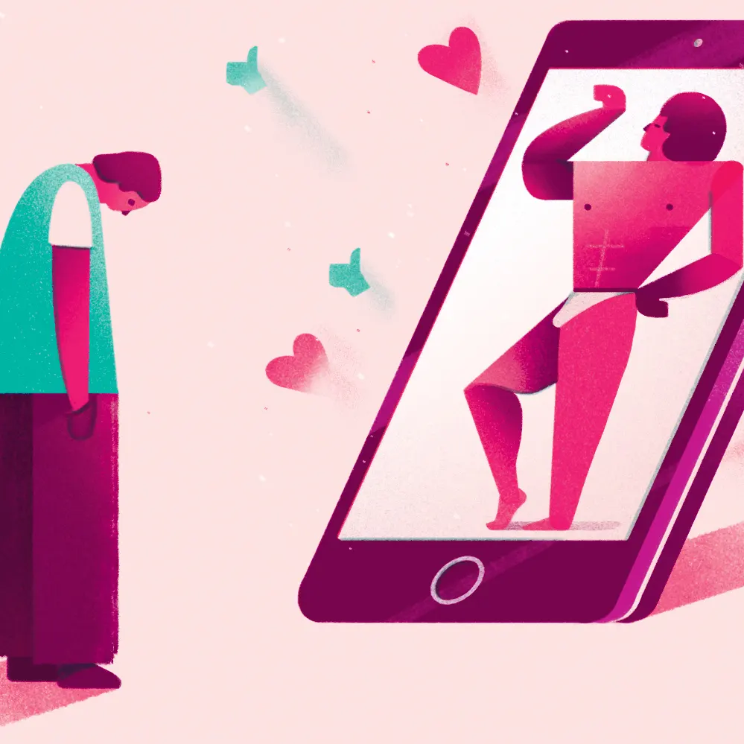
https://www.theguardian.com/commentisfree/2017/sep/06/social-media-good-evidence-platforms-insecurities-health
Accessed 15 May 2021
2.1. Identify TWO examples of media. (2x1)(2)
(Lower Order)
2.2 Discuss the negative impact that social media could have on your personal
lifestyle choices. (2x2)(4)
(Middle Order)
2.3 Propose TWO practical strategies that the media could implement to discourage
unhealthy sexual behaviour amongst the youth. (2x2)(4)
(Higher Order)

(10)
Question 3
Read the following extract from a recent research paper on youth behaviour in South Africa, and answer the questions that follow:

Changing Youth Behaviour in South Africa
Globally, youth risk behaviour, including risky sexual behaviour, is a public health concern and South Africa is no exception. Although the human immunodeficiency virus (HIV) infection rate is decreasing in South Africa, youth are severely affected by HIV, violence and unplanned teenage pregnancy. It is also widely acknowledged that the high prevalence of HIV and other sexually transmitted infections and rate of teenage pregnancy are fuelled by high-risk behaviours.
https://www.ncbi.nlm.nih.gov/pmc/articles/PMC7059634/ Accessed 15 May 2021

3.1 List TWO unwanted consequences of unhealthy sexual behaviour. (2x1)(2)
(Lower Order)
3.2 Discuss the role that peers play in healthy decision-making
regarding sexual behaviour. (1x2)(2)
(Middle Order)
3.3 Discuss the role that religion plays in healthy decision-making
regarding sexual behaviour. (1x2)(2)
(Middle Order)
3.4 Considering what you have learnt about the value of informed decision making, evaluate
the importance of teaching healthy sexual behaviour in schools. (2x2)(4)
(Higher Order)

(10)

Question 4
Study the following extract about Lizeka and answer the questions that follow.

https://unsplash.com/photos/DokE5D4GbDk Accessed 17 May 2021

Lizeka has just joined the Representative Council of Learners (RCL) at her school. On a weekly basis she finds that certain members of the RCL ask her to do some of their duties. Lizeka finds it tremendously difficult to say 'no'. She thinks that it will cause an argument and that she will come across as rude. She also feels that people are taking advantage of her, her workload related to the RCL is increasing and this causes her stress levels to rise, she starts dreading going to school and her self-esteem and confidence are now being impacted on. She remembers her LO teacher taught them to be assertive, but she still struggles.
Source of extract unknown.

4.1 State the definition of assertive behaviour. (1x1)(1)
(Lower Order)

4.2 Explain the impact that Lizeka’s lack of assertiveness is having on her emotional
wellbeing. (2x2)(4)
(Middle Order)
(5)
[TOTAL SECTION B: 25 MARKS]

SECTION C (Choice)
Answer any TWO questions in this section.
Your responses must consist of paragraphs.
Marks will only be allocated for responses written in full sentences.
Question 5
Examine the graph below and answer the questions that follow.
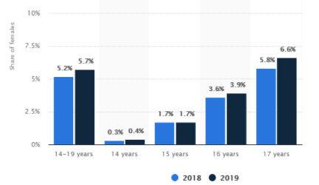
This bar chart shows the percentage of births to teenage mothers in South Africa
in 2018 and 2019.
https://www.bbc.com/news/world-africa-45889366 Accessed 15 May 2021
Write an essay on teenage pregnancy. Use the following as a guideline:
- Identify TWO risk factors for teenage pregnancy that could account for
these high numbers, as shown in the graph. (2x1)(2)
(Lower Order)
- Discuss TWO ways in which having to care for a baby as a teenager might
be detrimental to the young mother’s education. (2x2)(4) (Middle Order)
- Propose TWO strategies that parents of teenagers could do to reduce the percentage
of teen pregnancies in South Africa. (2x2)(4)
(Higher Order)
Question 6
Study the advertisement for Valentine’s Day and answer the questions that follow:
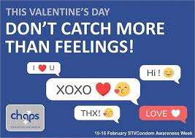

https://www.picuki.com/profile/chapseswatini Accessed 18 May 2021
Write an essay on sexually transmitted diseases and healthy sexual behaviour.

Use the following as a guideline:

- Identify TWO myths related to sexually transmitted diseases. (2x1)(2) (Lower Order)
- Explain how having an STI could impact a teenager’s emotional health. (2x2)(4)
(Middle Order)
- Recommend TWO practical ways that schools could empower teenagers to deal with unhealthy sexual behaviour. (2x2)(4)
(Higher Order)

Question 7
Read the extract below and answer the questions that follow.
INFORMED DECISION-MAKING SKILLS

Children and teenagers have been found to be poor decision-makers if they feel pressured, stressed or are seeking attention from peers. The difference between what teenagers know and what they choose can be explained in terms of “cold” and “hot” situations. Cold situations are choices made during times of low emotional arousal. During these periods, teenagers are able to make well-reasoned and rational decisions based on information available to them.
Hot situations refer to choices during periods of high emotional stress. Hot situations increase the chance of teenagers engaging in risk-taking with little self-control or consideration of the consequences of their actions.
https://theconversation.com/a-parents-guide-to-why-teens-make-bad-decisions-88246
Accessed 15 May 2021
Write an essay on making personal lifestyle choices through informed decision-making.
Use the following as a guideline:
- Define informed decision-making. (1x1)(1)
(Lower Order)
- State ONE reason why informed-decision making is important. (1x1)(1)
(Lower Order)
- Discuss TWO of the steps of informed decision-making. (2x2)(4)
(Middle Order)
- Evaluate the role that the environment could have on your personal lifestyle choices.
(2x2)(4)
(Higher Order)

[TOTAL SECTION C: 20 MARKS]

MEMORANDUM
Question 1.1
Various options are provided as possible answers to the following questions. Choose the correct answer and write only the letter (A–D) next to the question number (1.1.1 – 1.1.5) in the answer book, for example 1.1.6. E

1.1.1 Choose the option that best describes the concept “appropriate response”:

A. exact, manipulative and suitable action
B. manipulative action, based on all the facts
C. suitable and acceptable action for a particular situation ✔
D. assertive action, but not suitable for a particular situation (1)
(Lower Order)

1.1.2 Being assertive means

A. knowing your rights, so you will fight for them without being rude. ✔
B. making demands and accepting only your way as the right way.
C. not asking for help and considering only what you want and need.
D. never backing down and not listening to what others think or say. (1)
(Lower Order)

1.1.3 Unhealthy sexual behaviour means

A. being too young when you have sex. ✔
B. having protected sex.
C. abstaining from sex.
D. being faithful to one sexual partner. (1)
(Lower Order)

1.1.4. A risk factor for teenage pregnancy

A. Protective parents.
B. Clear future goals.
C. Strong religious beliefs.
D. Alcohol and drug use. ✔ (1)
(Lower Order)

1.1.5. Community norms are

A. Rules and regulations enforced by society ✔
B. Family values that are put in place by parents.
C. School rules that are formulated by society.
D. Rules and regulations enforced by government. (1)
(Lower Order)
(5x1)(5)

Question 1.2

Fill in the missing words:

1.2.1 While in ____________, a person potentially exposed to COVID-19 has limited contact
with family, friends and peers. (1)
(Lower Order)
isolation✔ OR lockdown
1.2.2 _____________ is being able to express what you would like clearly and confidently. (1)
(Lower Order)
Assertive✔

1.2.3 The concept of _________ is the decision not to have sexual intercourse. (1)
(Lower Order)
abstinence✔
1.2.4 Being sexually active is a _____________ factor for STD’s, it means that such behaviour
___________ a person’s chances of developing that disease. (2)
(Lower Order) risk ✔ increases✔
(5x1)(5)

Question 1.3
Match the concept in COLUMN A that best matches each statement in Column B. Write only the appropriate letter (A - G) next to the number (1.3.1 – 1.3.5).

Column A | Column B
1.3.1. Goal setting | A. Financial support
1.3.2. Risk factor for unhealthy sexual behaviour | B. Influence personal lifestyle choices
1.3.3. Community norms | C. Causes low self-esteem and emotional scars
1.3.4. Abstinence | D. An important life skill needed for success
1.3.5. Unhealthy sexual behaviour | E. Prevention of HIV/AIDS
 | F. Poverty

1.3.1 D
1.3.2 F
1.3.3 B
1.3.4 E
1.3.5 C
(5x1)(5)
(All Lower Order)

Question 1.4

1.4.1 Identify TWO unwanted results of unhealthy sexual behaviour. (2x1)(2)
(Lower Order)
Any TWO relevant answers for ONE mark each ✔✔
- Teenage pregnancy
- STIs
- HIV/AIDS
- Low self-image
- Emotional scars

1.4.2 Suggest TWO ways that we can protect ourselves from the spreading
of COVID-19. (2x1)(2)
(Lower Order)
Any TWO relevant answers for ONE mark each ✔✔
- Wash hands regularly
- Use hand sanitizer
- Practice social distancing
- Stay at home if you are showing symptoms
1.4.3 State ONE of the symptoms of STIs. (1x1)(1)
(Lower Order)
Any relevant answer for ONE mark ✔
- Discharge from the penis or vagina
- Sores on the penis, vagina or anus
- Painful sex
- Burning feeling when you pass urine
- Pain in the lower stomach

Question 1.5
Indicate whether the following statements are TRUE or FALSE. Write only 'true' or 'false' next to the question number (1.5.1 – 1.5.3). Give a reason if the statement is FALSE

1.5.1 Abstinence is only a choice for people who have never had sexual intercourse before.
False ✔
One can start practicing abstinence at any time ✔

1.5.2 Scabies is a common STI.
True ✔

1.5.3 If you are infected with HIV, you will not see symptoms for many years.
False ✔
Some people can develop symptoms shortly after being infected ✔

(5)
(All Lower Order)
[TOTAL SECTION A: 25 MARKS]

SECTION B (Compulsory)
Answer all the questions in this section. Write your answers in full sentences.

Question 2
Study the cartoon below and answer the questions that follow.
https://www.theguardian.com/commentisfree/2017/sep/06/social-media-good-evidence-platforms-insecurities-health
Accessed 15 May 2021
2.1. Identify TWO examples of media. (2x1)(2)
(Lower Order)
Any TWO relevant answers for ONE mark each ✔✔
- Newspapers ✔
- Radio ✔
- TV ✔
- Magazines ✔
- Social media ✔
2.2 Discuss the negative impact that social media could have on your personal
lifestyle choices. (2x2)(4)
(Middle Order)
Any TWO of the below or any relevant answers for TWO marks each
(i.e. ONE mark for statement and ONE mark for qualifier / explanation)
- We could try to create unrealistic goals ✔ because we try to keep up with the lifestyles of those on social media ✔
- Social media influencers or other forms of media such as advertising could demonstrate unhealthy lifestyle choices✔, which we want to copy which are not in line with our values which we based our goals on.
- Media can also place a lot of pressure on you ✔ you might feel like there’s a lot of pressure to look a certain way or to have certain things ✔
- Social media may distract you✔ from putting in the time and effort you achieve your goals ✔
- Social media may make you feel like you need to portray your achievement of goals or choices to the world ✔ where you are supposed to achieve goals for your own satisfaction or achievement ✔
2.3 Propose TWO practical strategies that the media could implement to discourage
unhealthy sexual behaviour amongst the youth. (2x2)(4)
(Higher Order)
Any TWO of the below or any relevant answers for TWO marks each
(i.e. ONE mark for statement and ONE mark for qualifier / explanation)
- Do not send mixed messages ✔ that might confuse the youth ✔
- Create awareness campaigns ✔ that emphasize healthy sexual behaviour ✔
- Avoid advertising✔ that glorifies unhealthy sexual behaviour ✔
(10)

Question 3
Read the following extract from a news article and answer the questions that follow:

Changing Youth Behaviour in South Africa
Globally, youth risk behaviour, including risky sexual behaviour, is a public health concern and South Africa is no exception. Although the human immunodeficiency virus (HIV) infection rate is decreasing in South Africa, youth are severely affected by HIV, violence and unplanned teenage pregnancy. It is also widely acknowledged that the high prevalence of HIV and other sexually transmitted infections and rate of teenage pregnancy are fuelled by high-risk behaviours.
https://www.ncbi.nlm.nih.gov/pmc/articles/PMC7059634/ Accessed 15 May 2021

3.1 List TWO unwanted consequences of unhealthy sexual behaviour. (2x1)(2)
(Lower Order)
Any TWO relevant answers for ONE mark each ✔✔
- Teenage pregnancy
- STIs
- Low self-esteem
- Poor grades at school

3.2 Discuss the role that peers play in healthy decision-making regarding sexual behaviour. (1x2)(2)
(Middle Order)
The below or any relevant answer for TWO marks
(i.e. ONE mark for statement and ONE mark for qualifier / explanation)

- Friends can encourage you or support your decision to wait or abstain from sex✔ or
they can make you feel like you should engage to feel included ✔

3.3 Discuss the role that religion plays in healthy decision-making regarding sexual
behaviour. (1x2)(2)
(Middle Order)
The below or any relevant answer for TWO marks
(i.e. ONE mark for statement and ONE mark for qualifier / explanation)

- Some religions can be very strict ✔ and guide decisions related to when sex should occur (for example, in a marriage) ✔. OR
- Religions guide us towards moral decision making ✔ and this can impact our decisions regarding sexual behaviour ✔

3.4 Considering what you have learnt about the value of informed decision making, evaluate
the importance of teaching healthy sexual behaviour in schools. (2x2)(4)
(Higher Order)
Any TWO of the below or any relevant answers for TWO marks each
(i.e. ONE mark for statement and ONE mark for qualifier / explanation)

- It should be taught in schools as not all parents discuss sex with their children✔ and they are uninformed ✔
- Some children feel awkward going to their parents regarding questions about sex✔ and might need a place where they can ask questions to make informed decisions ✔
- Parents may not give all the information ✔ that a child needs to make informed decisions about sex ✔
- Some children don’t grow up in an environment where they can learn about sex from their parents ✔and are unable to make informed decisions ✔
- Some parents don’t want to talk about sex with their children or aren’t around to do so ✔ - in this case, where are those learners supposed to find out more information✔
(10)

Question 4
Study the following extract about Lizeka and answer the questions that follow.
https://unsplash.com/photos/DokE5D4GbDk Accessed 17 May 2021

Lizeka has just joined the Representative Council of Learners (RCL) at her school. On a weekly basis she finds that certain members of the RCL ask her to do some of their duties. Lizeka finds it tremendously difficult to say 'no'. She thinks that it will cause an argument and that she will come across as rude. She also feels that people are taking advantage of her, her workload related to the RCL is increasing and this causes her stress levels to rise, she starts dreading going to school and her self-esteem and confidence are now being impacted on. She remembers her LO teacher taught them to be assertive, but she still struggles.
Source of extract unknown.

4.1 State the definition of assertive behaviour (1x1)(1)
(Lower Order)
Being firm, confident and clear about your needs ✔

4.2 Explain the impact that Lizeka’s lack of assertiveness is having on her emotional
wellbeing. (2x2)(4)
(Middle Order)
The TWO below or any relevant answers for TWO marks each
(i.e. ONE mark for statement and ONE mark for qualifier / explanation)

- Not saying no is making her busier ✔ and this is increasing her stress levels a great deal ✔
- Because of her stress levels, her self-esteem is being affected ✔ and her confidence is being impacted negatively ✔
(5)
[TOTAL SECTION B: 25 MARKS]

SECTION C (Choice)
Answer any TWO questions in this section.
Your responses must consist of paragraphs. Marks will only be allocated for responses written in full sentences.
Question 5
Examine the graph below and answer the questions that follow.

This bar chart shows the percentage of births to teenage mothers in South Africa
in 2018 and 2019.
https://www.bbc.com/news/world-africa-45889366 Accessed 15 May 2021

Write an essay on teenage pregnancy. Use the following as a guideline:
- Identify TWO risk factors for teenage pregnancy that could account for
these high numbers, as shown in the graph. (2x1)(2)
(Lower Order)
Any TWO relevant answers for ONE mark each ✔✔
- Not using contraceptives
- Alcohol and drugs
- Poverty
- Single-parent homes
- Lack of love
- Peer pressure
- Family and community norms

- Discuss TWO ways in which having to care for a baby as a teenager might be
detrimental to the young mother’s education. (2x2)(4) (Middle Order)
Any TWO of the below or any relevant answers for TWO marks each
(i.e. ONE mark for statement and ONE mark for qualifier / explanation)

- A teenage mother may have to leave school ✔ to look after the baby ✔
- They may have to get a part-time job to pay for medical expenses ✔ which could make them tired in class/ unable to finish all their homework ✔
- They may have to miss school ✔ to go to medical appointments or check-ups the baby needs ✔
- Propose TWO strategies that parents of teenagers could do to reduce the percentage
of teen pregnancies in South Africa. (2x2)(4)
(Higher Order)
Any TWO of the below or any relevant answers for TWO marks each
(i.e. ONE mark for statement and ONE mark for qualifier / explanation)
- Parents should be open and honest ✔ about sexual health ✔ from a young age.
- Parents should be available ✔ for their teenagers to talk to them. ✔
- Parents should refer their children to accurate and sensitive ✔ sources of information ✔
- Parents should be calm✔ and accepting when talking about sex to their children. ✔

(10)

Question 6
Study the advertisement for Valentine’s Day and answer the questions that follow:

https://www.picuki.com/profile/chapseswatini Accessed 18 May 2021
Write an essay on sexually transmitted diseases and healthy sexual behaviour.

Use the following as a guideline:

- Identify TWO myths related to sexually transmitted diseases. (2x1)(2) (Lower Order)
Any TWO relevant answers for ONE mark each ✔✔

- If you insist on wearing a condom, you have an STI
- Safe sex that prevents STIs means condomise
- Using condoms is always safe as protection against an STI
- Explain how having an STI could impact a teenager’s emotional health. (2x2)(4)
(Middle Order)
The below or any relevant answers for TWO marks each
(i.e. ONE mark for statement and ONE mark for qualifier / explanation)
- It could lead to feelings of guilt or shame ✔ that impact self-esteem ✔
- It could also impact one’s self-image ✔ because they feel used/dirty ✔
- Recommend TWO practical ways that schools could empower teenagers to deal with unhealthy sexual behaviour. (2x2)(4)
(Higher Order)
Any TWO of the below or any relevant answers for TWO marks each
(i.e. ONE mark for statement and ONE mark for qualifier / explanation)
- Get health care professionals / experts ✔ to speak to the learners. ✔
- LO and Life Science teachers ✔ could ensure their lesson content is up to date ✔
- Hold workshops ✔ about sexual health and STIs ✔
- Send home information ✔ to parents ✔
NOTE TO TEACHER: Accept other plausible answers.

(10)

Question 7
Read the extract below and answer the questions that follow.
INFORMED DECISION-MAKING SKILLS

Children and teenagers have been found to be poor decision-makers if they feel pressured, stressed or are seeking attention from peers. The difference between what teenagers know and what they choose can be explained in terms of “cold” and “hot” situations. Cold situations are choices made during times of low emotional arousal. During these periods, teenagers are able to make well-reasoned and rational decisions based on information available to them.
Hot situations refer to choices during periods of high emotional stress. Hot situations increase the chance of teenagers engaging in risk-taking with little self-control or consideration of the consequences of their actions.
https://theconversation.com/a-parents-guide-to-why-teens-make-bad-decisions-88246
Accessed 15 May 2021
Write an essay on making personal lifestyle choices through informed decision-making.
Use the following as a guideline:
- Define informed decision-making. (1x1)(1)
(Lower Order)
Making a choice based on knowledge of options available ✔
- State ONE reason why informed-decision making is important. (1x1)(1)
(Lower Order)
Any ONE relevant answer for ONE mark✔
- It allows one to make good choices
- It affords the opportunity to feel comfortable with the choice made.
- You are more likely to make choices in line with your values
- Discuss TWO of the steps of informed decision-making. (2x2)(4)
(Middle Order)
Any TWO of the below or any relevant answers for TWO marks each
(i.e. ONE mark for statement and ONE mark for qualifier / explanation)

- Recognize the problem ✔ this will help with clarity and identifying options ✔
- Educate yourself about various options ✔so that you are fully aware of all the choices available to you✔
- Learn from others ✔ who might be able to point things out to you that you have not yet considered ✔
- Act ✔ do not procrastinate, but make a decision ✔
- Evaluate the role that the environment could have on your personal lifestyle choices.
(2x2)(4)
(Higher Order)
Any TWO of the below or any relevant answers for TWO marks each
(i.e. ONE mark for statement and ONE mark for qualifier / explanation)
- If we live in an area of high crime ✔ it could impact our choices and limit our freedom ✔
- Pollution in our environment✔ might limit us from making certain choices ✔
- The environment you create around you at home and at school ✔could impact or increase your productivity, effectiveness, and even your motivation ✔
(10)

[TOTAL SECTION C: 20 MARKS]

