GRADE 9 LIFE ORIENTATION

TOPIC:
CONSTITUTIONAL RIGHTS AND RESPONSIBILITIES (CRR)
Terms 1 and 2
2021

2 HOURS 70 MARKS
NOTE TO TEACHERS: Remember, this is a bank of questions and therefore may contain some overlap. Keep this in mind when selecting questions for your paper. Use the table below to help you when choosing your questions.

Weighting (suggested) | Weighting (Actual) | Cognitive level | Bloom’s taxonomy
40% (28 marks) | 34 marks | Lower Order | Level 1&2
40% (28 marks) | 22 marks | Middle Order | Level 3&4
20% (14 marks) | 14 marks | Higher Order | Level 5&6
All essay questions are weighted equally.
Learners must complete the full combination related to a particular question.

REMINDER: Teenactiv papers should be considered as a bank of questions from which teachers can choose when creating their own question papers.

Control test should include components of each topic covered in terms 1 & 2 for 2021.
______________________________________________________________________________
INSTRUCTIONS AND INFORMATION
- The question paper consists of THREE sections, namely
SECTION A, SECTION B and SECTION C.
- The questions in SECTION A and SECTION B are compulsory.
- Answer any TWO questions in SECTION C.
- Read ALL the questions carefully.
- Number the answers correctly according to the numbering system used in this question paper. Start each question on a new page.
- Write neatly and legibly.
- This paper consists of 12 pages and 7 questions. (27 pages including Memo)

SECTION A (Compulsory)
Answer all the questions in this section.
Question 1.1
Various options are provided as possible answers to the following questions. Choose the correct answer and write only the letter (A–D) next to the question number (1.1.1 – 1.1.5) in the answer book, for example 1.1.6. E
1.1.1 Heritage Day is celebrated on

A. 21 March
B. 16 June
C. 24 September
D. 25 May (1)
(Lower Order)
1.1.2 This number is significant on Nelson Mandela Day:

A. 64, because this was the age that he was released from jail.
B. 65, because this is how many years he spent in jail.
C. 67, because this is how many years he served the country.
D. 68, because this is for how many years he spent in jail. (1)
(Lower Order)
1.1.3 A day that is celebrated in South Africa AND internationally:

A. Women’s Day
B. Africa Day
C. Freedom Day
D. Human Rights Day (1)
(Lower Order)
1.1.4. The protesting against pass laws in 1960 in Sharpeville inspired this public holiday:

A. Day of Reconciliation
B. Freedom Day
C. Human Rights Day
D. Nelson Mandela Day (1) (Lower Order)
1.1.5. Prejudice is not a way to uphold the values of the constitution because:

A. prejudice is an assumption not based on fact.
B. prejudice can lead to greater understanding.
C. prejudice includes assumptions based on truth.
D. prejudice is factual knowledge about a group. (1)
(Lower Order) (5x1)(5)
Question 1.2
Fill in the missing words:

1.2.1 A ________ is a condition that limits a person’s movements, senses of activities. (1)
(Lower Order)
1.2.2 A refugee is a person that leaves his/her country because of _____________. (1)
(Lower Order)
1.2.4 Braille is a form of reading to assist and accommodate _______ people. (1)
(Lower Order)
1.2.5 Women’s Day is a national/international day that celebrates ________
who have fought for __________. (2)
(Lower Order)
(5x1)(5)
Question 1.3
Match the concept in COLUMN A that best matches each statement in Column B. Write only the appropriate letter (A - G) next to the number (1.3.1 – 1.3.5).

Column A | Column B
1.3.1. Africa Day | A. 21 March
1.3.2. Human Rights Day | B. Celebrated by doing something of service in the community
1.3.3. Heritage Day | C. 16 June
1.3.4. Freedom Day | D. 25 May
1.3.5. Nelson Mandela Day | E. Celebrated to remind us that we are all equal
 | F. Celebrates the cultural heritage of South Africa

(5x1)(5)
(All Lower Order)

Question 1.4

1.4.1 List TWO characteristics of a positive role model. (2x1)(2)
(Lower Order)
1.4.2 Why do we celebrate national health days? (2x1)(2)
(Lower Order)

1.4.3 Provide the specific term used to describe treating people differently based on
their skin colour. (1x1)(1)
(Lower Order)
(5)

Question 1.5
Indicate whether the following statements are TRUE or FALSE. Write only 'true' or 'false' next to the question number (1.5.1 – 1.5.3). Give a reason if the statement is FALSE

1.5.1 People with HIV/AIDS can also contribute skills and talents to society.

1.5.2 The reason the 27 April is a public holiday is because this is the day Nelson Mandela was
released from prison.

1.5.3 Workers Day is celebrated only in South Africa.

(5)
(All Lower Order)
[TOTAL SECTION A: 25 MARKS]

SECTION B (Compulsory)
Answer all the questions in this section. Write your answers in full sentences.

Question 2
Read the article below and answer the questions that follow.
Online Learning a Challenge for Special Needs Children
3 May 2021
The Covid-19 pandemic lockdown raised the bar for teachers everywhere, but the challenges were even greater for children with disabilities. Getting specialist support to these children during the lockdown became a major challenge, especially as the majority were from poorer households with limited access to computers and other crucial technology to remain in touch and on top of their curricula.
A recent study by associate professor Judith McKenzie, head of disability studies at the University of Cape Town, highlighted concerns from a teacher at a school for the deaf regarding challenges of remote learning for her pupils: “We are finding it very difficult to contact all our families. Some phone numbers don’t exist. For deaf children, the videos that we send are data-intensive, hence initially there was not a good response during lockdown.”
https://www.dispatchlive.co.za/news/opinion/2021-05-03-opinion-online-learning-a-challenge-for-special-needs-children/
Accessed 17 May 2021
2.1. What specific disability is mentioned in this article? (1x1)(1)
(Lower Order)
2.2 Apart from lockdown, name ONE other way to prevent the spread of
COVID-19. (1x1)(1)
(Lower Order)
2.3 Discuss TWO ways how we can ensure that we treat people with
disabilities equally, to show and respect all people’s constitutional rights. (2x2)(4)
(Middle Order)
2.4 Describe TWO ways how you could care for someone living with a hearing impaired
disability. (2x2)(4)
(Middle Order)

(10)

Question 3
Read the following extract and answer the questions that follow:

Proposed marriage law changes for South Africa get the green light
22 April 2021
President Cyril Ramaphosa’s cabinet has approved the publication of the Green Paper on Marriages for public consultation. “The paper makes proposals on unions of people from all sexual orientations, religious and cultural persuasions. It also proposes the complete removal of child marriages in our future marriage regime,” said minister in the Presidency Khumbudzo Ntshavheni. “Despite all the changes that have been made in the marriage legislation post-1994, there are still serious gaps in the current legislation. For instance, the current legislation does not regulate some religious marriages such as the Hindu, Muslim and other customary marriages that are practised in some African or royal families”.

https://businesstech.co.za/news/lifestyle/485339/proposed-marriage-law-changes-for-south-africa-get-the-green-light/ Adapted. Accessed 15 May 2021

3.1 Identify the constitutional value that is undermined by gaps in the current marriage
legislation. (1x1)(1)
(Lower Order)
3.2 Explain the constitutional value of supremacy. (1x2)(2)
(Middle Order)
3.3 Recommend TWO practical strategies how you, as a Grade 9 learner, can apply the
constitutional value of human dignity at school. (2x2)(4)
(Higher Order)
(7)
Question 4
Study the following cartoon and answer the questions that follow.
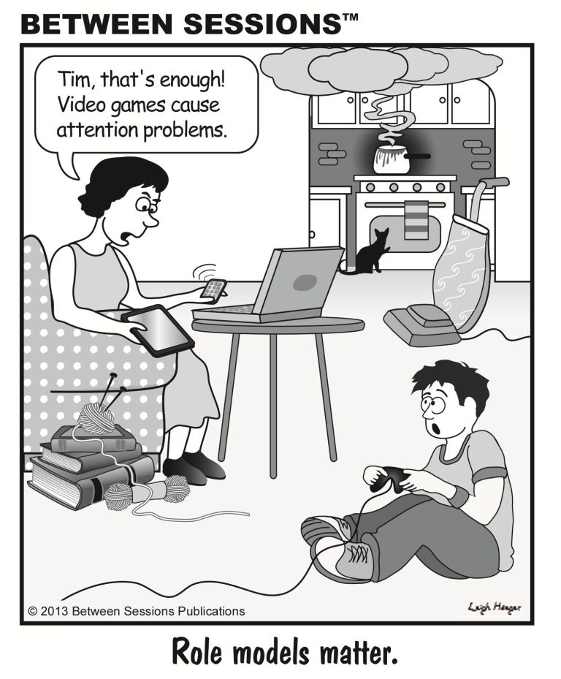
https://hdmodello.blogspot.com/2020/02/role-models-cartoon.html

4.1 Explain the concept ‘role model’ and give ONE reason why the woman in this cartoon is
acting as a poor role model for her son. (1+1)(2)
(Lower Order)
4.2 Discuss TWO negative consequences that a parent as a role model could have on a
teenager. (2x2)(4)
(Middle Order)
4.3 This cartoon notes that role models matter. Evaluate the importance of having role
models in our lives. (1x2)(2)
(Higher Order)
(8)
[TOTAL SECTION B: 25 MARKS]

SECTION C (Choice)
Answer any TWO questions in this section.
Your responses must consist of paragraphs. Marks will only be allocated for responses written in full sentences.
Question 5
Examine the image below and answer the questions that follow.
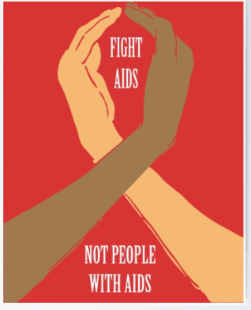

https://www.redbubble.com/i/poster/HIV-AIDS-day-Solidarity-support-by-LadyDevil/17714360.LVTDI
Accessed 17 May 2021
Write an essay on respect for people infected with and affected by HIV/AIDS.
- List TWO reasons why people with AIDS are not treated with equal rights. (2x1)(2)
(Lower Order)
- Explain the importance of World AIDS Day for people affected by or infected
with the virus. (2x2)(4)
(Middle Order)
- Recommend TWO ways your school could become a more welcoming and accepting
environment for learners who are HIV positive, so that we treat them equally and with dignity. (2x2)(4)
(Higher Order)
Question 6
Study the image and answer the questions that follow:
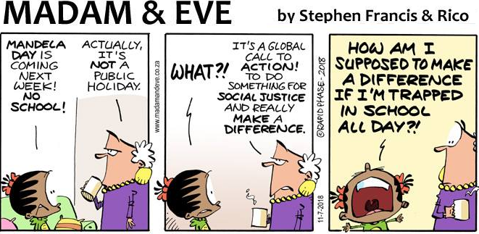
https://www.facebook.com/madamandevecartoon/photos/d41d8cd9/1687650964616281/
Accessed 14 May 2021
Write an essay on planning a celebration for and participating in Nelson Mandela Day.

Use the following as a guideline:

- On which date (day and month) is Mandela Day celebrated? (1x1)(2)
(Lower Order)
- You want to plan a successful celebration at school to mark Nelson Mandela Day. Discuss TWO guidelines for planning a successful celebration of a national day. (2x2)(4)
(Middle Order)
- Propose TWO ways that you could celebrate Nelson Mandela Day while still at school (2x2)(4)
(Higher Order)
(10)

Question 7
Read the quote below by Zozibini Tunzi, Miss South Africa and Miss Universe 2019.
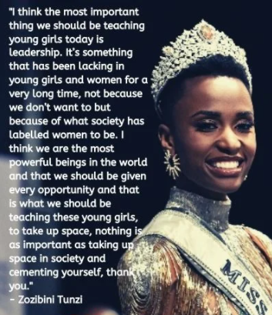
https://www.news24.com/parent/Child_7-12/Development/she-won-for-being-ginormously-kind-what-the-miss-universe-win-means-to-sas-girls-20191210 Accessed 20 May 2021

Write an essay on role models.
Use the following as a guideline:
- Identify ONE constitutional value that appears to be important to
Zozibini Tunzi. (1x1)(1)
(Lower Order)
- State ONE quality of a positive role model. (1x1)(1)
(Lower Order)
- Discuss TWO ways how celebrities motivate teenagers to work for unity and equality.
(2x2)(4)
(Middle Order)
- Motivate TWO reasons why Tunzi is a positive role model for young girls, when so many people still believe that these kinds of competitions put too much pressure on young girls to look a certain way. (2x2)(4)
(Higher Order)

[TOTAL SECTION C: 20 MARKS]

MEMORANDUM
SECTION A (Compulsory)
Answer all the questions in this section.
Question 1.1
Various options are provided as possible answers to the following questions. Choose the correct answer and write only the letter (A–D) next to the question number (1.1.1 – 1.1.5) in the answer book, for example 1.1.6. E

1.1.1 Heritage Day is celebrated on

A. 21 March
B. 16 June
C. 24 September ✔
D. 25 May (1)
(Lower Order)

1.1.2 This number is significant on Nelson Mandela Day:

A. 64, because this was the age that he was released from jail.
B. 65, because this is how many years he spent in jail.
C. 67, because this is how many years he served the country. ✔
D. 68, because this is for how many years he spent in jail. (1)
(Lower Order)

1.1.3 A day that is celebrated in South Africa AND internationally:

A. Women’s Day ✔
B. Africa Day
C. Freedom Day
D. Human Rights Day (1)
(Lower Order)

1.1.4. The protesting against pass laws in 1960 in Sharpeville inspired this public holiday:

A. Day of Reconciliation
B. Freedom Day
C. Human Rights Day ✔
D. Nelson Mandela Day (1)
(Lower Order)

1.1.5. Prejudice is not a way to uphold the values of the constitution because:

A. prejudice is an assumption not based on fact. ✔
B. prejudice can lead to greater understanding.
C. prejudice includes assumptions based on truth.
D. prejudice is factual knowledge about a group. (1)
(Lower Order)

(5x1)(5)
Question 1.2
Fill in the missing words:

1.2.1 A ________ is a condition that limits a person’s movements, senses of activities. (1)
(Lower Order)
Disability ✔
1.2.2 A refugee is a person that leaves his/her country because of _____________. (1)
(Lower Order)
War ✔ OR
discrimination ✔

1.2.4 Braille is a form of reading to assist and accommodate _______ people. (1)
(Lower Order)
Blind ✔OR
Visually impaired ✔

1.2.5 Women’s Day is a national/international day that celebrates ________ who have
fought for __________. (2)
(Lower Order)
Women ✔
Equality OR rights ✔
(5x1)(5)

Question 1.3
Match the concept in COLUMN A that best matches each statement in Column B. Write only the appropriate letter (A - G) next to the number (1.3.1 – 1.3.5).

Column A | Column B
1.3.1. Africa Day | A. 21 March
1.3.2. Human Rights Day | B. Celebrated by doing something of service in the community
1.3.3. Heritage Day | C. 16 June
1.3.4. Freedom Day | D. 25 May
1.3.5. Nelson Mandela Day | E. Celebrated to remind us that we are all equal
 | F. Celebrates the cultural heritage of South Africa

(5x1)(5)
(All Lower Order)
1.3.1 D
1.3.2 A
1.3.3 F
1.3.4 E
1.3.5 B

Question 1.4

1.4.1 List TWO characteristics of a positive role model. (2x1)(2)
(Lower Order)
Any TWO relevant answers for ONE mark each ✔✔
- Is humble
- Thinks before making decisions
- Works hard
- Is honest and genuine
NOTE TO TEACHER: Accept other plausible answers

1.4.2 Why do we celebrate national health days? (2x1)(2)
(Lower Order)
To bring awareness about an illness or condition ✔
AND
to educate people about an illness or condition ✔

1.4.3 Provide the specific term used to describe treating people differently based on
their skin colour. (1x1)(1)
(Lower Order)
Racism ✔

Question 1.5
Indicate whether the following statements are TRUE or FALSE. Write only 'true' or 'false' next to the question number (1.5.1 – 1.5.3). Give a reason if the statement is FALSE

1.5.1 People with HIV/AIDS can also contribute skills and talents to society.
True ✔

1.5.2 The reason the 27 April is a public holiday is because this is the day Nelson Mandela was
released from prison.
False ✔
This day is a public holiday because it was the first democratic election in SA ✔

1.5.3 Workers Day is celebrated only in South Africa.
False ✔
Workers Day is celebrated all around the world ✔
(5)
(All Lower Order)
[TOTAL SECTION A: 25 MARKS]

SECTION B (Compulsory)
Answer all the questions in this section. Write your answers in full sentences.

Question 2
Read the article below and answer the questions that follow.
Online Learning a Challenge for Special Needs Children
3 May 2021
The Covid-19 pandemic lockdown raised the bar for teachers everywhere, but the challenges were even greater for children with disabilities. Getting specialist support to these children during the lockdown became a major challenge, especially as the majority were from poorer households with limited access to computers and other crucial technology to remain in touch and on top of their curricula.
A recent study by associate professor Judith McKenzie, head of disability studies at the University of Cape Town, highlighted concerns from a teacher at a school for the deaf regarding challenges of remote learning for her pupils: “We are finding it very difficult to contact all our families. Some phone numbers don’t exist. For deaf children, the videos that we send are data-intensive, hence initially there was not a good response during lockdown.”
https://www.dispatchlive.co.za/news/opinion/2021-05-03-opinion-online-learning-a-challenge-for-special-needs-children/
Accessed 17 May 2021
2.1. What specific disability is mentioned in this article? (1x1)(1)
(Lower Order)
Deaf ✔
OR
hearing impaired
2.2 Apart from lockdown, name ONE other way to prevent the spread of
COVID-19. (1x1)(1)
(Lower Order)
ANY ONE ✔
- Wash hands regularly
- Wear masks
- Social distance

2.3 Discuss TWO ways how we can ensure that we treat people with
disabilities equally, to show and respect all people’s constitutional rights. (2x2)(4)
(Middle Order)

Any TWO of the below or any relevant answers for TWO marks each
(i.e. ONE mark for statement and ONE mark for qualifier / explanation)
- It means that people with disabilities do not need to be patronized or treated as inferior ✔ but you uphold their constitutional right to equality ✔
- It means that we should ask people with disabilities if they would like or need assistance before assuming they do / forcing it on them ✔ so that you can uphold their constitutional right to dignity ✔
- It means that there needs to be provisions and support in place that allows people with disabilities to be treated the same as people who are able-bodied ✔ so you uphold their constitutional right to equality ✔
- It means that people with disabilities should be given equal access to opportunities that people who are able bodied have ✔ so you uphold their constitutional right to equality ✔

2.4 Describe TWO ways how you could care for someone living with a hearing-impaired
disability. (2x2)(4)
(Middle Order)
Any TWO of the below or any relevant answers for TWO marks each
(i.e. ONE mark for statement and ONE mark for qualifier / explanation)
- Treat them so that they feel respected and equal ✔ so one should not treat them any differently from how one treats the rest of one’s friends ✔
- Find out how you can give extra support (if needed) ✔ so be there for them in a tactful manner ✔
- Become empowered, find out information about their disability ✔ in order to understand their point of view and have empathy ✔

(10)

Question 3
Read the following extract and answer the questions that follow:

Proposed marriage law changes for South Africa get the green light
22 April 2021
President Cyril Ramaphosa’s cabinet has approved the publication of the Green Paper on Marriages for public consultation. “The paper makes proposals on unions of people from all sexual orientations, religious and cultural persuasions. It also proposes the complete removal of child marriages in our future marriage regime,” said minister in the Presidency Khumbudzo Ntshavheni. “Despite all the changes that have been made in the marriage legislation post-1994, there are still serious gaps in the current legislation. For instance, the current legislation does not regulate some religious marriages such as the Hindu, Muslim and other customary marriages that are practised in some African or royal families”.

https://businesstech.co.za/news/lifestyle/485339/proposed-marriage-law-changes-for-south-africa-get-the-green-light/ Adapted. Accessed 15 May 2021

3.1 Identify the constitutional value that is undermined by gaps in current marriage
legislation. (1x1)(1)
(Lower Order)
Equality ✔
3.2 Explain the constitutional value of supremacy. (1x2)(2)
(Middle Order)
The below or any relevant answer for TWO marks
(i.e. ONE mark for statement and ONE mark for qualifier / explanation)

- The Constitution is the ultimate authority ✔ and no one can interfere with it ✔
3.3 Recommend TWO practical strategies how you, as a Grade 9 learners, can apply the
constitutional value of human dignity at school. (2x2)(4)
(Higher Order)
Any TWO of the below or any relevant answers for TWO marks each
(i.e. ONE mark for statement and ONE mark for qualifier / explanation)
- Respect other learners at school who are different ✔ as they too should be treated with respect ✔
- Be mindful of your actions and how you act at school ✔ because we often degrade and disrespect others without realizing we are doing it ✔
- Be willing to be empowered and / or follow the good examples of others ✔ because this will make you aware of your classmates or fellow learners ✔
- Organize awareness/educational campaigns about the value ✔ by making posters/talking about it in class ✔so that all your fellow learners can be educated.
(7)

Question 4
Study the following cartoon and answer the questions that follow.
https://hdmodello.blogspot.com/2020/02/role-models-cartoon.html

4.1 Explain the concept ‘role model’ and give ONE reason why the woman in this cartoon is
acting as a poor role model for her son. (1+1)(2)
(Lower Order)
A role model is someone who sets a good example for others ✔
AND
- The mother’s actions do not match her words ✔ OR
- She is telling her son to stop gaming so much but she herself is surrounded by electronics ✔

4.2 Discuss TWO negative consequences that a parent acting as a poor role model
could have on a teenager. (2x2)(4)
(Middle Order)
Any TWO of the below or any relevant answers for TWO marks each
(i.e. ONE mark for statement and ONE mark for qualifier / explanation)
- A learner could come to view the example set by the negative role model as a good one to follow ✔ and do the same things, which could get them into trouble ✔
- It could result in the learner normalizing and accepting poor behaviour ✔ and therefore put them at risk for tolerating the behaviour in the future ✔
- A parent is the leader in the family and thus set the tone for value building/forming✔ and if the role model is a poor example, teenagers might build a set of values that do not build on good constitutional values ✔ and miss meeting (or even setting) important goals ✔
- Parents who are not involved in the community ✔ could result in their teenagers not being good members of the community ✔
4.3 This cartoon notes that role models matter. Evaluate the importance of having role
models in our lives. (1x2)(2)
(Higher Order)
Any ONE of the below or any relevant answer for TWO marks
(i.e. ONE mark for statement and ONE mark for qualifier / explanation)
- While it is important to follow the example of others ✔ we always consider our choices carefully as we alone are accountable for the outcomes ✔
- Looking at role models can be motivating and inspiring ✔ but we must remember that people are flawed and can disappoint us ✔
- Following one person completely might result in disappointment ✔ therefore it is better to follow specific qualities or characteristics ✔
(8)
[TOTAL SECTION B: 25 MARKS]

SECTION C (Choice)
Answer any TWO questions in this section.
Your responses must consist of paragraphs. Marks will only be allocated for responses written in full sentences.
Question 5
Examine the image below and answer the questions that follow.

https://www.redbubble.com/i/poster/HIV-AIDS-day-Solidarity-support-by-LadyDevil/17714360.LVTDI
Accessed 17 May 2021

Write an essay on respect for people infected with and affected by HIV/AIDS.
- List TWO reasons why people with AIDS are not treated with equal rights. (2x1)(2)
(Lower Order)
Any TWO relevant answers for ONE mark each
- There is a stigma attached to the disease ✔
- People do not know enough about how to become infected and are worried they will get it ✔
- There is a high cost to treating the disease ✔
- Employers are worried people with AIDS will be absent a lot ✔

- Explain the importance of World AIDS Day for people affected by or infected
with the virus. (2x2)(4)
(Middle Order)
Any TWO of the below or any relevant answers for TWO marks each
(i.e. ONE mark for statement and ONE mark for qualifier / explanation)

- World AIDS Day is a day where people are educated and informed about HIV/AIDS ✔ which will lead to less discrimination against people affected by / infected with the virus ✔
- Because more people become aware of the virus on World AIDS Day ✔ people who are affected by or infected with the disease might receive more support, understanding and tolerance / change their attitude and behaviour towards them ✔
- People who are infected with the virus might find out more accurate information on World AIDS Day ✔ and therefore be able to manage the illness better ✔
- More education about the condition ✔ might result in myths being broken down ✔
- Recommend TWO ways your school could become a more welcoming and accepting
environment for learners who are HIV positive, so that we treat them equally and with dignity. (2x2)(4)
(Higher Order)
Any TWO of the below or any relevant answers for TWO marks each
(i.e. ONE mark for statement and ONE mark for qualifier / explanation)
- Awareness about how the virus is spread should be raised through campaigns ✔ so that learners who are HIV positive will be understood and not feared ✔
- Teachers need to go on training courses ✔ so that they know the specific needs of a learner who is HIV positive ✔
- The school could celebrate World Aids Day to be a part of something bigger ✔ and in that way connect with other schools and resources in the community ✔
- The tuckshop should include healthy food in their offering ✔ so that learners with HIV can buy food from the tuckshop but also focus on their health ✔

Question 6
Study the image and answer the questions that follow:
https://www.facebook.com/madamandevecartoon/photos/d41d8cd9/1687650964616281/ Accessed 14 May 2021
Write an essay on planning a celebration for and participating in Nelson Mandela Day.

Use the following as a guideline:

- On which date (day and month) is Mandela Day celebrated? (1x1)(2)
(Lower Order)
18th July ✔
- You want to plan a successful celebration at school to mark Nelson Mandela Day. Discuss TWO guidelines for planning a successful celebration of a national day. (2x2)(4)
(Middle Order)
Any TWO of the below or any relevant answers for TWO marks each
(i.e. ONE mark for statement and ONE mark for qualifier / explanation)

- Become informed about the day✔, so that the day can be meaningful ✔ and not just a party
- Be proactive ✔ otherwise you will end up doing nothing or your day may not work out as you planned ✔
- Aim to educate people ✔ so that the celebration creates awareness about the reason for celebrating on that day✔
- Recruit positive people who share your enthusiasm about the day ✔ so that you can motivated by like-minded people ✔

- Propose TWO ways that you could celebrate Nelson Mandela Day while still at school (2x2)(4)
(Higher Order)
Any TWO of the below or any relevant answers for TWO marks each
(i.e. ONE mark for statement and ONE mark for qualifier / explanation)
- Collect and donate books to your local library ✔ so that more people will have access to a greater number of books ✔
- Collect and distribute children's books to under-resourced schools ✔ to benefit children in need ✔
- Clean your school grounds and pick up litter ✔so that your school will benefit from the day ✔
- Community cleaning project ✔ to serve the rest of the community ✔
- Help in the afternoon to read to the aged if you live close to an old age home ✔ so that the elderly will feel cared for ✔
NOTE TO TEACHER: Accept other plausible answers that indicate a creative form
of celebration AND explain how it serves others.

Question 7
Read the quote below by Zozibini Tunzi, Miss South Africa and Miss Universe 2019.

https://www.news24.com/parent/Child_7-12/Development/she-won-for-being-ginormously-kind-what-the-miss-universe-win-means-to-sas-girls-20191210 Accessed 20 May 2021
Write an essay on role models.
Use the following as a guideline:
- Identify ONE constitutional value that appears to be important to Zozibini
Tunzi. (1x1)(1)
(Lower Order)
ANY ONE ✔
  - Equality
  - Human Dignity

- State ONE quality of a positive role model. (1x1)(1)
(Lower Order)
- Humble
- Admits faults
- Works hard
- Tries to strengthen community
- Treats people equally
- Treats people with respect
- Discuss TWO ways how celebrities motivate teenagers to work for unity and equality.
(2x2)(4)
(Middle Order)
The below or any relevant answers for TWO marks each
(i.e. ONE mark for statement and ONE mark for qualifier / explanation)
- Celebrities often stand for and talk about subjects ✔ that others are afraid to talk about and this could be inspiring to teenagers ✔
- Celebrities are successful and talented ✔ and because of this, teenagers want to follow in their footsteps ✔
- Motivate TWO reasons why Tunzi is a positive role model for young girls, when so many people still believe that these kinds of competitions put too much pressure on young girls to look a certain way. (2x2)(4)
(Higher Order)
Any TWO of the below or any relevant answers for TWO marks each
(i.e. ONE mark for statement and ONE mark for qualifier / explanation)
- Tunzi is focused on others, not herself ✔ as she highlights the importance of giving opportunities to other young girls in this quote ✔
- Tunzi advocates/stands for equality between genders ✔ making her a good role model to follow when it comes to equality in society ✔
- Tuniz’s quote emphasizes how powerful women are ✔ which is an inspiring value to stand for ✔
- Tunzi encourages girls to take up space, and take a stand ✔ which makes her a good role model for other girls to do the same ✔
[TOTAL SECTION C: 20 MARKS]

